COMPOSITION: ELECTRONIC MEDIA II
March 30, 2009
Synthesis in Max/MSP

- Discussion of Additive Synthesis

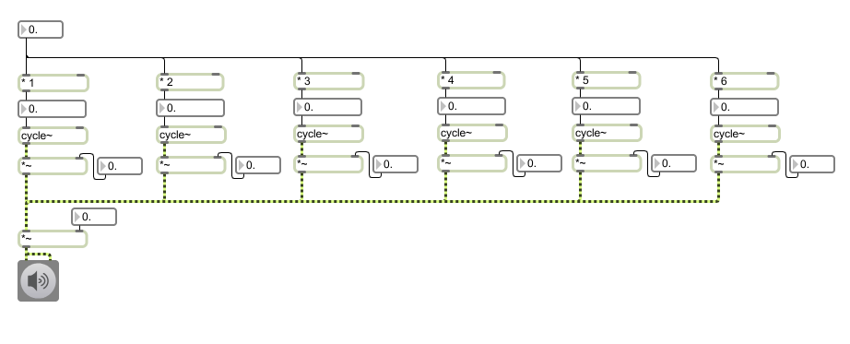
- Basic Frequency Modulation (FM) Synthesis

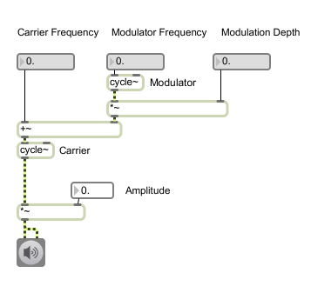
  - Go to File menu and choose New Patcher
  - Create a dac~ object with a toggle switch, or an ezdac~ object.
  - Place a *~ object above dac~ object. Connect the outlet of the *~ object to the inlets of the dac~ object. Connect a flonum to the right inlet of the*~ object.
  - Create a cycle~ object and connect its outlet to the left inlet of the *~ object. This cycle~ object will serve as the carrier.
  - Create a +~ object and connect its outlet to the left inlet of cycle~ object.
  - Create another *~ object and connect its outlet to the right inlet of the +~ object.
  - Create another cycle~ object and connect its outlet to the left inlet of the *~ object in step 1f. This cycle~ object will serve as the modulator.
  - Connect flonums to the following:
    - +~ object - left inlet
    - Modulator cycle~ object – left inlet
    - *~ object of step 2f – right inlet
- To achieve better control over the frequency, envelope and timbre of the sound add the following to the patcher in step 2.

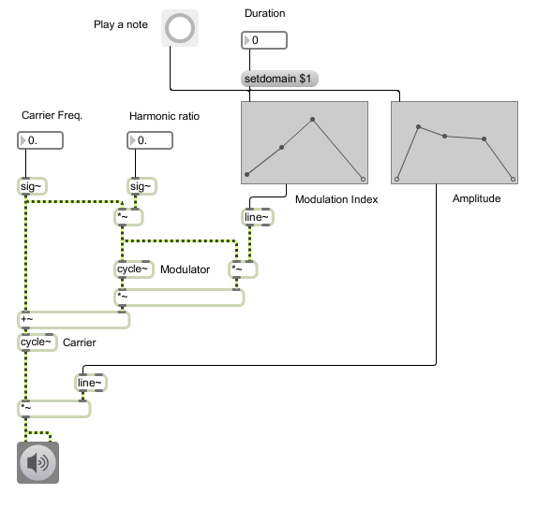

  - Disconnect all flonums.
  - Create a sig~ object and connect its outlet to the left inlet of the +~ object. Place the sig~ object high enough above the +~ object as shown in the picture. Connect a flonum to the inlet of this sig~ object.
  - Create a *~ object and connect its outlet to the left inlet of the modulator cycle~ object. Connect the outlet of the sig~ object of step 3b to the left inlet of this *~ object.
  - Create another sig~ object and connect its outlet to the right inlet of the *~ object of step 3c. Connect a flonum to the inlet of this sig~ object.
  - Create another *~ object and connect its outlet to the right inlet of the *~ object below the modulator cycle~ object. Connect the outlet of the *~ object of step 3c to the left inlet of the *~ object you have just created.
  - Create two line~ objects. Connect one of them to the right inlet of the *~ object of step 3e, and the other to the right inlet of the *~ object above the dac~.
  - Create two function objects and connect their outlets (second from the left) to the left inlets of the line~ objects of step 3f.
  - Create a button object and connect it to the inlets of the two function objects.
  - Connect a number to a message with the argument “setdomain $1”. Connect the message to the inlets of the two function objects.

- Ring Modulation and Amplitude Modulation

Ring Modulation
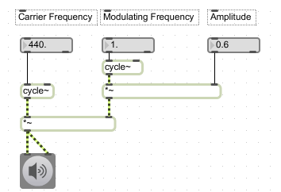

Amplitude Modulation
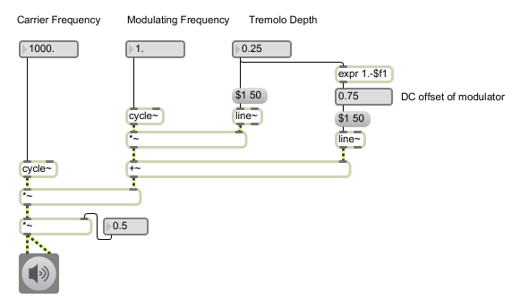

- One band filter with biquad~ object and filtergraph~ object

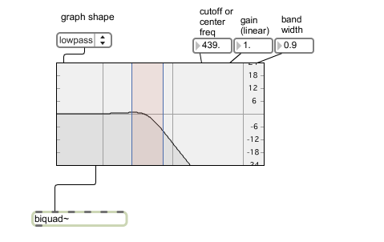
  - Second outlet from the left of filtergraph~ object connects to the second inlet from the left of the biquad~ object. Signal input is in the left inlet of the biquad~ object.
  - umenu object in left inlet of the filtergraph~ object controls the graph shape – low pass, high pass, band pass etc.
  - flonums in the three inlets from the right controls band width, gain and cutoff/center frequency.

