025:250 COMPOSITION: ELECTRONIC MEDIA I
Fall 2010
Peak Menus and Key Commands

1. Peak Pro 6
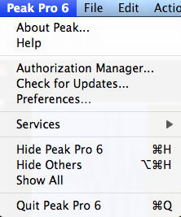

2. File
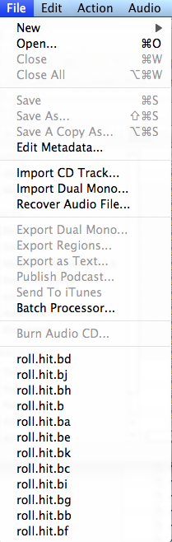

3. Edit
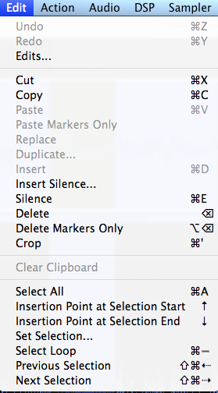

4. Action
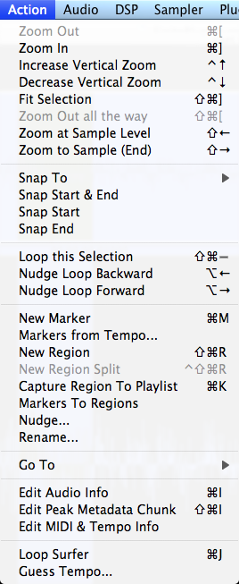

5. Audio
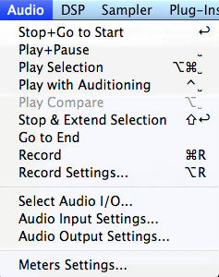

6. DSP
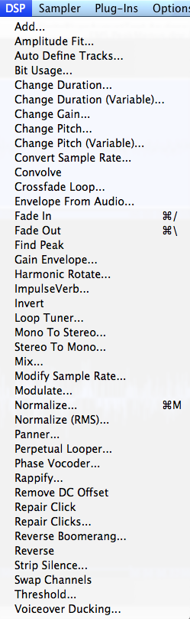

7. Sampler
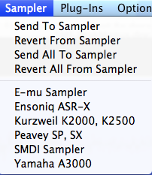

8. Plug-ins
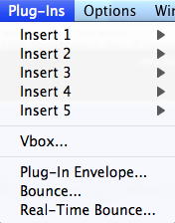

9. Options
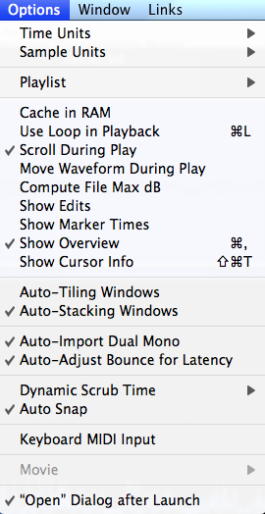

10. Window
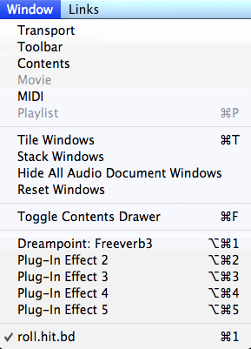

11. Links
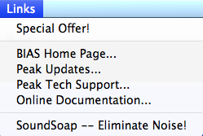

12. Key commands:
a. Extremely useful
b. Teachers be frugal
c. Standard key commands that all Apple apps share
d. Standard key commands that all time-line apps share
e. Standard key commands that all audio apps share
f. Key commands used only by a particular app
g. Key commands programmed by the user (In class discussion about multi-user computers).

13. File key commands:
a. New mono file = cmd n
b. New stereo file = cmd shift n
c. Silence = cmd n

14. Edit key commands:
a. copy = cmd c
b. paste = cmd v
c. cut = cmd x
d. In class discussion of cut, which retains a copy in the clipboard, and delete, which does not.
e. silence = cmd e

15. Action key commands:
a. Zoom out = cmd ]
b. Zoom in = cmd [
c. In class discussion of this function in other apps

16. Action key commands:
a. Play = spacebar
b. Set vertical line cursor to beginning of file: return
c. In class discussion of playback in other apps

17. DSP key commands customized for EMS:
a. Fade in = cmd /
b. Fade out = cmd \
c. normalize = cmd m (“mormalized” ha-ha)
d. In class discussion of why this is done

18. To make or change a key command for an action, do the following:
a. Peak 6>Preferences. A window like the one below will appear:
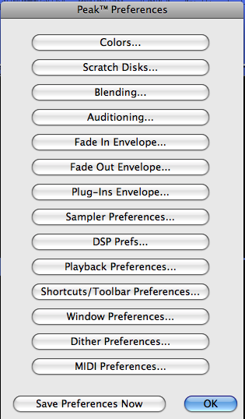

b. Select Shortcuts/Toolbar Preferences. A window like the one below will appear:
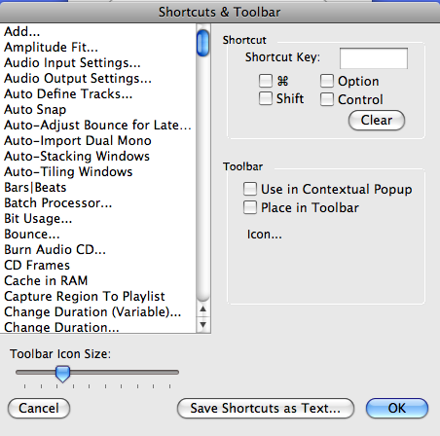

c. In class discussion of how to use this.

19. No other key commands need to be used in this class unless requested by users.

20. Discussion of how to make a handout like this.
a. Font = Times New Roman, 11 point
b. Margins = Top 0.5” Bottom = 0.5” Left = 0.75” Right = 0.5”
c. Tap stop position = 0.23”
d. This tab distance works for 1 and 2-digit numbers, as discussed in class.
e. Screenshots = cmd 4 This lets user draw a rectangle around area to be captured. Snapshots are placed on the desktop, where they can be dragged and dropped onto the Word document.

