Composition: Electronic Media II
Spring 2010
Handouts for EMS

1. The document has the following features:
a. All margins are .5”.
b. The tab is set to .2”.
b. The font is Times New Roman 11 point.
c. The heading of the handout should be like the one above. The top two lines will be exactly the same for every
handout of the semester.
d. The third line is the title of the handout.

2. Notice that the line you are reading now is created by typing “2.”, followed by a tab, followed by “Notice that…” Watch what just happened here. I typed “Watch,” then Word automatically go to the next lower line. This looks sloppy for reasons that I won’t explain.

3. Now, I will describe how to make the document neater by using the tab stop for aligning text. I am running out of words. What you should do when the text is kicked down to the next line is to place the I-beam cursor to the left of “words” and hit Enter. Then hit tab. Look at the results in item 3 below.

3. Now, I will describe how to make the document neater by using the tab stop for aligning text. I am running out of
words.

4. Now we will look at the next level, as shown below.
a. Hi there.

5. In item 4, I typed…”as shown below.” Then I hit enter. Then tab, then I typed the letter “a”. After this, I hit tab, then
typed “Hi there.”

6. Discussion of the quote marks.
a. The accepted rule is generally that when a sentence ends with a right quote mark, the period is placed between the
last letter and the quote mark.
b. As much as I dislike doing so, in these handouts I place the period to the right of the right quote mark, like “this”.
c. Not “this.”
d. This is because I frequently have students create names for files and objects that need to be written exactly.
Consider the file name “LF. 1a.” I am afraid that the student will write the file name as LF.1a. instead of LF.1a
which I like better. Decimal-place numbers can also be misread using the older, accepted use of quotes.

7. Spacing.
a. I generally do not have spaces between items a, b, c, etc.
b. Like this.

8. Page breaks.
a. the text starting on the next page should be started by “d. and so on” or “6b. and so on”.
b. Notice that the use of the tab makes doing this easier.
c. Make a reasonable effort to begin the next page with a new item number, like the one shown in the next item.

9. This is the start of the new page.

10. The number ten, here, is typed this way:
a. Type “10”
b. Hit tab.
c. Type “The number ten…”
d. Next hit return, then tab, the type “a”.
e. This method insures that the text will line up correctly.

11. Screen shots are always good, especially when explaining a complex series of steps in Pro Tools or other software.
a. Using the right screen shots will make it easy for the student to follow the discussion, and work alone for the first
time.
b. Often a student will just follow the screen shots and not read the text unless absolutely necessary. Since people
have the tendency to work this way, try to accommodate that in the handout.

12. To make a screen shot, do the following:
a. Type cmd-4.
b. Notice the cursor change to a sight with a set of coordinates.
c. Draw a rectangle over the window.
d. When drawing the rectangle over a window or menu, try to stay within borders for neatness.
e. This one is good:

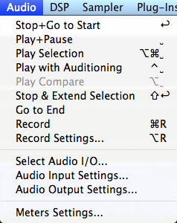

f. This one is a little sloppy:

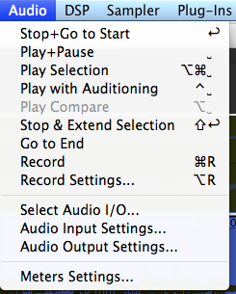

13. Placing screen shots in the document.
a. After drawing the rectangle, release the mouse and you will hear the sound of a camera shutter.
b. The image is saved to the desktop as “Picture 1”, “Picture 2” etc.
c. If you want to save the screen shots for some reason, immediately rename it.
d. Drag the image from the desktop into the window of the handout.
e. Click in the lower right-hand corner to resize it. You can work with the sizes of these to control the page breaks in
the document.

14. Although I vary my procedure sometimes, I recommend placing the image as follows:
a. Create a space between the text and image, as shown below:

b. Create a space between the image and the next lower line of text, as shown above.
c. If it looks better or solves a spacing or page break problem, it is OK to leave out one or both spaces.
d. The left side of the image should be tabbed so that it lines up with the first tab (the first tab is the space between a
number with period and the next text; it also aligns with the lower case letters a, b, c…

15. If you will be giving information verbally or written on the white board, sometimes it helps to leave space in the
handout for a few words written down by the student.

16. Another strategy is to list terms and leave blank spaces or underlines for the student to fill in, such as those below:

- additive synthesis

b. subtractive synthesis

c. FM synthesis

17.I usually go over the handout in class, step by step.
a. By methodically going from step to step, the student sees that nothing of importance is left out.
b. Keep the writing as clear and dry as possible.
c. Refer as little as possible to other software or techniques other than the one at hand. If you need to discuss these
things, try doing it either at the beginning of the presentation or the end. If you need to go back and forth between two programs, refer to both of them clearly in the handout.
d. I often like to have one student read from the handout and direct another student controlling the software at the computer. This keeps everyone in class alert, since they, too, will be sitting at the computer in the next step. Most importantly, this helps make the operations of the software more concrete.
e. As mentioned above, the handout should be tightly focused on the topic. But when going over the handout in the manner described above in Item 17.d, it can be useful to put the handout on hold for a minute or two, and expand on an idea in discussion, on the white board, or on the computer itself.
f. To close the discussion above, then say something like, “Let’s see, where were we?” Of course you should know where you are. The trick here is to get the students to direct the handout discussion. This is one of many tricks you should learn to get students talking. The basic trick here is to ask a question that they easily know the answer to. The answer is not the issue, the student’s awareness and voice are what are important.
g. Make sure that you end the discussion on the last item in the handout. If you break of the discussion and move to another activity, students might feel a slight sense of disorganization and not following through or completing the discussion.

18. Disseminating the handout.
a. Students like getting a handout every class, which promotes attendance and a sense of organization.
b. Students sometimes keep handouts in a notebook, which is helpful when working alone.
c. Most people do not make nearly enough copies of handouts. This is because:
i. More people come to class or to hear a talk than anticipated.
ii. Other people, like the professor, TAs, or guests need handouts.
iii. Sometimes students lose a handout and need a new one next week.
d. In all of these situations, the presentation is stalled while the problem is dealt with.
e. When making copies, consider the cost/benefit ratio very carefully from the point of view of your time. Is it worth
saving your printer ink to go to Copy Works when you could just print out 20 pages on your printer?
f. Handouts that are stapled are much easier to handle, distribute, and follow the discussion than loose pages.
g. However, collating and stapling handouts takes time that might be better used on some other aspect of class
preparation. I generally don’t staple anymore, unless it seems important to do so.
h. After the discussion, place extra copies in a convenient location, the drawer used in class. This helps students who
lose track or leave them at home.
- Keep 2-3 in your back-back or briefcase in case cornered by a student.
j. Name the handout file something like “EMS.F2010.ProToolsMenus.1c” and store it in a folder.
k. Handouts can be revised, re-cycled, and be kept as part of a teaching materials file for tenure and promotion.

c. Stapling

2. File
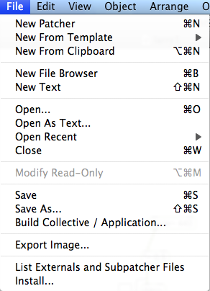

- New Patcher
- Open (also double click on file icon or drag and drop onto Max icon).
- Save As: I recommend making frequent saves and saves as to protect your work. I use “Larry.1a”, “Larry.1b”
“Larry.1c” and “Larry.2a”, “Larry.2b”, etc. The number represents a major structural change in a patch; the letter
represents a series of backup copies made every hour or so.

3. Edit
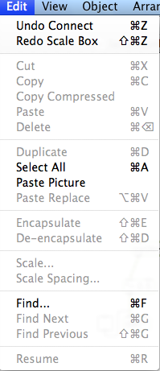

a. Memorize copy, cut, paste, undo key commands for speed.

4. View
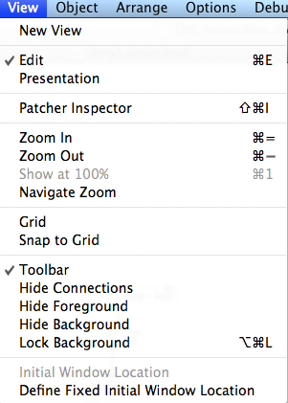

- Edit should generally be checked.
- Presentation should generally be unchecked.
- Patcher inspector, Grid, Snap to Grid will be very useful for aligning objects. Will be discussed later.
- Toolbar should generally be checked.
- Hide and lock functions will be discussed later.

5. Object
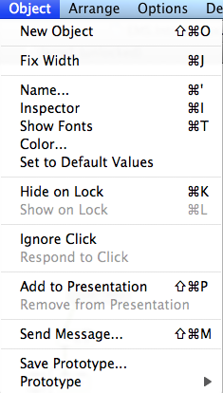

a. Inspector sets range and increments of sliders.

6. Arrange
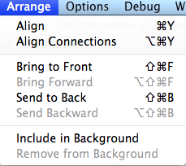

a. Good for positioning objects.

7. Options
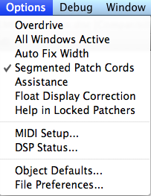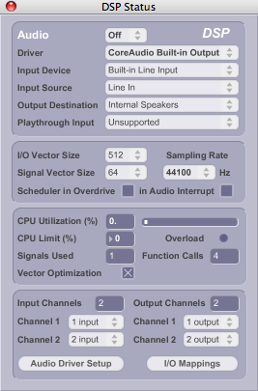
8. Debug
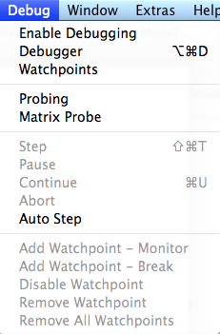

9. Window
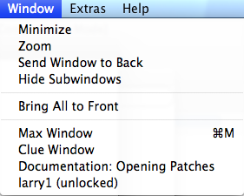
a. Useful when working with sub-patches.

10. Extras
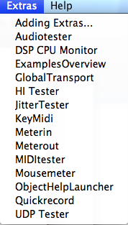

a. Useful for testing audio paths and flow of data.

11. Help
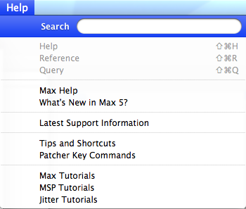

- Help resources and tutorials.
- The Max tutorials are classics.

