025:250 COMPOSITION: ELECTRONIC MEDIA I
Fall 2011
Recording with microphone, Focusrite, Metric Halo, Peak

1. The first step in recording sounds for an electronic composition is the most important. Consider bringing to the
recording session objects like the ones below:
a. Wooden sticks, such as popsicle sticks, wooden matches, branches, etc. These can be tapped on different
surfaces and can be broken to produce a very interesting loudness curve in the attack. Time-stretching and
pitch-shifting are good tools for exploring these sounds.
b. Rubber objects, such as balloons, kitchen objects, rubber bands, and children’s and dog’s toys. Wetting the fingers and rubbing over the surfaces produces interesting quasi-steady-state sounds that can be pitch-shifted. Thwonking the object by bending it back, then letting it hit a surface. Rubber bands are a very tich resource when pulled taut and plucked. Letting the air out of balloons can be a good source sound, while popping a balloon gives a resonance frequency determing by the dimensions of the room.
c. Metal objects are known for their generally inharmonic sonic character. Spinning coins have a nice envelope. Striking pots and pans produce interesting overtones. In order to capture these overtones, it may be advisable to increase the volume of the mic and hit the pan as hard as possible. The attack can be edited out, leaving only the overtones ringing.
d. Paper can be struck when pulled taut, torn fast and slow, crumpled, and folded.
e. Glass can be rubbed with wet fingers, lightly struck, and broken.
f. Jars of things like coins, unpopped popcorn, and marbles can be shaken repeatedly or just once. The result will be a mini sound-mass.
g. Suggestions for other sources will be discussed in class.

2. Recommended microphones are Earthworks, Avantone, and the Blue Baby Bottle. Additional mics are on order.

3. Connect the mic to a cable, then plug the cable into the leftmost jack underneath the Focusrite pre-amp module, as shown below:
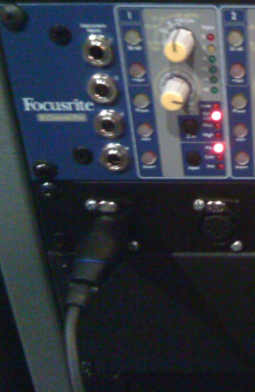

4. The jack shown above is hardwired to channel 1 of the Focusrite pre-amp unit. The individual pre-amp is shown below:
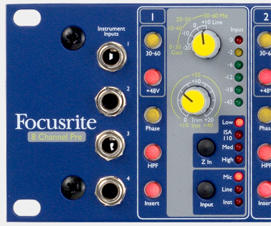

5. The recommended settings are:
a. +48 engaged for condensor mics; disengaged for dynamic and ribbon mics.
b. HPF engaged to minimize low rumble.
c. Z In Low selected for condensor mics; experiment with other Z In settings with dynamic and ribbon mics.
d. Input Mic selected.
e. The top knob should be set to +10 Line, at 12:00.
f. The botton knob will function as a volume control when recording.

6. Set up Peak for recording as follows:
a. Launch Peak by clicking on its icon in the dock:

b. In the Audio menu, select Record Settings, as shown below:
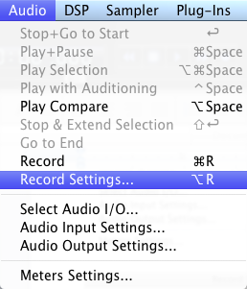

c. The transport window may show the sound level, as shown below:

d. The Record Settings window will appear, like the one below:
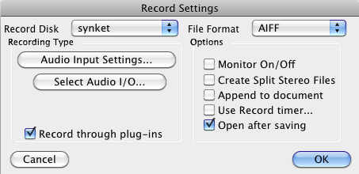

e. Set the values to those shown above.
f. Click on Audio Input Settings. A window like the one below will appear:
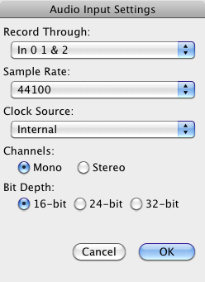

g. Set the values to those shown above. Class discussion of these values.
h. Click on the Select Audio I/O button. A window like the one below will appear:
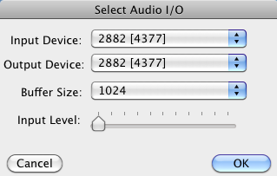

i. Set the values to those shown above. Class discussion of these values.

7. From the Audio menu, select Record, as shown below:
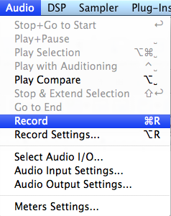

a. A Record window like the one below will appear:
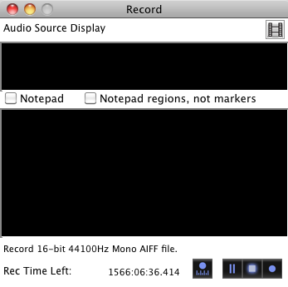
b. From left to right, the buttons at the lower bottom of the window have the following functions:
i. Left: Record Settings
ii. Second from left: Pause Recording
iii. Third from left: Stop Recording
iv. Right: Start Recording
8. Class demo and discussion about recording levels, naming and saving files.

9. A non-clipped sound is shown on the left. A clipped sound is shown on the right.
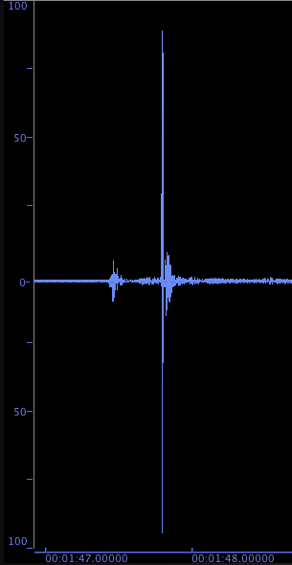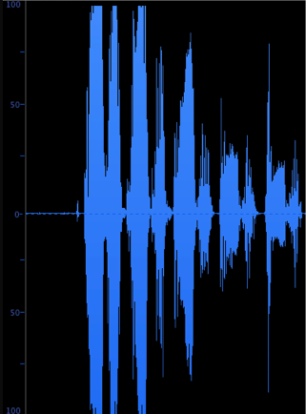

10. Discussion of other recording methods:
a. Line in
b. Icicle and other USB convertors
c. Pro Tools
d. Max/MSP

