025:250 COMPOSITION: ELECTRONIC MEDIA I
Fall 2011
Recording in Pro Tools with the Focusrite
Prepared by Will Huff

1. Step one. Connect a mic of your choosing to an XLR cable, then plug the XLR cable into the leftmost jack, underneath the Focusrite pre-amp module, as shown below:
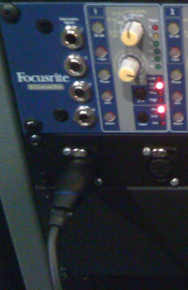

2. The jack shown above is hardwired to channel 1 of the Focusrite pre-amp unit. The individual pre-amp is shown below:
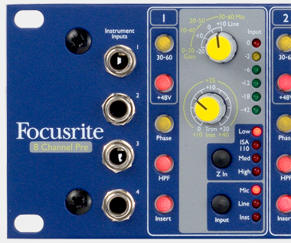

3. The recommended settings are:
a. +48 engaged for condensor mics; disengaged for dynamic and ribbon mics.
b. HPF engaged to minimize low rumble.
c. Z In Low selected for condensor mics; experiment with other Z In settings with dynamic and ribbon mics.
d. Input Mic selected.
e. The top knob should be set to +10 Line, at 12:00.
f. The botton knob will function as a volume control when recording.

4. Open up Pro Tools and create a new session, saving it to a location you will be able to find for future sessions.
a. Add new tracks (Track > New). Create as many stereo tracks as you feel you will need per the image below:
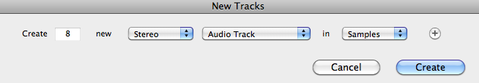

b. Notice the Edit Window on the left of your session. It should look like this, below:
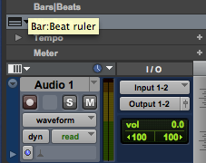

c. If you do not see this information, click on View > Edit Window Views and select I/O and Track Color:
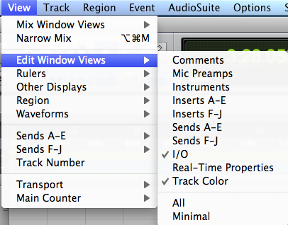

d. In the Edit Window underneath I/O, click on “Input” and select the channel to correspond with the channel you have plugged your mic into. In this case, channels 1-2. Because we are recording in a stereo track, we will need TWO mics. Simply repeat step 1 into the second-left most jack. Create a mono track (Track > New) if you plan to record with just one mic.

5. Recording
a. First, “record-enable” which tracks you want to record on. In this case, we will enable stereo track 1. Click on the red button with a circle in it in the Edit Window. Now this track is record-enabled. The button will flash to indicate this.
b. Then, in the transport bar, click on a similar button to “arm” recording. It too will flash when Pro Tools is armed to record. If you do not see the transport bar, click Window > Transport. The transport bar looks like this:
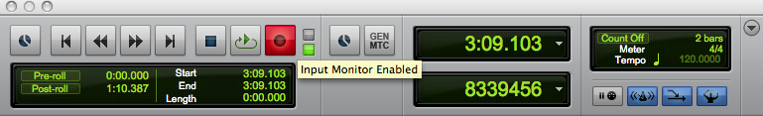

c. Hit the spacebar and recording will begin. Hit spacebar a second time to stop recording. Voila!

