025:251 COMPOSITION: ELECTRONIC MEDIA II
Spring 2011
Markov Chains in Max/MSP

1. Andrey Markov, a Russian mathematician, produced the first Markov model.

2. A Markov chain is a type of decision tree in which random choices follow given paths, as discussed in class.

3. Markov chains can represent many aspects of nature, biology, language, physics, and baseball (cue Shane).

4. The example on the next page shows a Markov chain that can generate sentences.

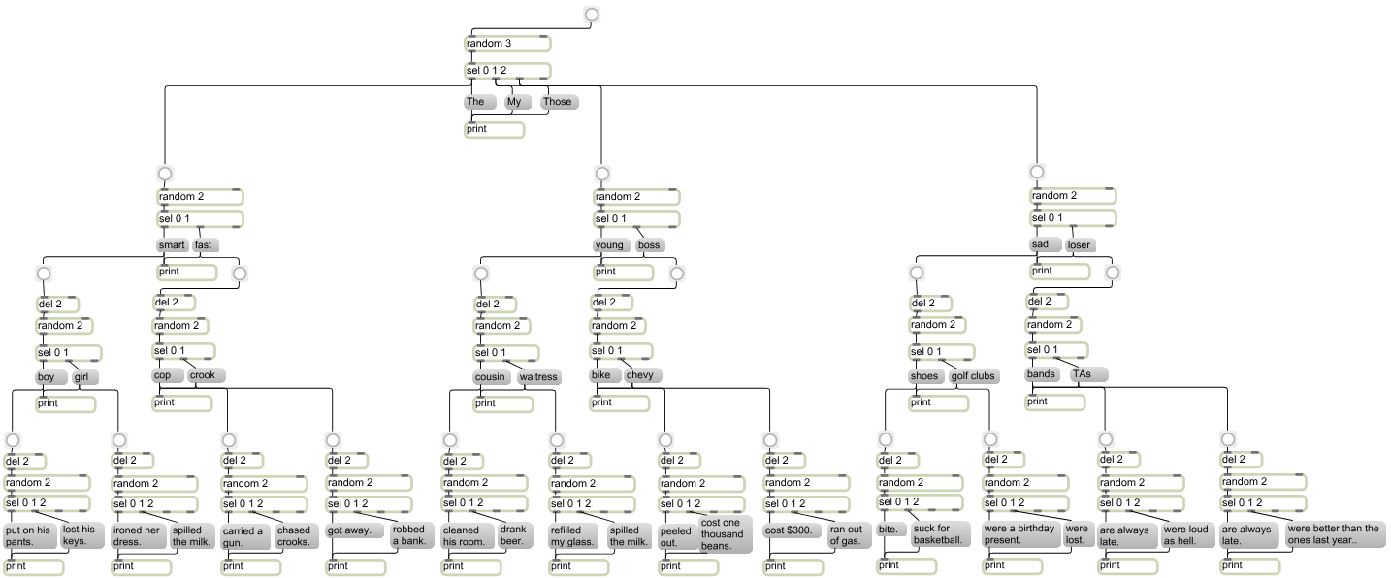

5. The example below shows another Markov chain, where every choice has a 1 in 3 chance of occuring. This is shown in
the different tables, below.

 | A |  |  |  |  |  |  |  |  | B |  |  |  |  |  |  |  |  | C
 | AA |  |  | AB |  |  | AC |  |  | BA |  |  | BB |  |  | BC |  |  | CA |  |  | CB |  |  | CC
 | AAA | AAB | AAC | ABA | ABB | ABC | ACA | ACB | ACC | BAA | BAB | BAC | BBA | BBB | BBC | BCA | BCB | BCC | CAA | CAB | CAC | CBA | CBB | CBC | CCA | CCB | CCC

 |  |  |  |  | A |  |  |  |  |  |  |  |  | B |  |  |  |  |  |  |  |  | C
 |  | AA |  |  | AB |  |  | AC |  |  | BA |  |  | BB |  |  | BC |  |  | CA |  |  | CB |  |  | CC
 | AAA | AAB | AAC | ABA | ABB | ABC | ACA | ACB | ACC | BAA | BAB | BAC | BBA | BBB | BBC | BCA | BCB | BCC | CAA | CAB | CAC | CBA | CBB | CBC | CCA | CCB | CCC

 |  |  |  |  | A |  |  |  |  |  |  |  |  | B |  |  |  |  |  |  |  |  | C
 |  | AA |  |  | AB |  |  | AC |  |  | BA |  |  | BB |  |  | BC |  |  | CA |  |  | CB |  |  | CC
 | AAA | AAB | AAC | ABA | ABB | ABC | ACA | ACB | ACC | BAA | BAB | BAC | BBA | BBB | BBC | BCA | BCB | BCC | CAA | CAB | CAC | CBA | CBB | CBC | CCA | CCB | CCC

6. A Max patch based on this model will be discussed in class. A graphic representation is not practical, since it will be
based on 39 sub-patches, as numbered below. Because this patch is open-ended, students should feel free to modify it for
their own purposes. This is not required for class, however.

 | A |  |  |  |  |  |  |  |  | B |  |  |  |  |  |  |  |  | C
 | 1 |  |  |  |  |  |  |  |  | 2 |  |  |  |  |  |  |  |  | 3
 | AA |  |  | AB |  |  | AC |  |  | BA |  |  | BB |  |  | BC |  |  | CA |  |  | CB |  |  | CC
 | 4 |  |  | 5 |  |  | 6 |  |  | 7 |  |  | 8 |  |  | 9 |  |  | 10 |  |  | 11 |  |  | 12
 | AAA | AAB | AAC | ABA | ABB | ABC | ACA | ACB | ACC | BAA | BAB | BAC | BBA | BBB | BBC | BCA | BCB | BCC | CAA | CAB | CAC | CBA | CBB | CBC | CCA | CCB | CCC
 | 13 | 14 | 15 | 16 | 17 | 18 | 19 | 20 | 21 | 22 | 23 | 24 | 25 | 26 | 27 | 28 | 29 | 30 | 31 | 32 | 33 | 34 | 35 | 36 | 37 | 38 | 39

