025:251 COMPOSITION: ELECTRONIC MEDIA II
Spring 2011
The Counter, Gate, and Gate~ objects in Max/MSP

1. The main purpose of the counter object is to send a bang after a given number of beats.

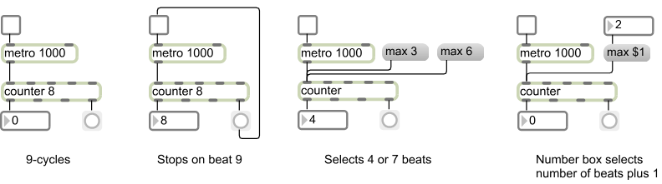

2. The two switchers, found in the object palette, send a control (non-audio) message from 1 of 2 inputs to 1 output
or 1 input, or 1 input to 1 of 2 outputs. Control of the switcher can be from a bang button, from message boxes 0
and 1, or by clicking on the switcher.

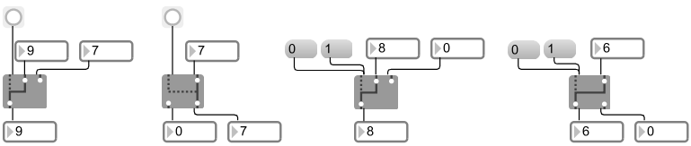

3. Related to a switcher is a gate object, shown on the left below. The gate object has only 1 input, but any user-
specified outputs. While the gate object sends a control (non-audio) message, the gate~ object sends audio
signals, as shown on the right below.

