025:251 COMPOSITION: ELECTRONIC MEDIA II
Spring 2011
User Interface Objects in Max/MSP

1. Some useful interface objects allow the user to more intuitively change parameters and view audio output. They
appear in the object palette as the icons shown below.

dial | gain~ | levelmeter~ | meter~ | scope~ | slider | spectroscope~ | waveform~

2. These appear in the patcher window as shown below.
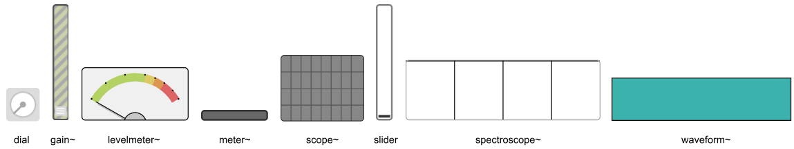

3. In-class demonstration of how objects can be re-sized and re-oriented.

4. The three control objects are dial, slider, and gain~. The inspectors for these objects are shown below.
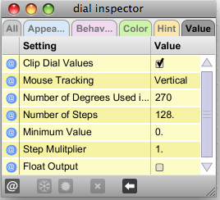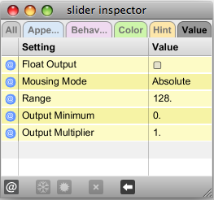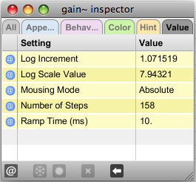

5. The five audio viewers are levelmeter~, meter~, scope~, spectroscope~, and waveform~. These will be discussed in class.

