025:251 COMPOSITION: ELECTRONIC MEDIA II
Spring 2011
Pitch Tracking in Max/MSP

1. The following soundfiles are excerpts from a performance of Lawrence Fritts’s 2001 Life-Drawing for flute and
tape. Lisa Bost performed the work at Electronic Music Midwest in 2008. These excerpts are taken from the solo intro, played at pp to f. The overall solo intro was normalized, but individual sounds were not.

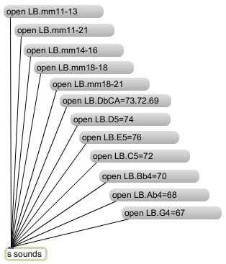

2. The soundfiles from Item 1, above, are sent to a receive object, “r sounds”. From here, the soundfile is sent to
both an sfplay~ object and a bang button. The bang is delayed by 50 ms, then acts trigger a message box “1” to
play the sound, as shown below.
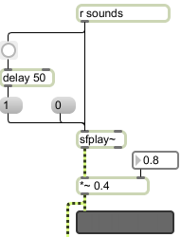

3. The module on the left, below, shows how both an adc~ live input on the left and the sfplay~ on the right are sent
to a selector~ object. The number box on the left sends 0 for off, 1 for adc~, and 2 for sfplay~ to be sent to the
pitch~ object on the left and the dac~ on the right.

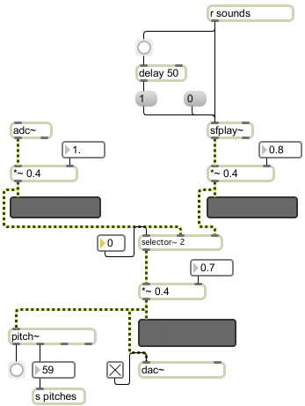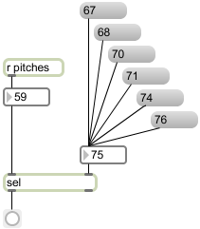

4. The pitch~ object is a pitch tracker that converts an audio signal into pitches number 0 – 127, where 60 = C4
(middle C). The bang on the left is triggered whenever a new note is detected. The pitch numbers are sent to the
“r pitches” object, shown on the right, above.

5. The pitch numbers are sent to a sel object. The value of this object is determined by the number box in the right
inlet. For convenience, the message boxes “67”, “68”, “70”, etc. are used to set the value of the sel object. As will be heard, however, the flute is playing flat enough that some numbers need to be lowered a semitone. In class, we will try adding a “- 1” object between the number box and the right inlet of the sel object. The bang button is triggered whenever the note being played matches the value of the sel object.

6. Ways in which the triggered bang button can be used in a composition will be discussed in class.

