025:251 COMPOSITION: ELECTRONIC MEDIA II
Spring 2011
Send, Receive, Panels, Arrange, and Color Palette in Max/MSP

1. The patch below is organized into groups. These show that the send object, also known as “s”, sends data to a receive or “r” object, as discussed in class.
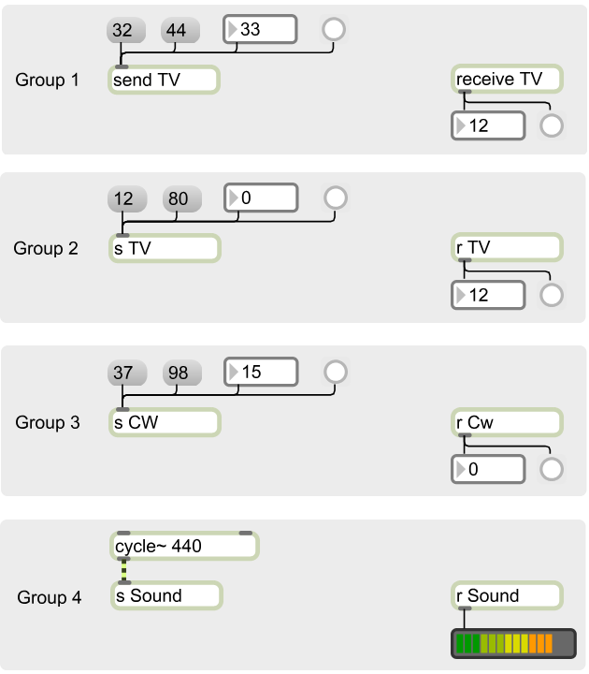

2. Note the following.
a. There can be more than 1 receive object, as shown in Groups 1 and 2.
b. The object names are case-sensitive, as shown in Group 3.
c. Audio can be sent, as shown in Group 4. (Note the gold and black braided audio cord between the
“cycle~ 440” and the “s Sound” object; and the black single control cord between “r Sound” and the audio
meter.
d. Sends and receives communicate not only within a single window, but between any patcher windows that are
open, including sub-patches and their parents, as discussed later in class.
e. The send and receive object is extremely useful when one tries to avoid passing a cord through or around a
group of objects.
f. It provides an alternative method of communicating between a parent window and its sub-patch, as discussed
later in class.

3. Discussion of the Panel object.

4. To add a panel to an area of a patch, do the following:
a. Create a complex of objects like the one shown below.

b. Open the palette and click on the Panel object, like the one shown here: .
c. An empty panel will be shown, like the one below.

d. Click on the lower right corner and resize to the desired shape.
e. Drag and position it overlaid on top of the complex shown in Step 4a. This will result in
an image like the one shown on the left, below.
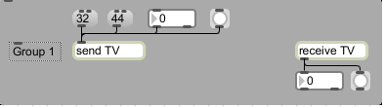

f. Go to the Arrange menu and experiment with Send Backward, Send to Back, Bring Forward, Bring to Front.
The image on the right, above, is shown with the panel sent to back.
g. To select a color, click once on the panel and open the Inspector by typing cmd + I. Select the Color tab, as
shown on the left, below.
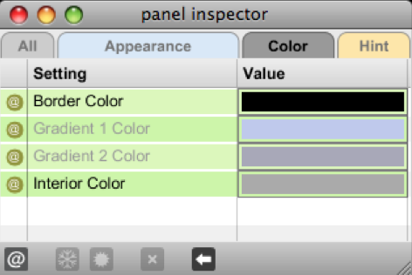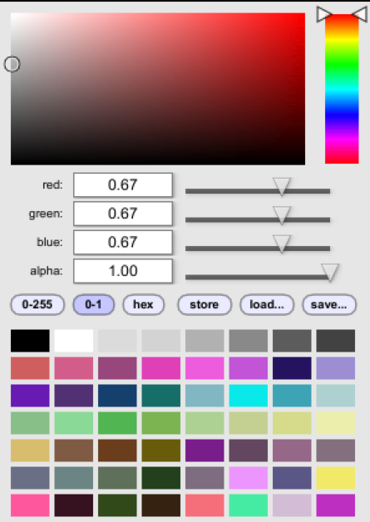

h. Click in the area to the right of “Interior Color”. A color palette will be shown, like the one on the right, above.
i. The different methods of choosing a color will be discussed in class.

