**025:250 COMPOSITION: ELECTRONIC MEDIA I**

**Fall 2012**

**Batch Processing in Peak**

1. Batch processing allows a large number of soundfiles to undergo the same transformation, such as pitch-shifting. This

allows a composer to build up a large collection of sounds for a composition.

2. To batch process a set of files, do the following.

a. Launch Peak. In the File menu, create a new stereo document.

b. In the File menu, select Batch Processing… A window will appear like the one below.

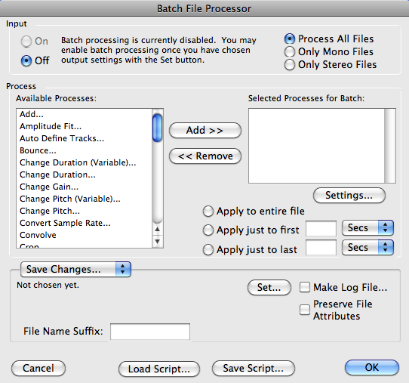

c. Click on the button “Set”. A dialog will appear like the one on the left, below.

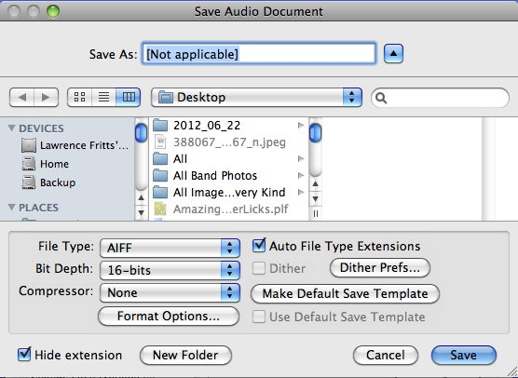 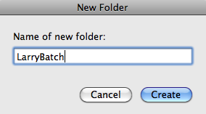

d. Click on the New Folder button, then create a new folder on the desktop named LarryBatch,

as shown in the window above on the right.

3. Do the following to the batch processing window, shown below.

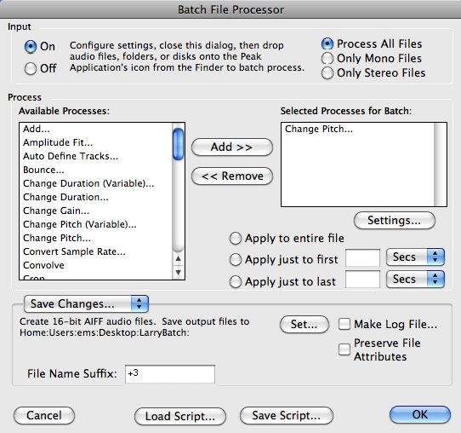

a. Turn the Input in the upper left corner On.

b. In the Available Processes menu on the left, select “Change Pitch”.

c. Click the “Add” button. A Change Pitch window like the one below will appear:

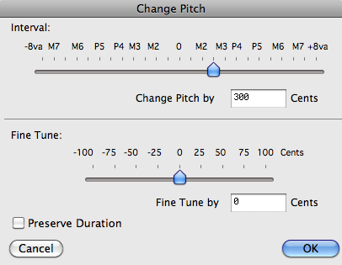

d. Set the field “Change Pitch by” to three semitones or 300 hundred cents.

e. The option of selecting or not selecting the “Preserve Duration” box will be discussed in class.

f. Click OK.

4. The batch processor should look like the one below.

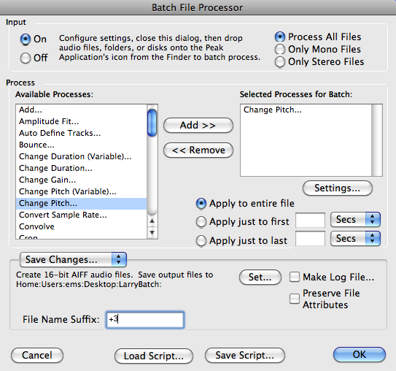

a. Type the text “+3” in the File Name Suffix field on the lower left.

b. Click OK.

5. Drag all of the files that you would like to be raised 3 semitones and drop them on the Peak icon in the Dock.

a. A small window will pop up showing the progress of the batch processing.

b. When the processing is finished, turn off the batch processor. OR ELSE, as explained in class.

c. Open the LarryBatch folder, and note that the original files have the suffix ”.aif+3”.

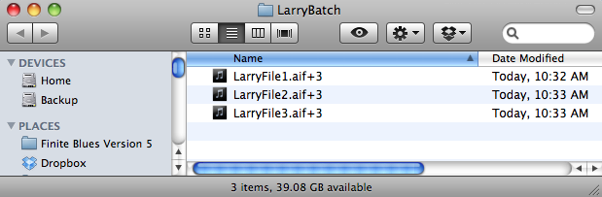

6. These files can be processed again, as shown below.

a. Open the batch processor by selecting it in the File menu.

b. In the batch processing window, shown below, click on the Settings button.

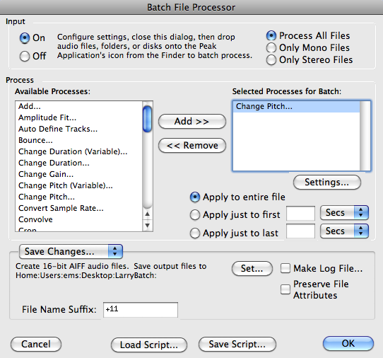

c. In the Change Pitch window, set the pitch to 11 semitones or 1100 cents and click OK.

d. In the batch processor, rename the File Name Suffix to “+11”.

e. Do not drop the LarryBatch folder on the Peak icon, as this will create a loop.

f. Instead, drag and drop each individual file that is sitting in the LarryBatch folder.

g. Alternatively, put the files in LarryBatch into a new folder, then drag and drop it on the Peak icon.

h. After the batch processing is finished, the LarryBatch folder should look like the one below.

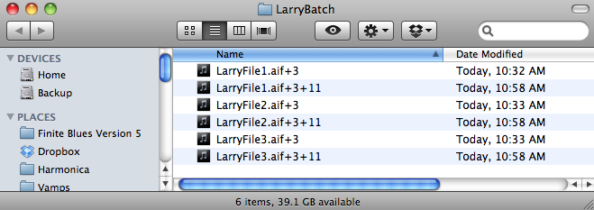

7. Before opening any of these files, or any at all, turn off the batch processor. That will prevent inadvertently

processing any file that is opened.