025:250 COMPOSITION: ELECTRONIC MEDIA I
Fall 2012
General Options in AudioSuite Plug-ins

- Normalizing is a very important function in audio mixing. Consider the issues below.

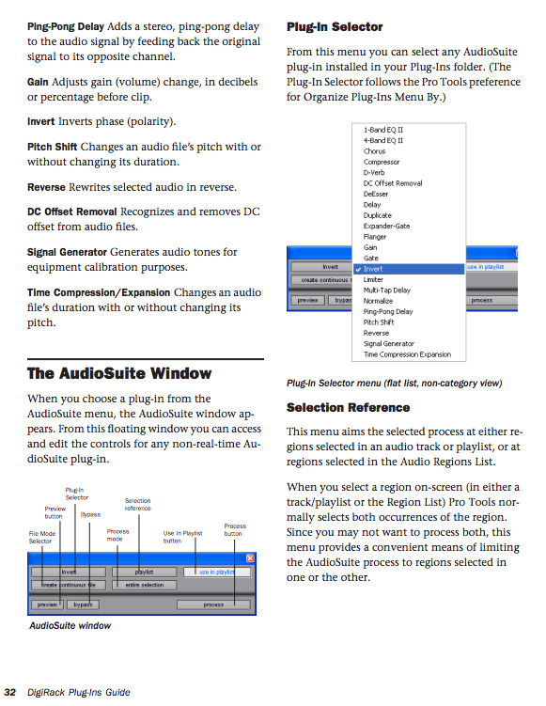

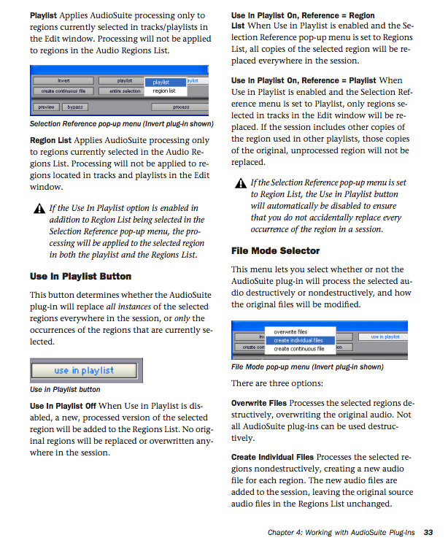

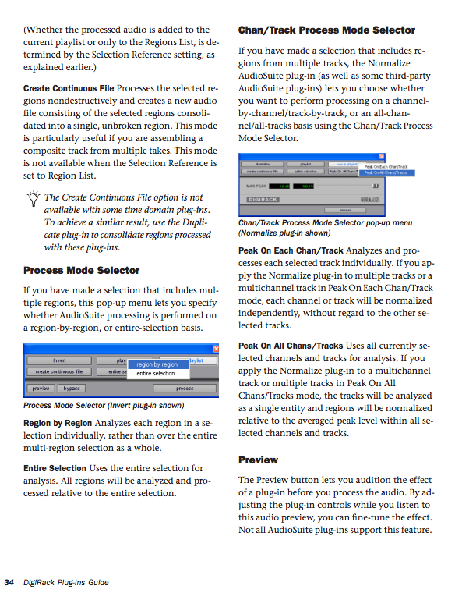

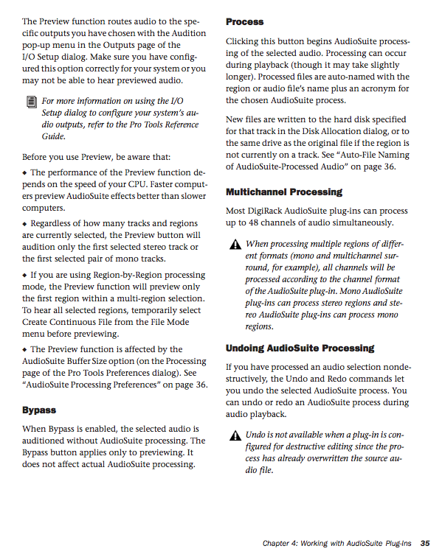

1. Plug-ins can be used in Pro Tools in 3 ways, as discussed below.
a. Regions can be selected by highlighting, and a plug-in can operate on those. The result will be an audio file
with an abbreviation at the end of the filename to identify the plug-in that transformed it. This is most
commonly used in electronic music composition and in sound effects for film.
b. A track can have one or more plug-ins as inserts. The plug-ins affect everything in the track, but they do not
process the regions into new audio files. This is most commonly used in multi-instrument recordings, where
each instrument has its own track. The values can be changed during the mixing process.
c. RTAS, or RealTime AudioSuite plug-ins are used in a similar way as inserts, except that each parameter of the
plug-in can be automated. This has potential applications in electronic music composition.
d. Approaches b and c, above, can also be used with a live input into the track, although this is not very common.

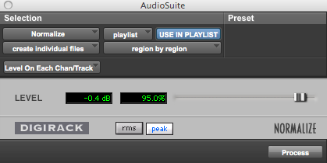

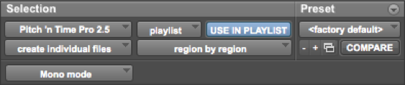

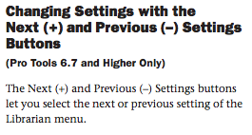

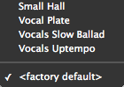

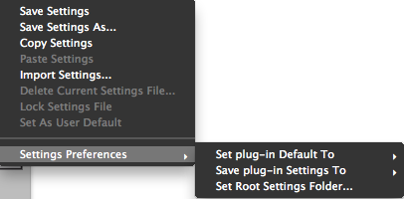

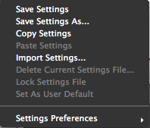

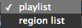

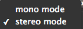

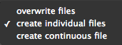

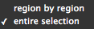

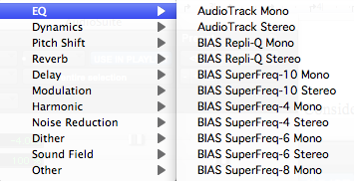

1. Principles of Pitch-Shifting
a. Definition of pitch-based sound: harmonic
b. Non-pitch: inharmonic
c. Instrument-like
d. Other-like
e. Sounds that are 1-2 semitones apart have voice-leading motion.
f. Sounds that are 3-5 semitones apart have gap-fill potential and suggestion for listener.
g. Sounds that are 6- and higher semitones apart have strong potential to be disjoint and unrelated.
h. Glisses have comical effect when rate is short.
i. Glisses have foreboding effect when rate is long.
j. Multiple glisses should have independent rates for rich, non-mechanical textures.
k. Multiple glisses with the same rate have potential to seem mechanical or synthesized.
l. Short sounds in a cloud or mass can create a virtual gliss when each successive note is a microtone higher.
m. Discussion of the relation between pitch and frequency.

2. Principles of Time-Expansion and Compression
a. Smearing
b. Metallic artifact
c. Shortened sounds have more punch
d. Lengthened sounds have ethereal quality that dominate the emotional structure of the context.
e. Long sounds in general, should not be very loud. They will have a strong presence even when played softly.

2. Pitch-shifting in Pro Tools.
a. There are two basic ways an audio file can be pitch-shifted.
b. One method is called varispeed. This term originally was used with tape recorders when the playback speed
was varied. When the speed increased, the pitch was raised. When the speed decreased, the pitch was lower.
c. The major shortcoming of varispeed transformations is that pitch and time are linked. Higher sounds are played
back faster, and lower sounds are played back slower.
d. The biggest advantage of varispeed transformations is that the audio quality is very clean, and unadulterated by
calculation artifacts.
e. Another method of pitch-shifting an audio file is to use a signal-processing algorithm to change pitch and
timing independently. There are many pitch-shifting algorithms. One of the best is employed in the plug-in,
Pitch ‘n Time Pro, by Serato.

3. Serato Pitch ‘n Time.
a. This plug-in has been used by people in the audio field for over 10 years. There are currently two versions:
Pitch ‘n Time LE, and Pitch ‘n Time Pro.
b. Pitch ‘n Time LE sells for around $250, while the Pro version sells for around $700.
c. In the Electronic Music Studios, the desktop computers in Studios 1 and 2 have the Pro version installed.
d. The studio’s laptop computers running Pro Tools has the LE version installed.
e. The LE and Pro versions used the same basic algorithms, and thus produce the same quality of sonic output.
f. The Pro version has additional features than the LE, as will be discussed below.

a. Mono. This can be place anywhere in the stereo field.
b. Stereo-ized centered mono. This file began has a mono file that was converted to stereo so that each side presented the exact same sound. This is indistinguishable from mono, to the ear.
c. Stereo-ized panned mono. The file began as a mono file that was converted to stereo and panned off-center in the process. This means that the left channel sound is identical to the right channel sound, except that one channel is louder than the other.
d. Discrete stereo. This is when the left channel sound is completely different than the right channel sound.
e. Mixed stereo. This is when the left channel contains some sounds that are louder and some that are softer than the sounds in the right channel

3. Special consideration. The key commands for changing the automation view to waveform view does not work when Pitch ‘n Time is open. This key command is “control opt – “.

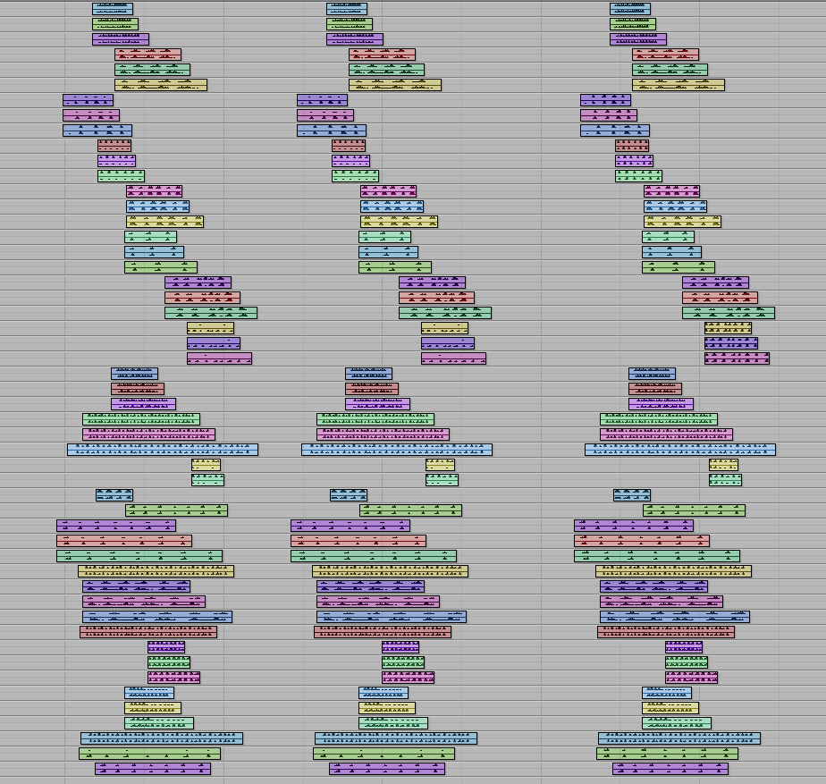

On the left are non-normalized regions.
In the middle are normalized regions that use a single peak as the reference.
On the right are normalized regions that use the peak in each track as the reference.

******************************************
Teaching Policies & Resources — Syllabus Insert

Administrative Home

The College of Liberal Arts and Sciences is the administrative home of this course and governs matters such as the add/drop deadlines, the second-grade-only option, and other related issues. Different colleges may have different policies. Questions may be addressed to 120 Schaeffer Hall, or see the CLAS Academic Policies Handbook at http://clas.uiowa.edu/students/handbook.

Electronic Communication

University policy specifies that students are responsible for all official correspondences sent to their University of Iowa e-mail address (@uiowa.edu). Faculty and students should use this account for correspondences (Operations Manual, III.15.2, k.11).

Accommodations for Disabilities

A student seeking academic accommodations should first register with Student Disability Services and then meet privately with the course instructor to make particular arrangements. See www.uiowa.edu/~sds/ for more information.

Academic Honesty

All CLAS students have, in essence, agreed to the College's Code of Academic Honesty: "I pledge to do my own academic work and to excel to the best of my abilities, upholding the IOWA Challenge. I promise not to lie about my academic work, to cheat, or to steal the words or ideas of others; nor will I help fellow students to violate the Code of Academic Honesty." Any student committing academic misconduct is reported to the College and placed on disciplinary probation or may be suspended or expelled (CLAS Academic Policies Handbook).

CLAS Final Examination Policies

The final examination schedule for each class is announced around the fifth week of the semester by the Registrar. Final exams are offered only during the official final examination period. No exams of any kind are allowed during the last week of classes. All students should plan on being at the UI through the final examination period. Once the Registrar has announced the dates and times of each final exam, the complete schedule will be published on the Registrar's web site.

Making a Suggestion or a Complaint

Students with a suggestion or complaint should first visit with the instructor (and the course supervisor), and then with the departmental DEO. Complaints must be made within six months of the incident (CLAS Academic Policies Handbook).

Understanding Sexual Harassment

Sexual harassment subverts the mission of the University and threatens the well-being of students, faculty, and staff. All members of the UI community have a responsibility to uphold this mission and to contribute to a safe environment that enhances learning. Incidents of sexual harassment should be reported immediately. See the UI Comprehensive Guide on Sexual Harassment for assistance, definitions, and the full University policy.

Reacting Safely to Severe Weather

In severe weather, class members should seek appropriate shelter immediately, leaving the classroom if necessary. The class will continue if possible when the event is over. For more information on Hawk Alert and the siren warning system, visit the Department of Public Safety website.

1. The example below shows how to apply Pitch ‘n Time to a region.

- The menu below navigates through all of the plug-ins in the Audiosuite.

- The menus below act on a selected region in the edit window (which is called the playlist) in Pro Tools.
The relation between playlist and region list will be reviewed in class.
- The menus below allow presets to be created, saved, and compared.
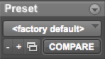
For the purposes of this class, presets are probably not worth the effort to create. Studio recordings of performances, as well as research projects that require consistency and rigor, might find presets useful.

- The menus below allow the creation of individual files, which is generally desired.

The menus are interactive, as will be demonstrated in class. For the purposes of this class, the menu items shown above are probably the most useful.

2. The panel below allows one to set several general functions.
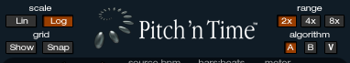
- The scale options are Lin, for linear, and Log, for logarithmic. In the grid window, discussed below, lines that
appear straight when Lin is selected will appear curved when Log is selected. The sliders in the lower panels will also appear scaled differently. In music, we hear in a linear fashion what is electrically a logarithmic function. In general, I recommend viewing such functions linearally, as this corresponds visually to what we hear.
- When the grid window is selected, the Show button displays lines in the background. When both Show and Snap are selected, edit handles will snap to the gridlines, as discussed below.
- The Range options are 2x, 4x, and 8x. When 2x is selected, time can be expanded up to twice as long and pitch can be shifted up or down an octave. When 4x is selected, time can be expanded up to 4 times as long and pitch can be shifted up or down 2 octaves. When 8x is selected, time can be expanded up to 8 times as long and pitch can be shifted up or down 4 octaves. The



