025:250 COMPOSITION: ELECTRONIC MEDIA I
Fall 2012
Peak Basics

1. Edit window below and Overview above.
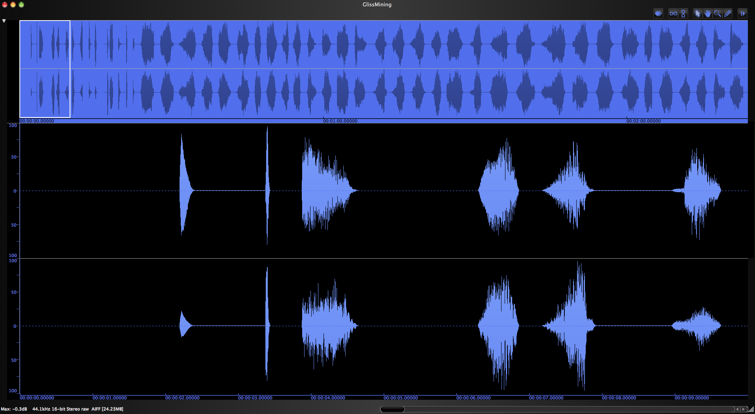

2. Edit window, horizontal zoom out = ⌘ ]
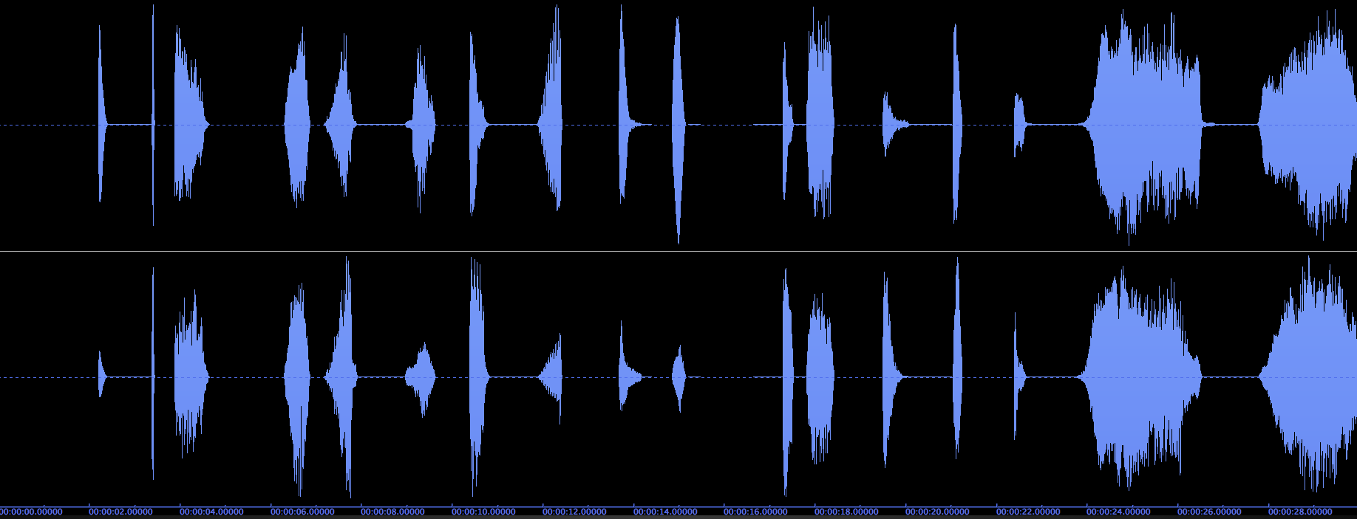

3. Edit window, horizontal zoom in = ⌘ [
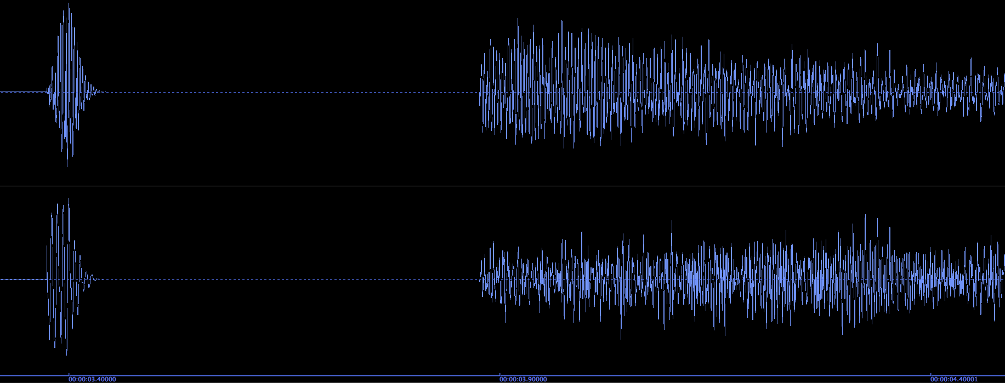

4. Commands from the Edit Menu:
a. Copy = ⌘ C
b. Cut = ⌘ X
c. Paste = ⌘ V
d. Insert Silence = ⌘ E

5. Commands from the DSP Menu:
a. Change Pitch = ⌘ P
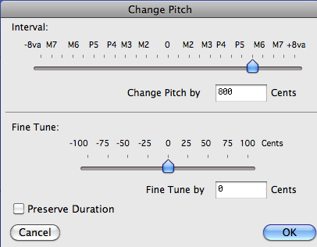

b. Change Gain = ⌘ G
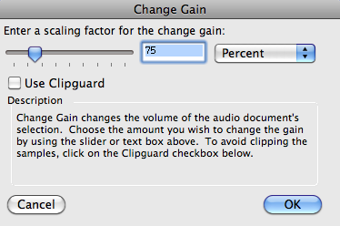

c. Normalize = ⌘ M
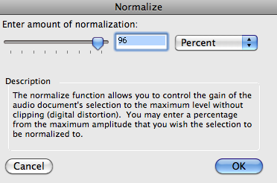

d. Fade in = ⌘ /

e. Fade out = ⌘ \

