025:250 COMPOSITION: ELECTRONIC MEDIA I

Fall 2013
Automation

Items below:

1.

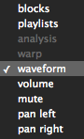

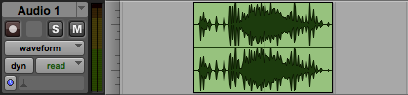

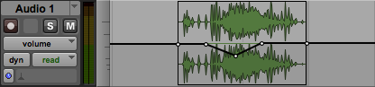

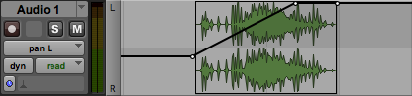

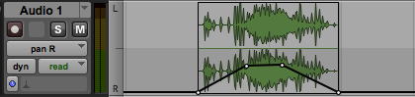

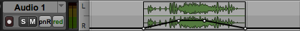

Items below:

