Composition: Electronic Music I
025:250
Fall 2013
Fades in Pro Tools

1. Fades can be used for several purposes. The two most likely uses are eliminating clicks at either end of a region and using fades to alter the character of the sample for musical purposes.

2. In the region below, cut from a trombone sample, are non-zeroes at both ends. This results in an audible click, sounding an undesirable pop. I’ve zoomed in for visual aid:
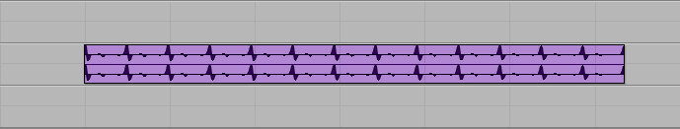

3. To eliminate clicks, select the entire region and type Command F to prompt the Fade window:
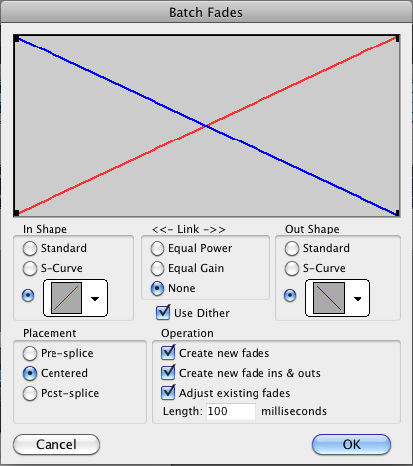

a. When using fades to eliminate clicks, you can set the length as low as 1 millisecond. However, I’d recommend at least 5-10 milliseconds for a more natural, less abrupt, attack and release:
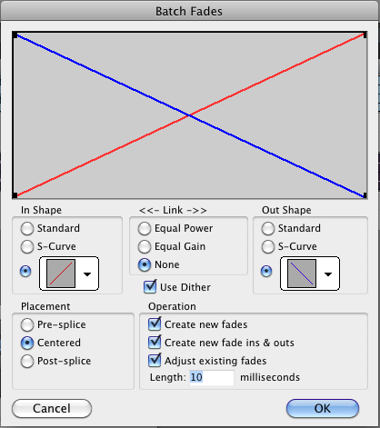
b. After clicking OK, the original region will now consist of three: a fade-in region, the majority of the sample, and a fade-out region:
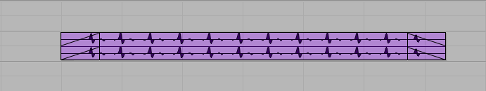

c. Remember to consolidate these as you go. Click on the middle region, which selects all three, and then press Option Shift 3. Notice the vertical lines are now gone as the fades have consolidated into the main region:
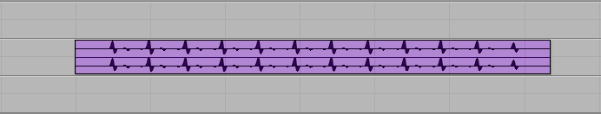

d. When creating fades for click-eliminating purposes, the shape selected results in a negligible difference in attack and release. In 3a, you see the linear ramp is selected. If I had selected a more exponential ramp like the one below, the result is practically the same with no audible difference. This is due to the short, 10 ms ramps:
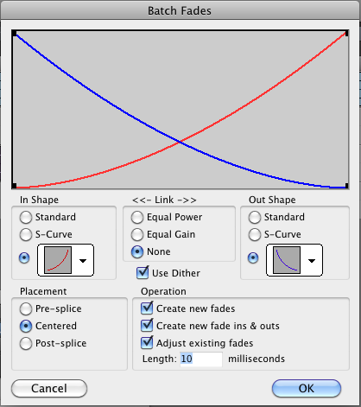

4. In addition to using fades for click elimination, you will also want to use them for musical purposes. In the image below, the upper track contains a trombone region, and the lower track contains a piano region. Using fades, we can adjust the trombone region’s attack and decay such that it imitates a piano or keyboard. 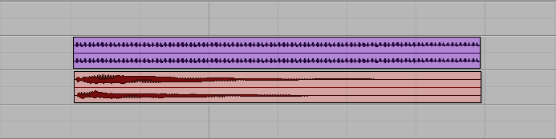

a. By the appearance of its waveform and its aural impression, the piano attack has a sudden ramp to a peak velocity and then decays somewhat linearly. To imitate the attack in the trombone, select the equivalent portion of the region that will correlate with the piano’s attack:
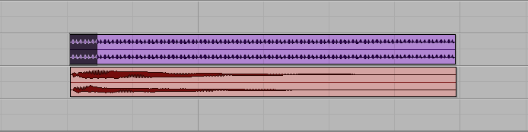

b. Type command F to prompt the Fades window:
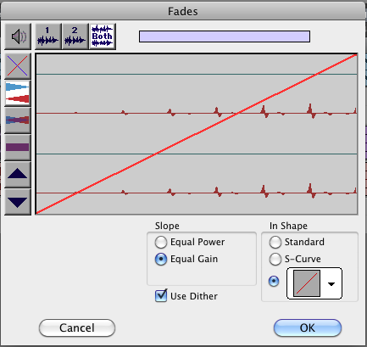

c. Because the piano attack is more sudden than a linear ramp, use the drop down menu under “In Shape” to select a more appropriate shape (the Fades window defaults to most recently used shape):
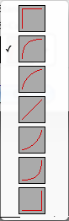

d. Click OK, then consolidate the regions (Option Shift 3) as before:
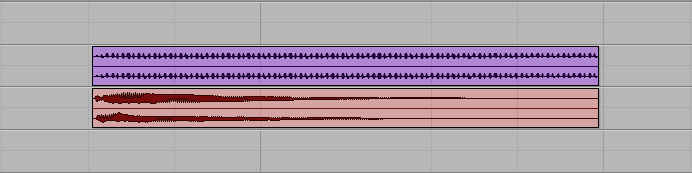

e. Repeat this process for the fade out by selecting the corresponding audio of the trombone region:
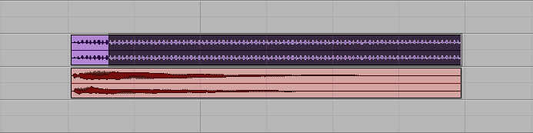
f. Type command F to prompt the Fades window. This time, select the linear ramp under “Out Shape”:
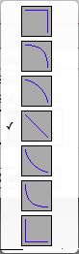

g. Click OK, consolidate the regions (Option Shift 3) once more, and the trombone region now resembles the piano in shape:
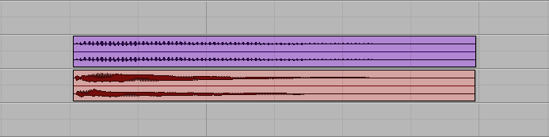

5. Alternatively, we could change the impression of a piano sample to a more plaintive tone, resembling an oboe. Here is a piano sample with its full decay lasting about 45 seconds:
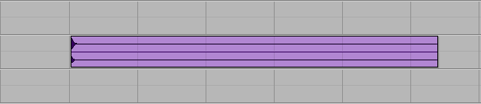

a. For the fade in, select well into the decay portion of the sample:
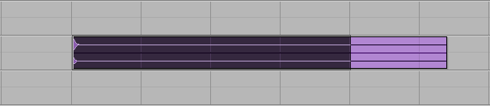

b. Type Command F to prompt the Fades window and select the linear ramp, defining the fade to ramp from 0 up to the level of volume in the decay:
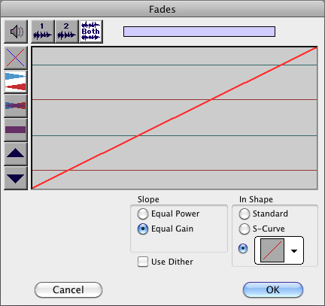
c. Click OK and remember to consolidate the regions (Option Shift 3).
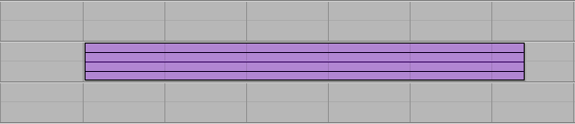

6. As can be clearly seen above, we will need to normalize the region. Select the audio and go to Audio Suite > Other > Normalize. Set to 95% to ensure we do not get any over’s:
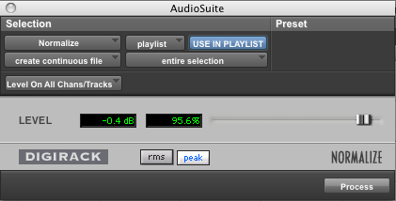

7. After normalizing, the file looks like this. Ground noise dominates the audio as the piano decays:
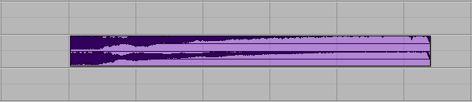

a. I’ve selected a portion of the region to use since the decay is predominantly noise:
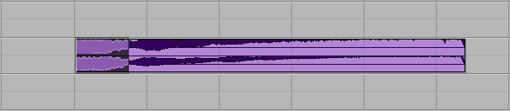

b. Copy and paste it as its own region:
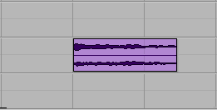

c. As a reference, here is an oboe sample. Notice its attack and release:
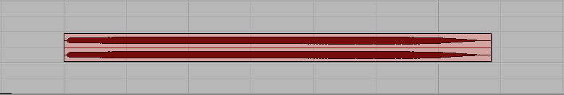

d. Select the beginning of the trombone region to create a fade in to imitate the oboe:
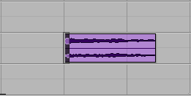

e. Type Command F and select the shape that best characterizes the oboe attack seen in 7c:
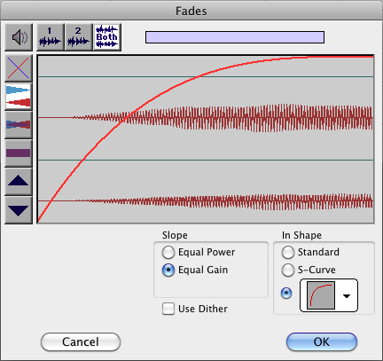

f. Click OK and consolidate regions (Option Shift 3)

g. Now select a portion of the audio to imitate the oboe release:
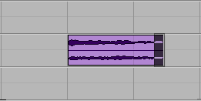

h. Type Command F and select the appropriate shape:
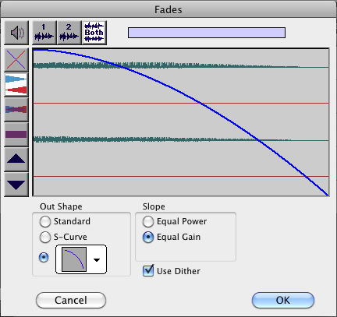

i. Click OK and consolidate regions (Option Shit 3). Now the piano imitates an oboe:
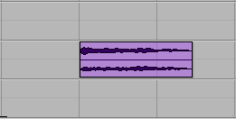

8. To eliminate noise due to normalization in step 6, try using iZotope Ozone 5.
a. Select the entire region and go to Audio Suite > EQ > iZotope Ozone 5
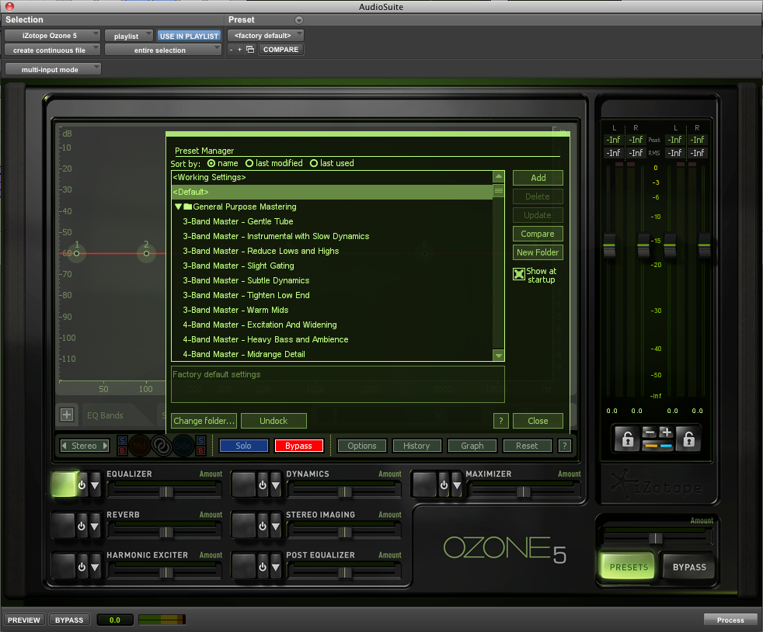

b. Close the Preset Manager. There will be four default bands:
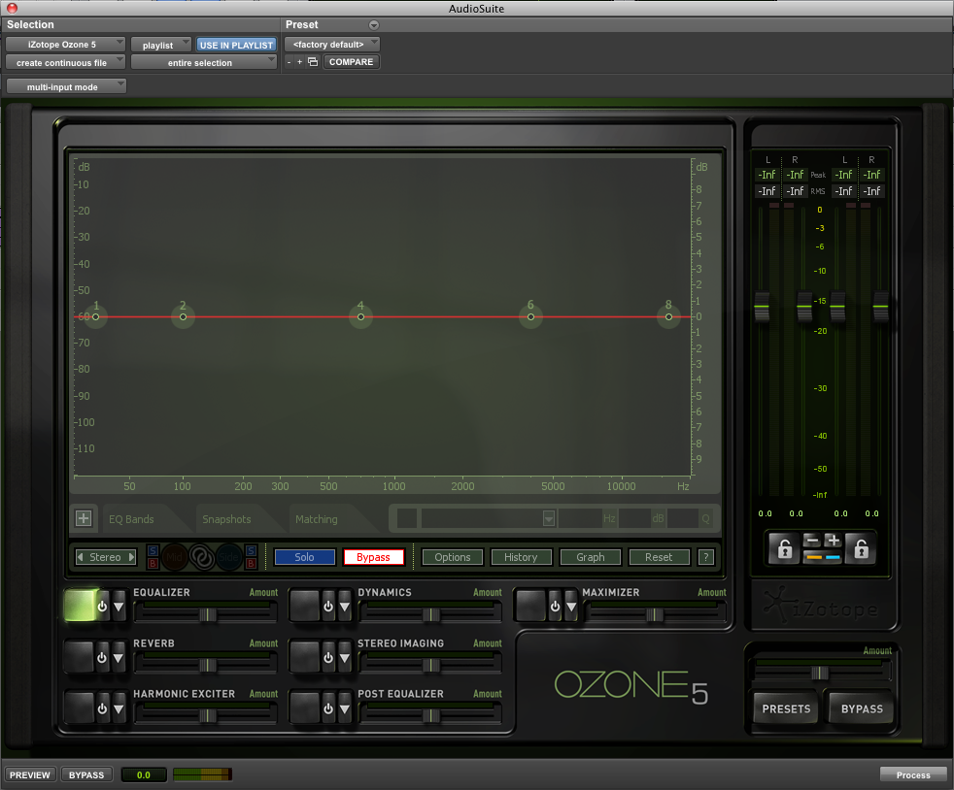

c. Near the middle of the Ozone 5 window, is a “+” next to EQ bands. After clicking on that, you can pick and choose your bands and how many you want:
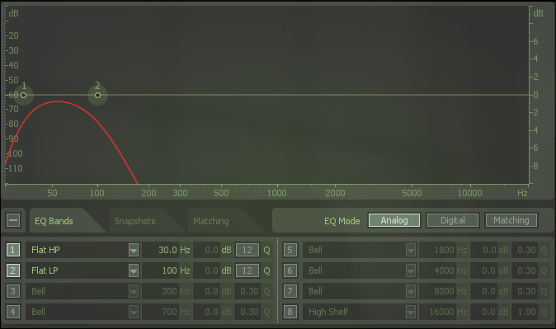

d. Click preview in the bottom left corner of the window. Click-and-drag the bands and adjust the slopes by click-and-dragging the brackets of each band until the noise has been satisfactorily removed. Then click process:
