Using the Structure Free Sampler
EMS Fall 2013

- Initial Setup
  - Start cold. Make sure that the MIDI interface being used is plugged in, and the keyboard is turned on.
  - In Pro Tools, create a stereo instrument track.
  - From the View menu, enable the following views:
    - Instruments
    - Inserts A-E
    - I/O
  - Make the changes in each of these views described below.
  - Inserts A-E
    - Click the first insert box.
    - In the dropdown menu that appears, select Multichannel Plugin > Instrument > Structure Free
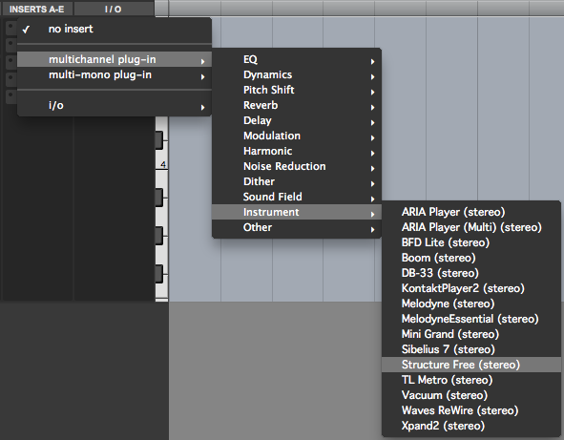

    - This will cause the Structure Free window to appear. Ignore this for now, until the following changes are made.
  - Instrument:
    - There are two gray boxes in this view; the top box shows the current MIDI source for this track, and the bottom box shows the current instrument to which MIDI information from this track is being routed.
    - The default setting will look like this:
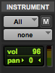
    - The All setting in the top box should suffice for basic usage; if more than one MIDI source is in use, this will have to be altered to route the information as desired.
    - The bottom box will have to be set to route information to the Structure Free plugin. This plugin has multiple input channels; match the track routing to the particular sample bank you want played (i.e., A1, B2, and C3, all active simultaneously, will need three instrument tracks routing to them each individually. Furthermore, there will need to be three sample patches running in Structure Free, each assigned to take input from one of these three channels.).
    - The Instrument view should end up resembling this:
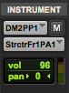
  - I/O
    - This controls the input and output of audio signal into the instrument track. For our purpose, we are concerned only with the audio output.
    - Make sure this is set to Analog 1-2, as shown below.
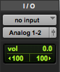
  - The instrument track is now properly configured.
- Setting up Samples
  - Place all the soundfiles that you wish to use as samples into one folder. For consistency’s sake, consider creating this folder within the main Pro Tools session folder.
  - Make sure that each soundfile has minimal delay at the beginning. Sampling can entail pitch shifting a soundfile down to fill in space between keys; any delay in the sound will be exaggerated by this process.
  - Name each file using the convention demonstrated below:
Dansound C3.aiff
    - The filename can be anything, this will only serve as a label for human convenience.
    - The important component is separated from the filename by a space. In this case, this information is C3.
    - This represents the specific key on the keyboard that will trigger this soundfile. More details will be given below.
  - In the Structure Free window, there is a switch labeled “Main | Browser”, pictured below.
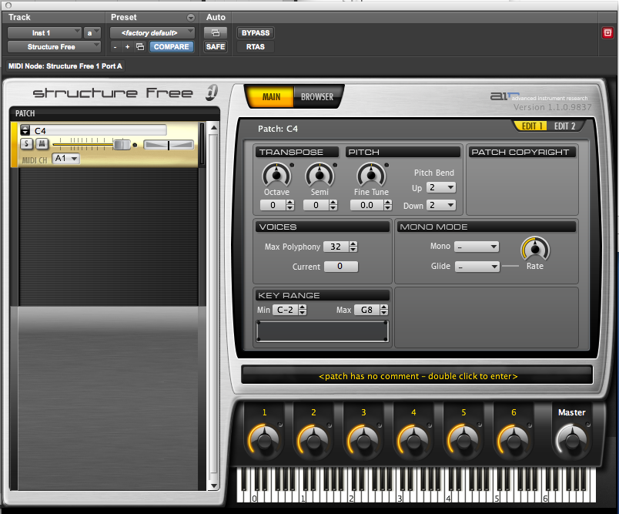
  - Select Browser. The plugin will switch from the display pictured above to a file selection display, pictured below.
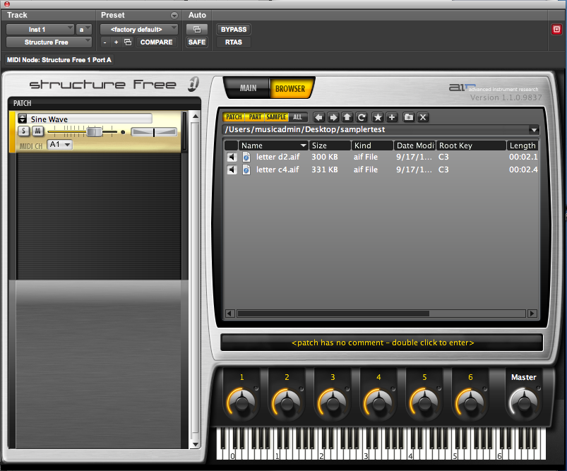
  - In the rectangular space above the keyboard, locate the folder containing your soundfiles. Double click this folder to display the contents in this space.
  - Select the soundfiles you wish to use through the sampler, and drag them onto the yellow box on the left hand side of the plugin.
  - This will cause a window to appear, allowing you to set particular details of how the soundfiles will be triggered. This is pictured below.
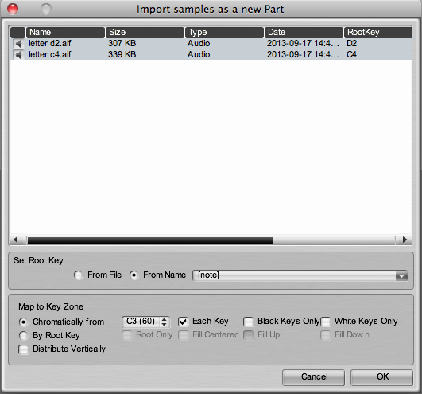
  - Notice that the rightmost column, ‘Root Key,’ is displaying the correct trigger key, as denoted by the file names.
  - The settings to change in this window are found under “Map to Key Zone.”
  - Instead of “Chromatically from…”, select “By Root Key.” This will direct the sampler to actually use the root key information that it has detected.
  - There are four options for the By Root Key setting:
    - Root Only: the soundfile will only trigger when its associated root key is pressed.
    - Fill Centered: Empty keys in between samples will be ‘split’ between the bordering samples. Empty keys below the lowest sample, and above the highest, will be filled in by transpositions of the lowest and highest samples, respectively.
    - Fill Up: Empty keys between samples will be filled in by the lower boundary sample. Empty keys above the highest sample will be filled in this way as well; keys below the lowest sample will be left inactive.
    - Fill Down: vice versa.
  - For our purposes, the best setting is likely to be Root Only. This will require a sample for each pitch, but allows for maximal control over sound quality.
  - Click OK. The sampler should now be configured to play and/or record.

