Introducing sfrecord~
Electronic Music II
Spring 2013
- sfrecord~ is an object used to record audio files to the hard disk.
  - Create a blank object and type sfrecord~. This will create the object, with the default single channel (mono recording).
  - To create a stereo sfrecord~, set the number of channels (2) in the object:
  - To use sfrecord~, we must send it the following, in order:
    - An open message, with the filename to be created
    - A message “samptype int24”, to set the output to 24 bits
    - A trigger to record. This will be a message containing just the number 1.
- For demonstration, we will be using a special feature of sfrecord~’s open messages.
  - Create a message box containing only the word “open”. Connect the outlet to sfrecord~’s left inlet.
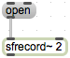
  - Clicking this message will open a file dialog, where we can choose a location and file name for sfrecord~’s output.
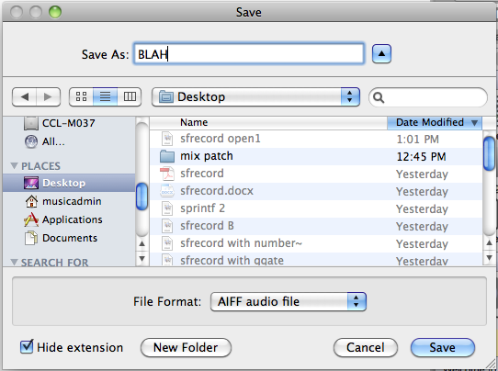
- The message setting sfrecord~’s bit depth will be sent to sfrecord~ following the open message.
  - Create a message box containing the following: samptype int24. Shown below:
  - Connect the outlet of the message to the left inlet of sfrecord~.
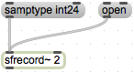
- The final piece of information sfrecord~ needs is a 1 to begin recording, or a 0 to stop recording.
  - Create two message boxes, one containing the number 1 and the other the number 0. Attach their outlets to sfrecord~’s left inlet:
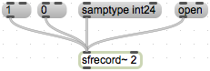
  - This is a functional basic setup.
  - One of the first improvements we can make is to ensure that we send information in the correct order. This is accomplished by using a trigger object:
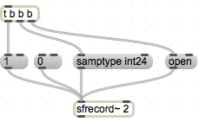
  - Now, every time we click the bang button at the top left, an open message will be sent, followed by our bit depth setting, followed by the trigger to start recording.
  - This setup still requires us to manually stop recording by clicking the 0 message. We can include this function in our trigger setup with a ggate:
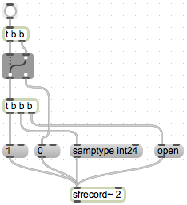
  - Now, each time we click the bang button, we will either initiate the sequence of events to start a new recording, or stop the current recording. We cannot send a start trigger without first stopping the recording.
- Closing remarks
  - One convenient troubleshooting object for sfrecord~ is number~. This serves as a timer, giving us a readout of how many milliseconds sfrecord~ has been recording. Attach the outlet of sfrecord~ to its left inlet.
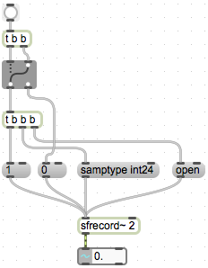
  - Another convenient reminder-object is an integer box. Attach the outlets of our 1 and 0 message boxes to its inlet. This will reflect the current state of the switch.
