Composition: Electronic Music II
025:251
Spring 2013
Recording in Max

1. In this handout we will discuss how to record in Max. The first step is setting up the audio-to-digital converter, [adc~], which can be used to route signal inputs from external devices into your patch. Arguments define inputs. Below is an [adc~] with a mic going into input 2. A toggle turns it on/off and [meter~] monitors level:
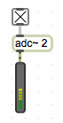

2. If you have trouble with getting signal into Max, make sure your arguments match your microphone inputs. Also you may want to check the audio status. Go to options > audio status and make sure the settings match the below screenshot. This is saved to the desktop:
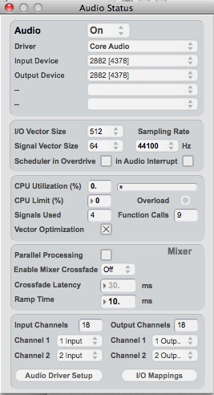

3. Similar to [send] and [receive], use [buffer~] and [record~] in tandem to store files. That is, [record~ test] will be stored to [buffer~ test]. You will also need to specify how much time you want to record. Below it is set to record the first two seconds once I toggle on [record~]:
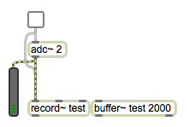

4. Similarly, [groove~] will play audio back per its associated [buffer~]. So [groove~ test] will play the contents of [buffer~ test]. [groove~] also needs to know which direction to play using [sig~] and from where in the file to begin using a message. Below, you will see [groove~ test] begins at 0 ms, and is currently set to play forward (1 = forward, -1 = backward). We can make use of the pitch shift patches we made in previous projects. (-.5 will play half-speed backwards…)
