Introducing sfrecord~
Electronic Music II
Spring 2013
- sfrecord~ is an object used to record audio files to the hard disk.
  - Create a blank object and type sfrecord~. This will create the object, with the default single channel (mono recording).
  - To create a stereo sfrecord~, set the number of channels (2) in the object:
  - To use sfrecord~, we must send it the following, in order:
    - An open message, with the filename to be created
    - A message “samptype int24”, to set the output to 24 bits
    - A trigger to record. This will be a message containing just the number 1.
- Like with the open message for sfplay~, we will be constructing our open message for sfrecord~ with sprintf.
  - In this example, I am creating sequentially numbered soundfiles, that I label as ‘takes.’ The total filename will be “Atake1”, “Atake2”, etc.
  - The sprintf setup we use to do this will bear a strong resemblance to the setup we used for sfplay~:
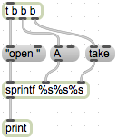
  - One additional feature we will add to this setup is a counter object.
  - This object outputs sequential numbers when it receives a bang in its left inlet. This will make integrating it into sprintf very simple.
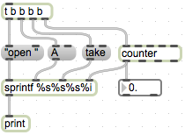
  - Notice that I added an integer slot to sprintf.
  - To restart counter, we send it the the message “goto 0” as follows:
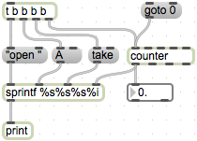
  - Connect the outlet of sprintf to sfrecord~.
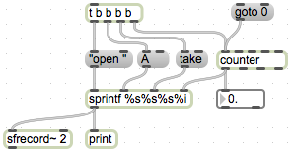
- The message setting sfrecord~’s bit depth will be sent to sfrecord~ following the open message.
  - Create a message box containing the following: samptype int24. Shown below:
  - Connect the outlet of the message to the left inlet of sfrecord~.
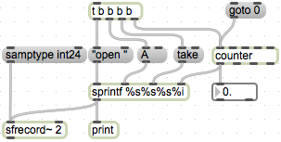
- The final piece of information sfrecord~ needs is a 1 to begin recording, or a 0 to stop recording.
  - Create two message boxes, one containing the number 1 and the other the number 0. Attach their outlets to sfrecord~’s left inlet:
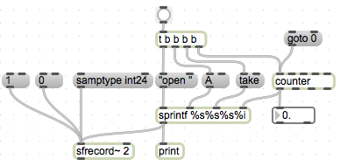
  - This is a functional basic setup.
  - One of the first improvements we can make is to ensure that we send information in the correct order. This is accomplished by using a trigger object:
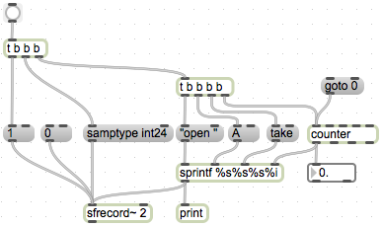
  - Now, every time we click the bang button at the top left, an open message will be created and sent, followed by our bit depth setting, followed by the trigger to start recording.
  - This setup still requires us to manually stop recording by clicking the 0 message. We can include this in our trigger setup with a ggate:
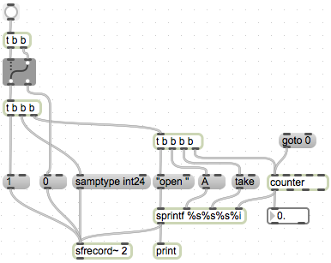
  - Now, each time we click the bang button, we will either initiate the sequence of events to start a new recording, or stop the current recording. We cannot send a start trigger without first stopping the recording.
- Closing remarks
  - One convenient troubleshooting object for sfrecord~ is number~. This serves as a timer, giving us a readout of how many milliseconds sfrecord~ has been recording. Attach the outlet of sfrecord~ to its left inlet.
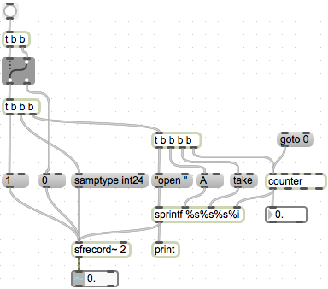
  - Another convenient reminder-object is an integer box. Attach the outlets of our 1 and 0 message boxes to its inlet. This will reflect the current state of the switch.
