Working with audio
Electronic Music II
Spring 2013
- Introducing panning (mono)
  - To create panning, we will begin with two elements:
    - a sound source (a sawtooth oscillator at 120 Hz)
    - a volume control (a float box)
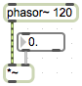
  - To avoid creating distortion from turning our source up too high, and to constrain the value to 0 or higher, we adjust the following settings for the float box in the Inspector:
    - minimum : set to 0.
    - maximum : set to 1.
    - Note : remember to add a decimal point after the number (so, 0., 1.). This will make sure that Max handles the object with float values (ie, with decimal places).
  - Create a dac~ and a toggle object. Connect the outlet of *~ to both inlets of dac~.
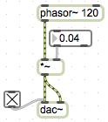
  - We now have a mono source, being controlled in amplitude, and then sent at that amplitude to both stereo channels.
  - In order to pan a mono source, we need to have a second volume control.
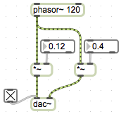
  - We can now control the amplitude of each channel independently.
  - To more fully recreate panning in the style of a mixing board, we need to link the value of the two volume controls. We can do this with some basic math objects.
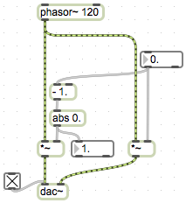
  - Some notes about this new setup:
    - I have introduced the – object and the abs object. – performs subtraction, and abs returns the absolute value of anything passed to its inlet.
    - Notice that I have added an argument for -, and that it has a decimal following it. This causes the calculation to be done with decimal places. Likewise, for abs I have added an argument to enable decimal places.
    - I have arranged the new objects so that the right channel is being adjusted from 0 – 1, and the left channel will mirror this adjustment. When the right channel amplitude = 1, the left channel will = 0, in other words the signal will be panned 100% to the right. Setting the amplitude to 0.5 will pan the signal center.
- Panning (stereo)
  - If we expand our mono panning setup by adding a second mono source, we get the following:
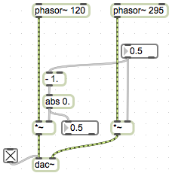
  - In this setup, we hear either right, left, or a mix by some percentage.
  - To recreate stereo panning, where each channel is treated independently, essentially we need to recreate our mono panning setup for both of our sources. However, there is a flaw hidden in this approach (demo).
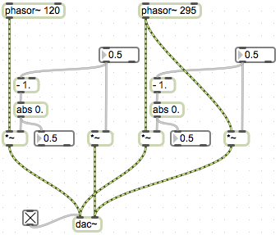
  - If we adjust the panning anywhere away from center on either setup, one of the stereo channels will be receiving a total amplitude greater than 1. This causes distortion.

