025:250 COMPOSITION: ELECTRONIC MEDIA I

Summer 2013
Notes for Recording on Friday, 7.19.13

PART I

Recording Sources
1. Doors (these can be extremely nice)
a. Slowly open, slowly close, rapidly open, rapidly close.
b. If you only have one or two doors, then create variety by changing mic placement.
c. Try recording the doors inside the studio suite. But if noise is too prevalent, then don’t waste time on one.
2. Drawers (like doors, these can be great sound sources).
a. In the mic cabinet, there are some small drawers holding mic clips and stuff.
b. In your office, you have quite a number of drawers. However, the air handling might be a huge problem. Noise
reduction with iZotope might help, as well as high-pass.
c. Can you record the doors and drawers on your own, when I am not there? There’s really nothing for me to add on
this, so I think you’ll do fine. Just watch for noise. If noise is too big a problem, then don’t bother recording.
3. Scissors
a. Each motion should be isolated for Slowly close, slowly open, quickly close, quickly open.
b. Rapid, continuous opening and closing. Imagine multiple tracks of this, both with one particular scissor, as well
as with much scissor variability.
c. I have 4-5, but see if you can scrounge or borrow more. (The reason is because each pair of scissors has only one
pitch. For more pitch variety, as well as timbre envelope, see if you can borrow more.
4. Whirly things.
a. These would be spun around and around, creating a whirring sound.
b. These are sometimes sold as cheap toys. These are plastic tubes about 1.5” diameter and 6 feet long. When
whirled, a pitched sound emerges.
c. Solid material, such as an electrical cord, guitar cable, string with a heavy washer tied to the end, etc. can be
highly effective, but potentially dangerous. Be sure that the spin path won’t send a washer to someone’s face if it
breaks. Belt would be very good.
5. Wooden clothespins.
a. These are good when dropped together. The resultant clatter will have a rhythmic and harmonic character.
b. Could you buy 20-40 of these? Avoid plastic.
6. Wooden pencils. I have a ton, so you don’t need to buy or scrounge more.
7. Paper of different sizes and thickness. The following actions will be used:
a. Waves (with heavier, larger paper, such as 8.5 x 11)
b. Fold
c. Tap with finger, as if flecking off a bug.
d. Crumpling, but start and stop; crumpling as if to toss in trash; crumpling as if to make a sound effect of a fire.
e. 8.5 x 11 is too large and thick. Smaller and thinner, like a store receipt will be more nuanced.
f. Can you see if you can find some suitable paper? Don’t buy any, just scrounge.
8. Shaker objects.
a. I have a sock that can hold a cup or two of uncooked rice, popcorn kernels, dried peas, etc.
b. Bottle of pills, like aspirin.
c. I also have dry cereal.
d. You don’t need to bring anything.
9. Metal measuring spoons.
a. I have two sets and could use more.
b. Because they are so thin, they ring and sustain well.
c. Could you see if you can find or borrow some things like this? Don’t buy anything, though.
10. Sheets of metal.
a. Baking sheets are good
b. In the top cabinet that came from my house recently, there are 10 or so thin metal trays that slide in/out for easy
configuration of an office supply area.
c. See what you can scrounge, but don’t buy anything.
PART II

Your handout on soundmining was very nice. Here are a couple of screenshot formatting guidelines we should follow this year, since I might turn this material into a book or online resource. Formatting is everything in the publishing world.

1. When doing screenshots in the Edit Window in Pro Tools, leave an empty track above and below the track with the region in it. Also, position the region so that it starts at a guide or grid line. Make the grab starting at the gridine to the left of the region. Finally, use the small view. This format is shown below.
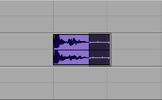

2. Exceptions will be necessary sometimes, so do your best to make the image match the general format as much as possible. One thing that will come up often is when you want to include the timeline above the first track. That’s fine, as long as you still keep the track empty. Also, you may want to show the track controls on the left sometimes.

3. It may seem like we are wasting a lot of space with the empty tracks, but we’re not. Space doesn’t cost anything, and clarity and ease of viewing is the most important thing. So, try to avoid anything that looks informal, or like some kind of off-the-cuff shortcut. Formality is the goal.

4. Another thing to format well are the Pro Tools window such as the Fades dialog. This is very tricky. Notice that the left, right, and bottom of the window is white. We need to have a small border around the whiteness, otherwise it looks like the window disappears. To manage this, position the window over the Edit Window with nothing viewable in it. It will be all gray. When you make the grab, include the gray area around the window in your selection. The result should look something like this:
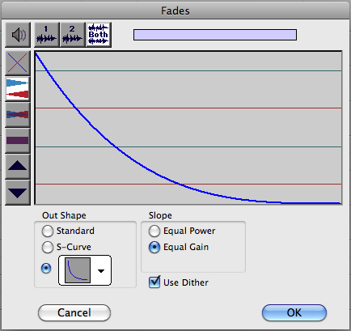

5. The Audiosuite Plug-ins window is pretty easy to capture. With these windows, make the grab from the outer edges of the window, without venturing outside the window. Except in special circumstances, always show the entire window. Don’t use any shortcuts by highlight only the relevant part of the window. Again, space costs nothing and we want the viewer to know that he/she is seeing the entire picture, with nothing hidden away.
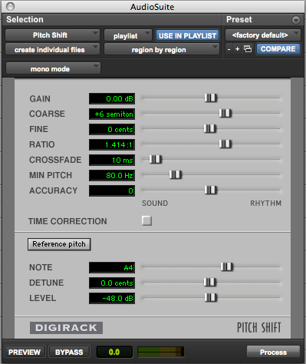

6. The size of the screengrabs is a tricky area. My preference is to make the windows 50%, and the selected part of the edit window 100%. These sizes should be good in an online format. The entire document can be scaled by me, or by the viewer. Consistency is the most important factor here. Now, the tricky thing is what to do with a paper handout in class. Don’t worry about wasting paper, when education and clarity are at stake. However, sometimes you will want to group elements together, rather than spreading them over 2 or 3 pages. In this case, go ahead and try alternate scalings. I can go back and change them later.

7. I have violated my formatting rule for indenting screenshots. Normally, I indent them to line up with the letters a, b, c, etc. However, this would look odd, as I am not using those letters in this part of the document.

8. If you have come away with one thing, it is that everything in formatting is conscious, and you should be aware of everything. Hopefully, the reader won’t notice the formatting. That is what happens when the formatting is standard and consistent. Any deviations from your earlier procedure will be felt, even if subsconsciously, by the reader. Through good formatting, you are establishing your voice as an authoritative one, one that can be trusted.

