Connecting your Laptop to the EMS TV Monitor

- Determine if you need a HDMI cable or a VGA DVI male-to-female adapter. These adapters will look like one of the following below:
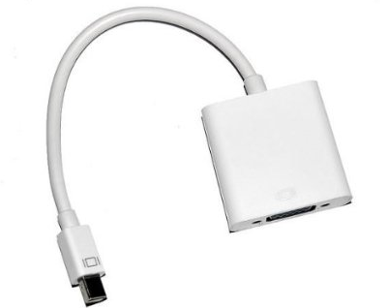
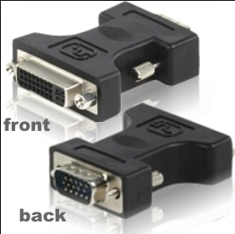
Figure 1.a HDMI Adapter for Mac
Figure 1.b VGA to DVI Male-to-Female Adapter for PC

- For those running a Macintosh computer, find the white HDMI adapter next to the mixer the table and plug it into the mini-Display port as shown in the following diagram:
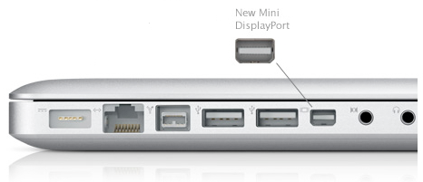
Please note, if you can’t find a mini-display port on your laptop with the same symbol as the one on the adapter, look for a port with a lightning symbol. It is acceptable to connect the HDMI adapter into this port.
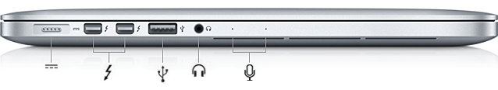
- Once you connect the HDMI adapter to the laptop, you will need to change the settings on the TV and your laptop.
- On your laptop go to System Preferences.
- Click on Displays.
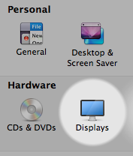
- On Displays, click on Arrangement.
- Click on Mirroring Displays if it isn’t activated.
- On the TV, after turning it on, click Input on the TV remote.
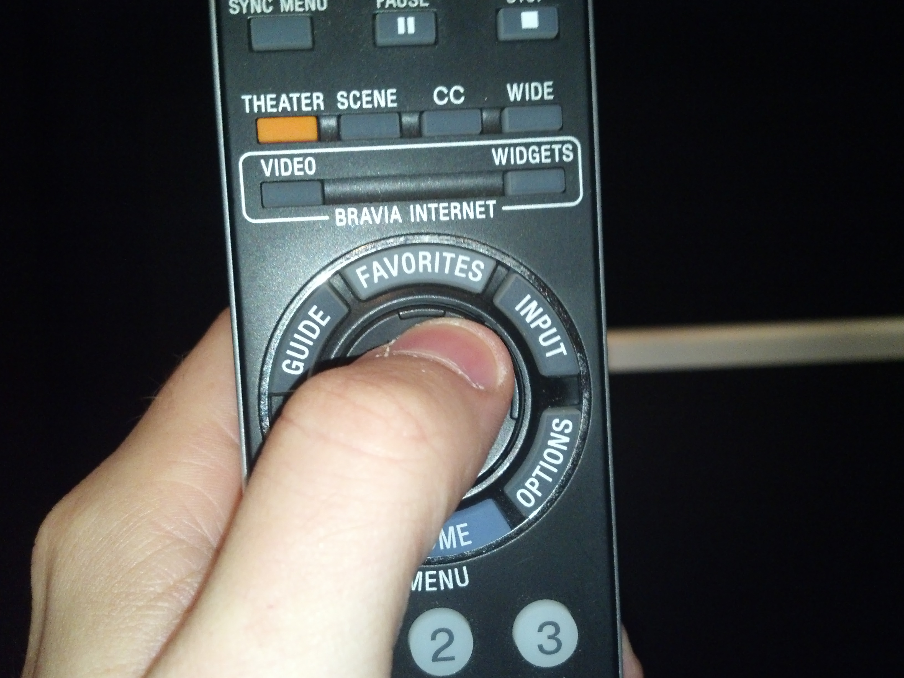
- Then, select HDMI 2. If you follow each step, what you see on your monitor should be visible on the TV screen.
- If you are unsure next time which input you should select on the TV, consider the label on the black cable where the HDMI adapter is attached: 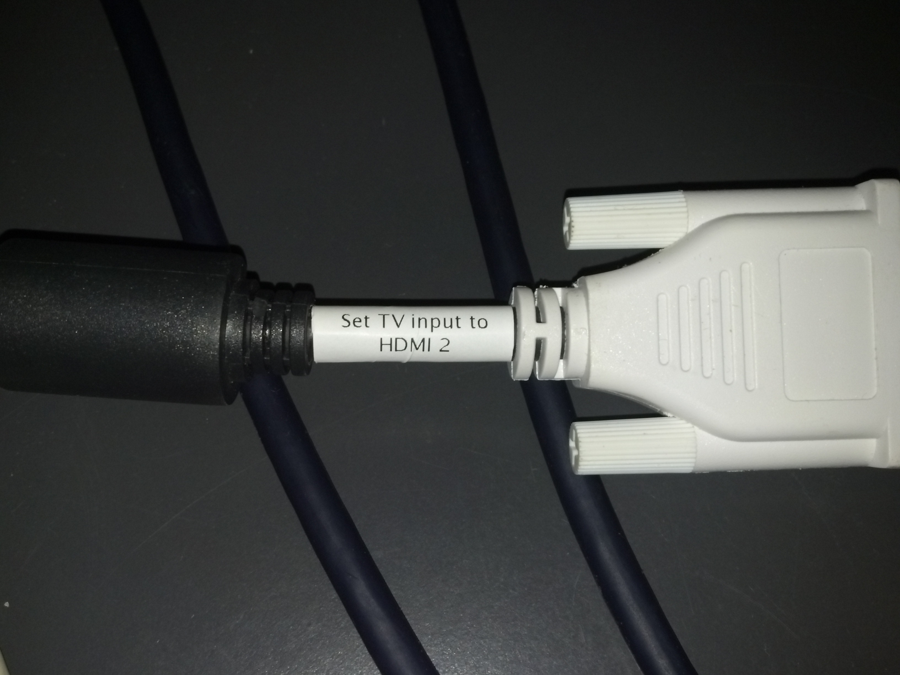
- If you have an older computer that requires a VGA to DVI adapter to connect to the TV, disconnect the two black and white adapters as shown below:
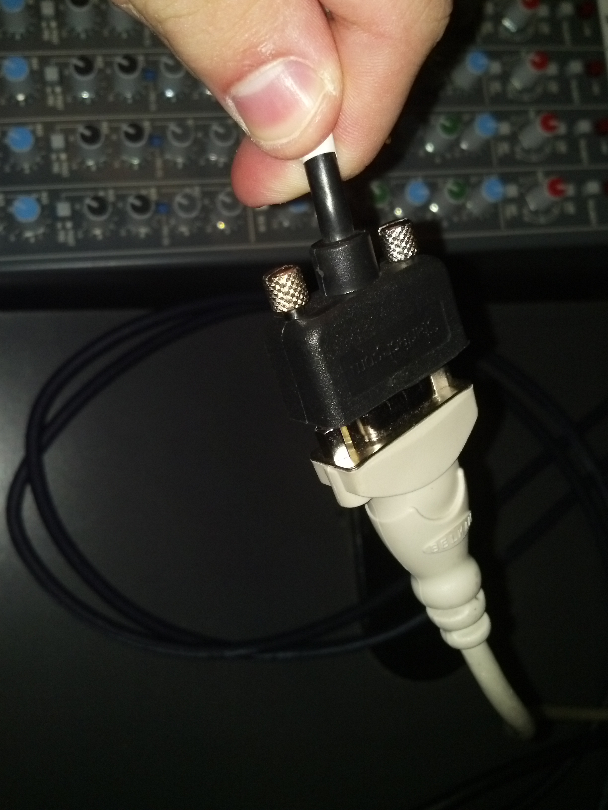
- Connect the black adapter to the VGA port on your computer. It should look something like this: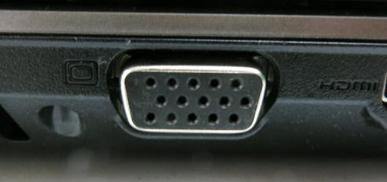
- On the television screen, go to Input and select PC, not HDMI 2. If you forget, remember the black VGA adapter has a white label that tells you what it’s connected to.
- On your computer, you will need to go to Start=>Control Panel=>Displays. You should have the option to change your monitor settings there so that you can display what is on the TV screen and monitor simultaneously.
- For all other questions or concerns, please contact one of the TAs for assistance.

