025:250 COMPOSITION: ELECTRONIC MEDIA I
Fall 2014
Plug-in Settings

- This handout focuses on the basic parts of Audio Suite plug-in settings on Pro Tools.
- Here are the plug-in settings for Q1 Stereo.
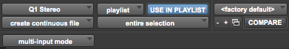
- The button on the top left corner indicates the plug-in currently in use. When you click this button, you can move from one plug-in to another, such as Q1 Mono, Q10 Stereo, Normalize, Pitch n’ Pro Time, etc.
- The playlist button has two options: playlist or region list.
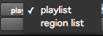
- Usually, we do not change this setting. The playlist setting allows you to process edits made to any file selected on a given track. If you process a file with region list selected and the “Use In Playlist” button activated, the plug-in will modify all instances of that file on all tracks.
- “Use in Playlist” is always selected. If it is not activated and you process a file with the playlist button selected, the new file is added to the region list. It does not modify the region you have selected.
- The button <factory default> is part of the presets button. If you have a particular setting for any plug-in that you like, you can save it and load it up again when you return to the plug-in after closing it or going to another one.
- The next button has three selections: overwrite files, create individual files, and create continuous file. We never overwrite files. Therefore, we select either “create individual files” or “create continuous file”.
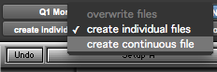
- Both options are important for editing multiple regions at a time. “Create individual files” keeps the individual files as separate regions after they have been processed by a plug-in. “Create continuous file” connects and consolidates all regions together.
- The next button has two selections: “region by region” or “entire selection”.
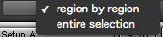
- Please note that both “region by region” and “entire selection” are linked to the selections from the previous button in #8. “Region by region” is always paired up with “create individual files”, and “entire selection” is always paired up with “create continuous file.” These pairings are unalterable.
- The minus and plus signs are used to scroll through presets when you have more than one of them saved.
- The little button with the two windows next to the plus sign is unusable in Audio Suite plug-ins. We’ll skip this button for now and return to them in another handout.
- The “Compare” button can be used to compare differences between two settings on a plug-in.
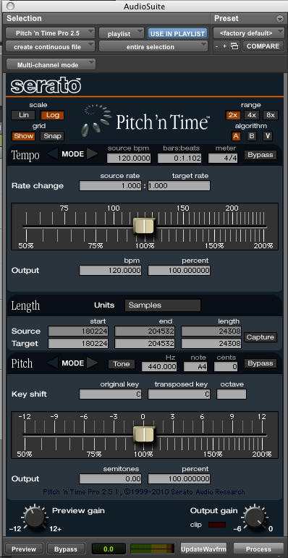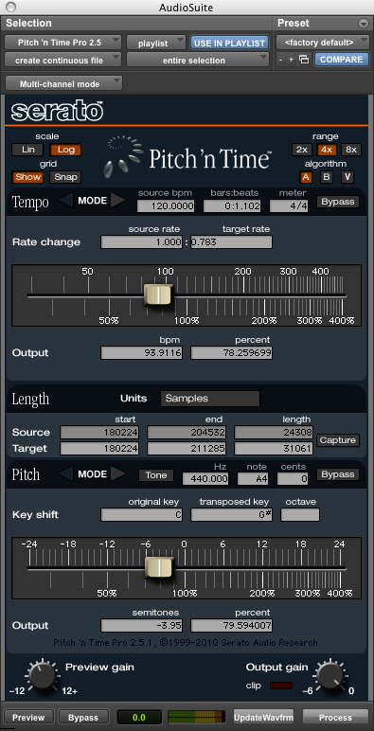
- Depending on the plug-in, another button is included below for audio input with selections such as “mono mode” or “multi-input mode” or even “stereo mode” in some cases.
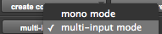
- Multi-input mode is generally preferred when working with stereo files. Mono mode is generally more preferable with mono or multi-mono channel files.

