025:250 COMPOSITION: ELECTRONIC MEDIA I
Fall 2014
Real-time Audio Suite Plugins - Basics
Jonathan Wilson

- Besides the Audio Suite plugins, we have in Pro Tools Real-time Audio Suite plugins too. Real-time plugins, unlike the ones you have been working with, use non-destructive editing. They do not create new files or permanently alter a region.
- To use a real-time plugin, we need to have inserts on display. To do this, click on the Edit Window View Selector and select “Inserts A-E”:
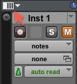
- Click on one of the tabs in the “Inserts A-E” column.
  - You’ll find the following options available: multichannel plug-in, multi-mono plug-in, and I/O. Let’s leave out the I/O for now. Use multichannel plug-ins for stereo tracks and multi-mono plug-ins for mono tracks.
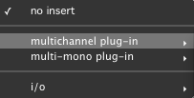
- Let’s try a multichannel plug-in called AIR Frequency Shifter.
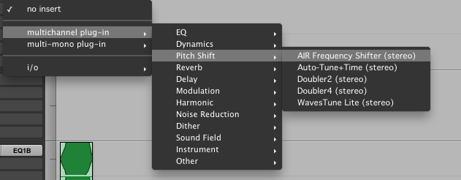
This can be used to shift an audio signal’s individual frequencies inharmonically.
- Let’s consider how each parameter is used in this plug-in:
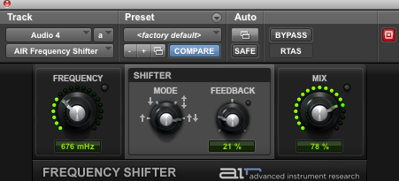
  - The frequency dial controls how much the frequency of a region on a track will shift.
  - The Shifter section allows you to control the direction in which the frequency shifts and the feedback of the signal through an algorithm.
  - With mode, you can select whether the frequency shifts up, down, in both directions equally and simultaneously, or whether the frequency shifts up in the right channel and down in the left.
  - Raising the feedback dial increases the number of times a signal will run through the plug-in’s algorithm.
  - Mix gives you the option to balance wet and dry signal. Dry signal is the original information/sound of a region. Wet signal is processed. In the case of this plug-in the wet signal is heard through the shift (up or down) in frequency.
- Suppose, however, you have more than one region on a given track, and you want to control when the real-time plug-in will affect a given region. We could click the bypass button, but if we have more than one track with real-time plug-ins, it would be easier to automate when this effect occurs. To do this, we need to add automation for the plug-in on that track. Click on the button with two windows, next to the bypass button.
- Clicking it will open up the plug-in automation options window.
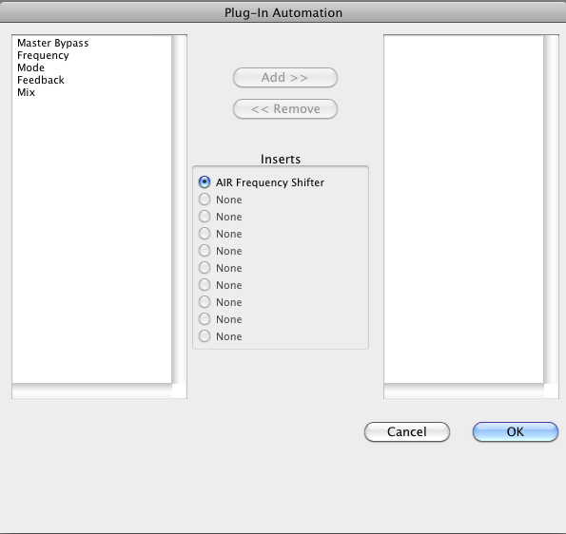
- Here, you can choose to add a specific parameter of the plug-in that you want automate. Click on the plug-in in the left column you want to add and then click the “Add <<<” button. When you click that button, the added parameter will be included in the right column. To remove it, click on the parameter in the right column and click the “<<< Remove” button. Let’s choose the “Master Bypass” button for now. Once you have added the parameters you wish to automate, click OK.
- Now, click on the “Wave” tab on the track. This is where you normally go to automate volume and panning. Below pan right is a new option called “(fx a) AIR Frequency Shifter”.
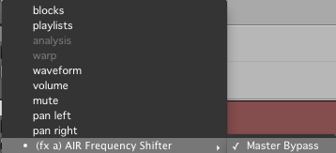
This is from the plug-in we just chose to automate.
- Scroll down to the new automation and click Master Bypass. An automation line can be seen at the bottom of the region as shown below:
  - This indicates that the Master Bypass option is off. To turn it on with this automation, add an edit point, and, to the right of the edit point, click, hold, and drag the line up. Now, it should look something like this:
  - This indicates that automation for Master Bypass to the left of the vertical line is disabled. Everything to the right of this line is enabled. We can also verify this by looking at the Insert A in the “Inserts A-E” column. Notice when you click to the left or right of this line, the color of the tab changes.
Before: After:
- With this handout I hope it will add to your understanding of how real-time plugins can be useful in your projects, both present and future. This concludes the basics of real-time plugins.

