025:250 COMPOSITION: ELECTRONIC MEDIA I
Fall 2014
Recording in Pro Tools with the Focusrite
Prepared by Will Huff, Edited by Jonathan Wilson

1. Connect a mic of your choosing to an XLR cable, then plug the XLR cable into the leftmost jack, underneath the Focusrite pre-amp module, as shown below:
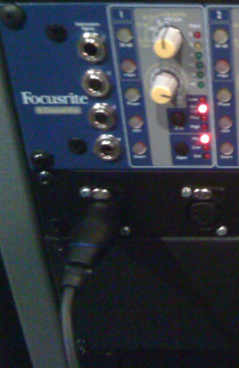

2. The jack shown above is hardwired to channel 1 of the Focusrite pre-amp unit. The individual pre-amp is shown below:
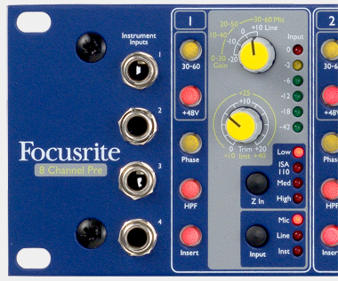

3. The recommended settings are:
a. +48 engaged for condensor mics; disengaged for dynamic and ribbon mics.
b. HPF engaged to minimize low rumble.
c. Z In Low selected for condensor mics; experiment with other Z In settings with dynamic and ribbon mics.
d. Input Mic selected.
e. The top knob should be set to +10 Line, at 12:00.
f. The bottom knob will function as a volume control when recording.

4. Open up Pro Tools and create a new session, saving it to a location you will be able to find for future sessions.
a. Add new tracks (Track > New). Create mono tracks if you plan to record using one mic; stereo if you are recording two:
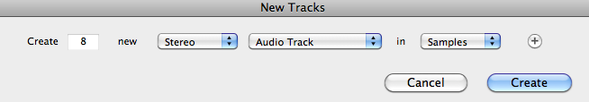

b. Notice the Edit Window on the left of your session. It should look like this, below:
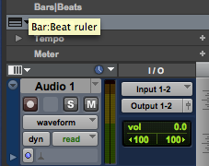

c. If you do not see this information, click on View > Edit Window Views and select I/O and Track Color:
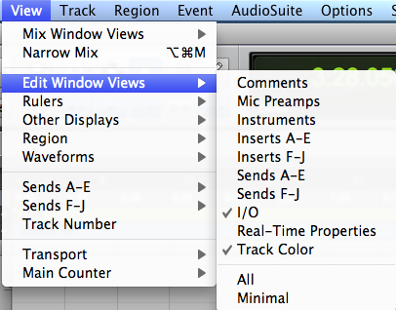

d. In the Edit Window underneath I/O, click on “Input” and select the channel to correspond with the channel you have plugged your mic into. In this case, channels 1-2. Because we are recording in a stereo track, we will need TWO mics. Simply repeat step 1 into the second-left most jack. Create a mono track (Track > New) if you plan to record with just one mic.

5. Recording
a. First, “record-enable” which tracks you want to record. In this case, we will enable stereo track 1. Click on the red button with a circle in it in the Edit Window. Now this track is record-enabled. The button will flash to indicate this.
b. Then, in the transport bar, click on a similar button to “arm” recording. It too will flash when Pro Tools is armed to record. If you do not see the transport bar, click Window > Transport. The transport bar looks like this:
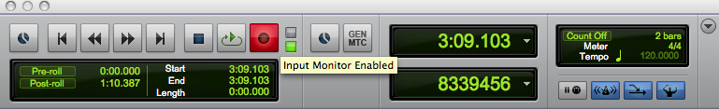

c. Hit the spacebar and recording will begin. Hit spacebar a second time to stop recording. Voila!
d. Warning! Raising the monitor faders when recording will cause ear-piercing feedback. Make sure all monitor faders (the red sliders) on the mixer are all the way down.
e. When you have finished recording, disarm all tracks.
f. Turn the top knob back to the 9:00 position and the bottom knob back to the 7:00 position. Then, the 30-60 (if used) and +48 buttons need to be deactivated.

Once you arm the track, check your levels to avoid overs. If you are recording from a distance greater than 1 meter away from the microphone and are not receiving a strong enough signal, you can push the 30-60dB button, which will increase the strength of the signal by 30dB.

