Composition: Electronic Media II
Spring 2015
Random

- In this handout we will explore the function of the random object.
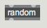
- The random object, when an argument is given, limits the range of numbers that can be sent out from this object.
- In the following example a random object with the argument 10 is provided.
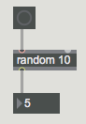
- When I hit the button, a random number between 0 and 9 will be sent to the integer box, which results in 10 different possible numbers that will be selected. When I hit the button again, the random object will send out another random number that will be displayed in the integer box.
- Of course, the random object has its limitations. Consider the following example:
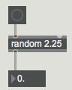
- What would happen if I click the button?
- Fill in your answer here: __________________________________.
- Fill in the correct answer here: _____________________________.
- You will also notice that the random object can also repeat the same number.
- It is possible to change the range of the random object without altering the argument. Consider the following example:
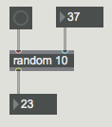
- When I add an integer box and connect it to the right inlet of the random object, the range of the random object can increase or decrease depending on what I set to the integer box.

