MUS:4250 COMPOSITION: ELECTRONIC MEDIA I
Fall 2016
Bounce to Disk

- Bounce to Disk is an important part of Pro Tools. It allows us to mix the audio from all desired tracks to a single audio file. Before you bounce, make sure to save your session.
- Before bouncing to disk, check for overs in ALL CLIPS. If there are any overs, check your volume automation.
- To bounce to disk, select the area that you wish to bounce. Then, go to File, scroll down to “Bounce to” and click “Disk…”
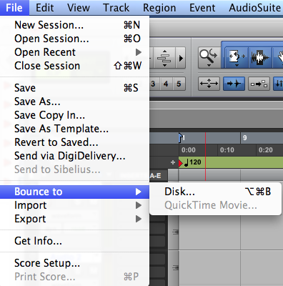
You can also access it by pressing “option command b”.
- Here are some things to consider when we are ready to bounce to disk.
  - Settings that should be used when bouncing to Disk:
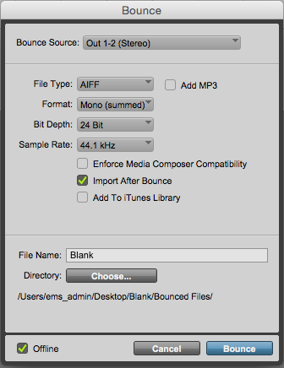
    - Bounce Source: Out 1-2 (Stereo)
    - File Type: AIFF
    - Add MP3: optional
    - Format: Mono (summed)
    - Depth: 24-bit
    - Sample Rate: 44.1kHz
    - Enforce Media Composer Capability: Unchecked
    - Import after Bounce: optional
    - Add to iTunes Library: optional
    - The offline button in the left-hand corner of the window should be checked.
  - Naming Bounced Files
    - Where it says File Name, you can type in the name for your bounced audio file. We use the ß symbol at the start of a bounced filename as an easy way to locate these files. For example, “ßMetals1.aiff” is considerably easier to find than “Metals1.aiff”. To get the ß letter, hold down “alt/option” and type “s”. Come up with a naming system simple and easy to remember.
    - There are two places you can save the files you bounce to disk.
      - By default Pro Tools 12 saves the bounced file to the folder “Bounced Files.” This folder is located in the folder that contains your Pro Tools sessions and audio files.
      - You can also choose to bounce your files into another folder if you want to bounce your file elsewhere. Click on the “Choose” button and select the folder that you wish to bounce to.
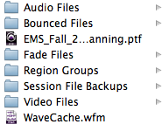
- Once you name your file, click the bounce button and wait for the bouncing process to finish. Once it’s finished, check for any overs in your tracks. If there are any, look for them and adjust the volume automation on that track.
  - If a rotating disk appears at the end of the bouncing process, very likely the audio driver on the computer crashed. Force the program to close (command + option + Esc, then select the application you wish to quit) and restart the computer. You should also check to see if the last file you bounced was done successfully.
- It is very helpful to open up the newly bounced file and check for overs. This can happen even when none of meters for the tracks show an over. A great way to check this is to insert the newly bounced file into your Pro Tools session and listen to it. If you find overs in the newly bounced audio file, go back to Pro Tools and adjust the volume automation where overs occur. Bounce the file again and check for further overs.

Note: If you want to bounce to stereo, choose the “Interleaved” format instead. ‘Multiple mono’ will create two mono files (left and right) that can be used as a stereo file in Pro Tools.

