MUS:4250 COMPOSITION: ELECTRONIC MEDIA I
Fall 2016
Recording in Pro Tools with the Earthworks 1024

1. Connect a mic of your choosing to an XLR cable, then plug the XLR cable into the leftmost jack, underneath the Earthworks 1024 pre-amp module, as shown below:

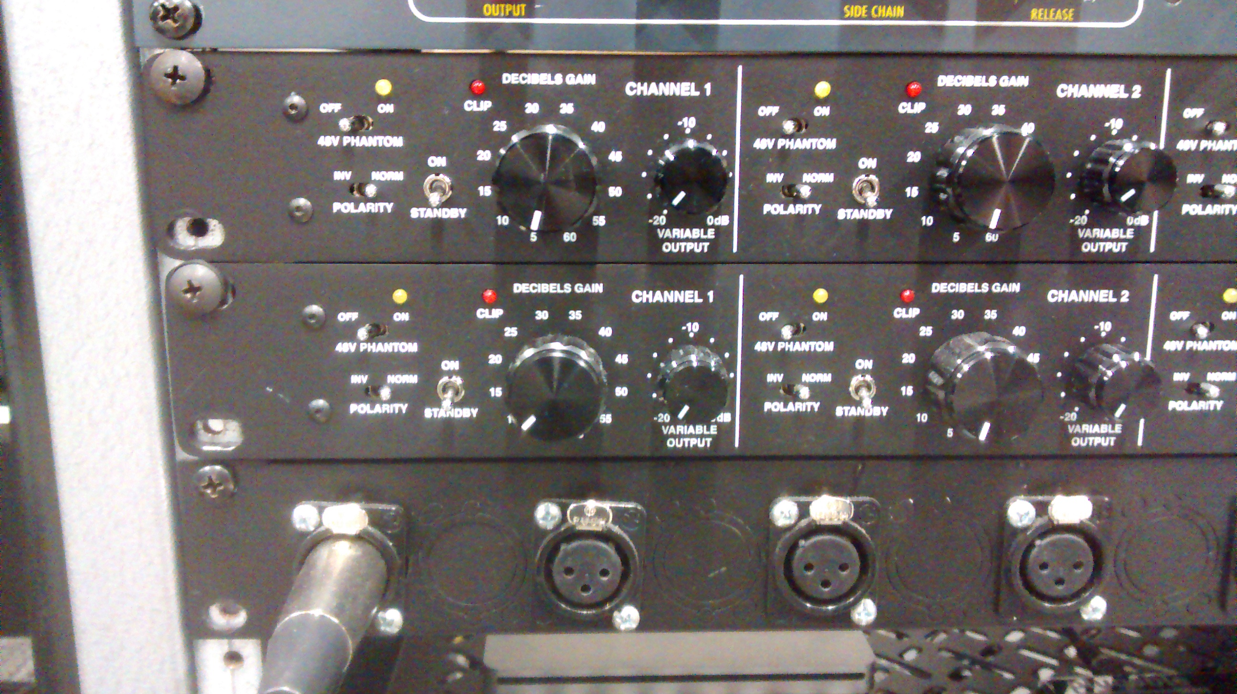

2. The jack shown above is hardwired to channel 1 of the Earthworks 1024 pre-amp unit. The individual pre-amp is shown below:
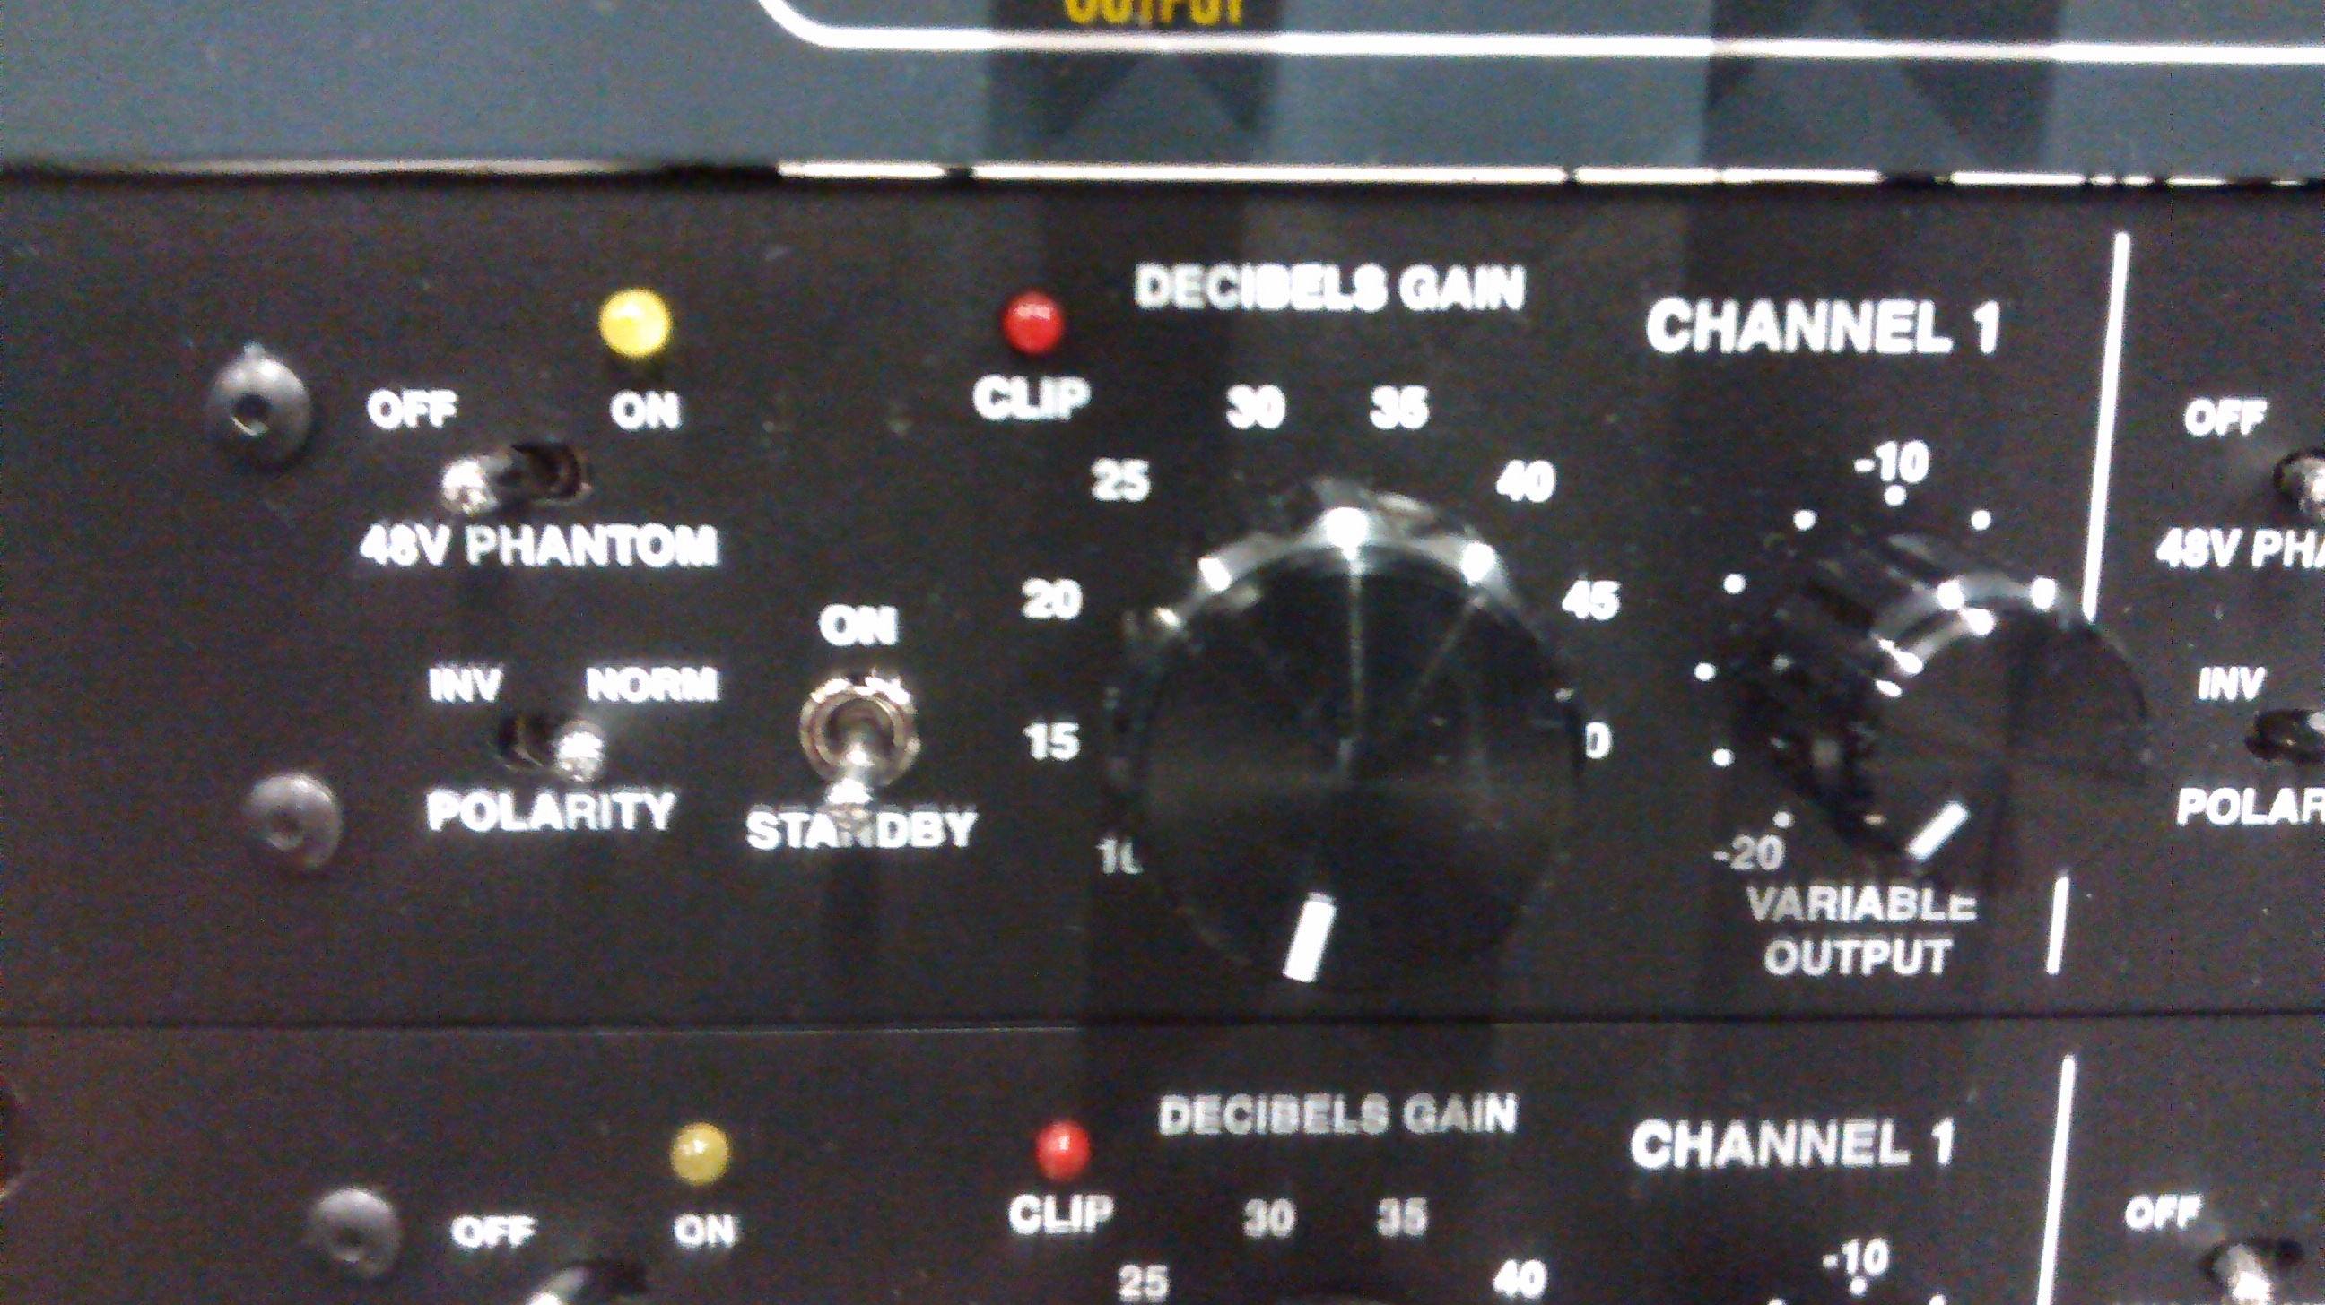

3. There are 2 Earthworks 1024 pre-amps stacked on top of each other, each marked channels 1-4. The top Earthworks preamp corresponds to channels 1-4. The bottom Earthworks preamp corresponds to channels 5-8. Channels 1-8 on the patchbay are indicated from left to right.

4. The recommended settings are:
a. Power/Standby switch turned to on position to arm the channel; Power/Standby switch turned to standby to disarm the channel.
b. 48V Phantom should be switched on for condenser mics only; Phantom Power Off for dynamic and ribbon mics.
c. Polarity switch should be set to Normal.
d. The Decibels Gain knob should be set to 35, at the 1:00 position. You might need to change this if the signal going through the microphone is too weak.
e. The Variable Output knob will function as a volume control when recording. You can make slighter adjustments to the strength of the signal level with this knob.
f. Please note that channels 1 and 2 of the Earthworks 1024 are hardwired into the Zener Limiter. Channels 3-8 bypass the Zener Limiter.

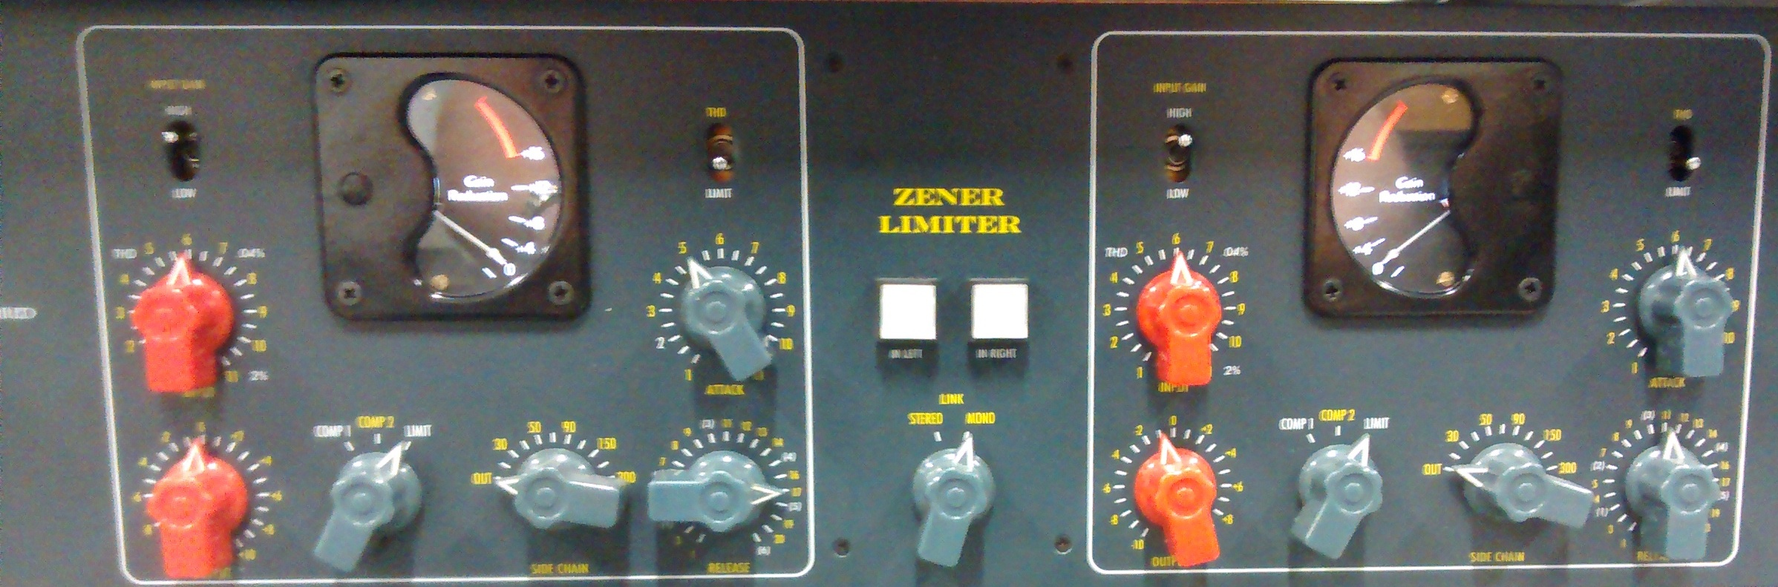

- Pushing the two white buttons will result in a bypass of the limiter, which means that the signal will not be altered by the limiter. The white squares will become blue when the bypass is activated. It can be used to compare the difference between dry and compressed sounds.
- We will discuss how the other parts of the Zener Limiter can be used at a later date. For now, know that if you’re recording in channels 1-2 on the Earthworks that it’s possible to bypass the limiter.

5. Open up Pro Tools and create a new session, saving it to a location you will be able to find for future sessions.
a. Add new tracks (Track > New). Create mono tracks if you plan to record using one mic; stereo if you are recording two:
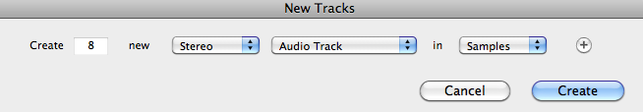

b. Notice the Edit Window on the left of your session. It should look like this, below:
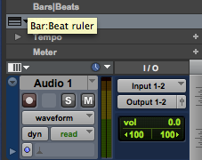

c. If you do not see this information, click on View > Edit Window Views and select I/O and Track Color:

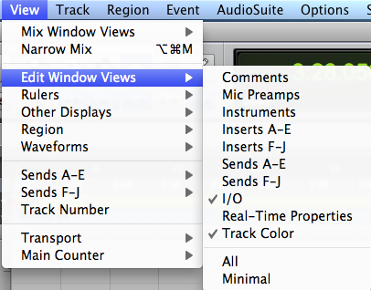

d. In the Edit Window underneath I/O, click on “Input” and select the channel to correspond with the channel you have plugged your mic into. In this case, channels 1-2. Because we are recording in a stereo track, we will need TWO mics. Simply repeat step 1 into the second-left most jack. Create a mono track (Track > New) if you plan to record with just one mic.

5. Recording
a. First, “record-enable” which tracks you want to record. In this case, we will enable stereo track 1. Click on the red button with a circle in it in the Edit Window. Now this track is record-enabled. The button will flash to indicate this.
b. Then, in the transport bar, click on a similar button to “arm” recording. It too will flash when Pro Tools is armed to record. If you do not see the transport bar, click Window > Transport. The transport bar looks like this:

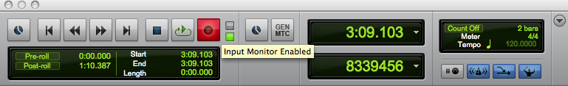

c. Hit the spacebar and recording will begin. Hit spacebar a second time to stop recording. Voila!
d. Warning! Raising the monitor faders when recording will cause ear-piercing feedback. Make sure all monitor faders (the red sliders) on the mixer are all the way down.
e. When you have finished recording, disarm all tracks.
f. Turn the Decibels Gain knob and Variable Output knobs back to the 7:00 position. Next, if you are using the 48V Phantom Power switch with a condenser mic, this should be turned off next. Then, flip the Standby/On switch to standby before disconnecting the XLR cable from the patchbay.
g. Make sure to wrap all XLR cables properly when you’re done. Please return all cables, microphones, studio stackers, blankets, and microphone stands to the right places.

Once you arm the track, check your levels to avoid overs. Adjust when necessary.

