025:250 COMPOSITION: ELECTRONIC MEDIA I
Aug. 29, 2007
Intro to Pro Tools

1. Prepare the audio system for Pro Tools as follows:
- Power up the studio as discussed in class.
- Bring up faders 1-2 and assign them to busses 1-2, 3-4, 5-6, 7-8.
- Bring up the busses to unity gain.
- Bring up faders 23-31 for desired diffusion.

2. Prepare a work folder for the Pro Tools session as follows:
- On the EMS Users drive, create a folder and name it “Larry.”
- Open up the “Larry” folder and in it, create a folder named “Sounds.”
- Place the soundfiles that you wish to use in your session in “Sounds.”

3. Launch Pro Tools by selecting its icon in the dock:

4. A menu bar like the one below will appear:

5. Create a new session as follows:
- Select File>New Session
- A dialog like the one below will appear:
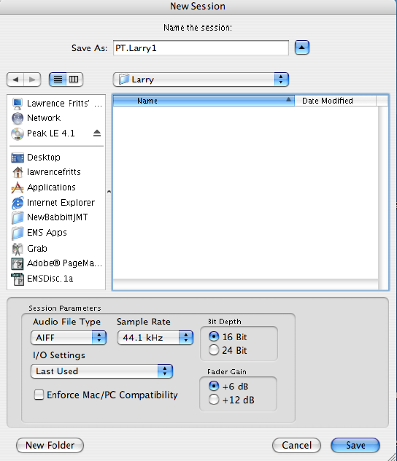
- Save As: “PT.Larry1”
- Where: “Larry.”
- Audio File Type: AIFF
- Sample Rate: 44.1 kHz
- Bit Depth: 16 bit
- I/O Settings, Fader Gain, Enforce Mac/PC Compatability: ignore for now.
- Select Save.

6. Notice the folders and file contained in the folder “Larry:”
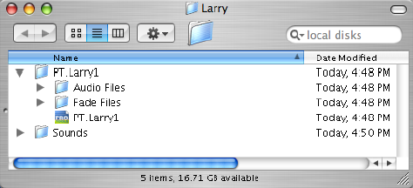
7. After selecting Save in Step 5i, an Edit Window like the one below will appear:
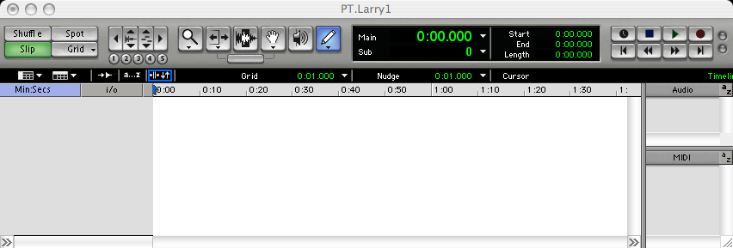

8. Discussion of Shuffle, Spot, Slip, Grid.

9. Discussion of Zoom functions.

10. Discussion of tools: Magnifying Glass, Trim, I-Beam Cursor, Grabber, Scrub, Pencil.

11. Dicussion of Time Display.

12. Discussion of Transport functions.

13. Discussion of Timeline.

14. Discussion of Audio Region List and MIDI Region List.
15. To create audio tracks, do the following:
- Select File>New Track.
- A dialog like the one below will appear:
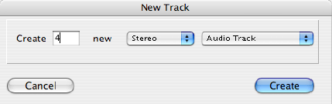

- Create: 4
- New: Stereo
- Audio Track

16. Click Create. A window like the one below will appear:
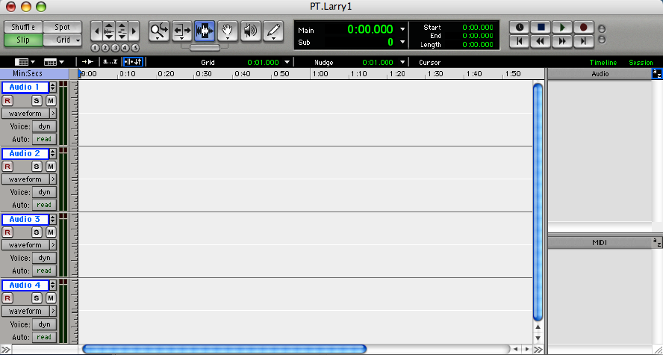

17. Discussion of window functions.

18. Note the following for each track:
- Track Name is Audio 1, 2,3, 4.
- R: record
- S: solo
- M: mute
- Waveform, blocks, volume, mute, pan.
- > selects: mini, small, medium, large, jumbo, extreme track heights.
- Voice: dyn
- Auto: read

19. Discussion of the i/o functions.

20. To import a soundfile into the Audio Region List, do the following:
- Using the Audio Region List submenu, select Import Audio. Note: beware of File>Import Audio to Track. A dialog like the one below will appear:
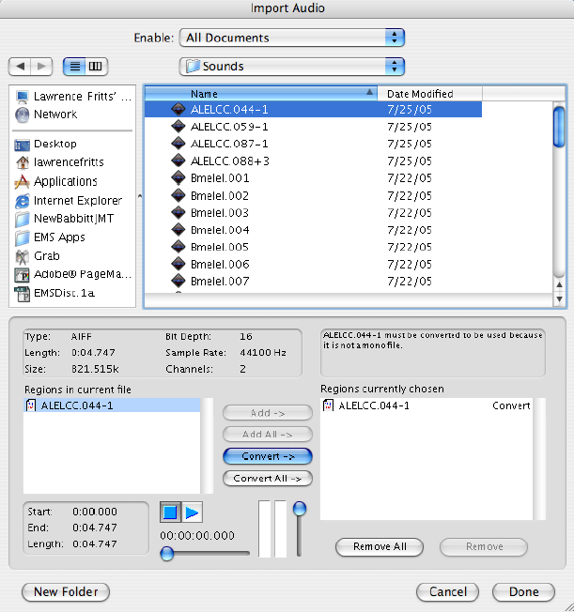

- Select the folder “PT.Larry1”>”Sounds”. The items shown in the list are the soundfiles you wish to import.
- Double-click on a soundfile to add it to the Region List. Multiple soundfiles may be added, also.
- Discussion of file info, auditioning, converting.

- Click Done. A dialog like the one below will appear:
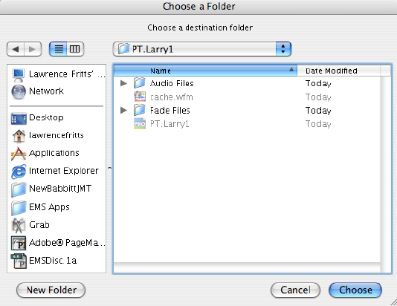
- Navigate to and select “PT.Larry1”>”Audio Files” and click Choose.
- The soundfile now appears in the Audio Region List, as shown below:
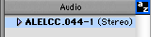

h) Discussion of audio file name and stereo formats.
21. The easy way to import soundfiles is to drag and drop the files from “Larry>Sounds” onto the Pro Tools icon in the dock. This bypasses the import dialog, as shown in class. The imported soundfiles now appear
in the Audio Region List, as shown below.
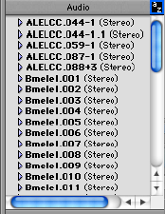

22. Navigate to the “Larry>PT.Larry1>Audio Files” folder and note the converted soundfiles, as shown below.
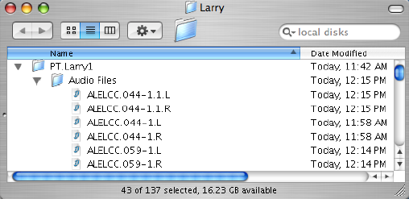

23. Discussion of importing mono files. Note: putting all mono soundfiles into the Audio Files folder is the
least confusing method of importing.

24. Using the Grabber tool, drag your soundfiles into the Edit Window, as shown below:
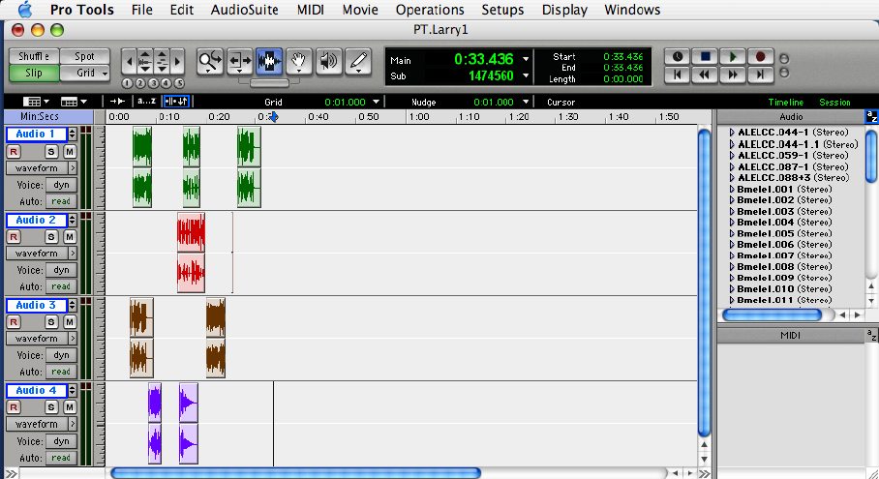

25. Experiment with Shuffle, Spot, Slip, Grid, Magnifying Glass, Trim, I-Beam Cursor, Grabber, Scrub, Pencil.

26. Experiment with track functions, name, solo, mute, waveform, volume, pan, track height.

27. Quit Pro Tools when you are done and have a nice day.

