Composition: Electronic Media I
August 24, 2005
Studie II and Poeme Electronique

Studie II was composed by Karlheinz Stockhausen 1954 in the WDR Studios in Cologne, Germany. Its source material is sine tones superimposed in groups of 5, then sent into an echo-chamber.

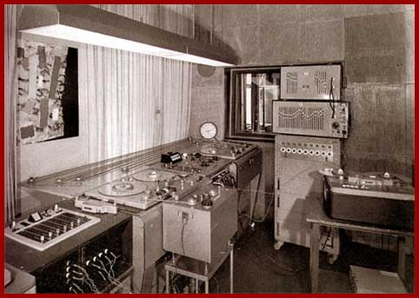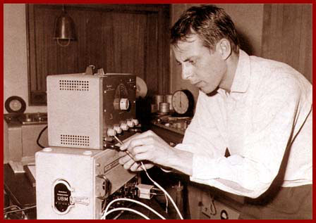

WDR Studio ca. 1967 Stockhausen ca. 1954

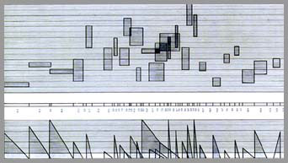

Score for Studie II

Poeme Electronique was composed by Edgard Varese for the 1958 Brussels World Fair. The piece was commissioned by Varese and the architect Le Corbusier by the electronics company, Philips. The work consisted of electronic sound, 400 loudspeakers, and film and still images projected inside the space. The design of the building was created by Iannis Xenakis, who later became well-known as a composer.

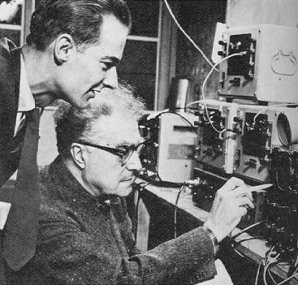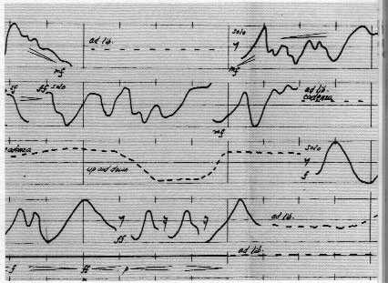

Varese and assistant composing Score for Poeme Electronique.
Poeme Electronique.

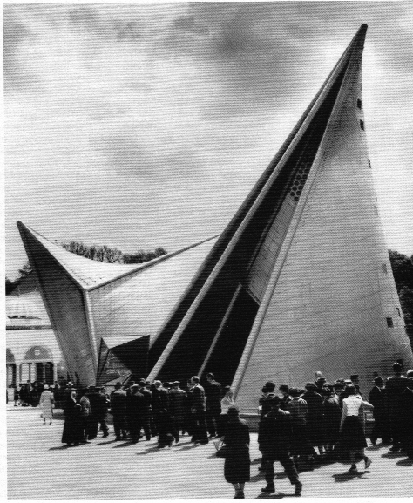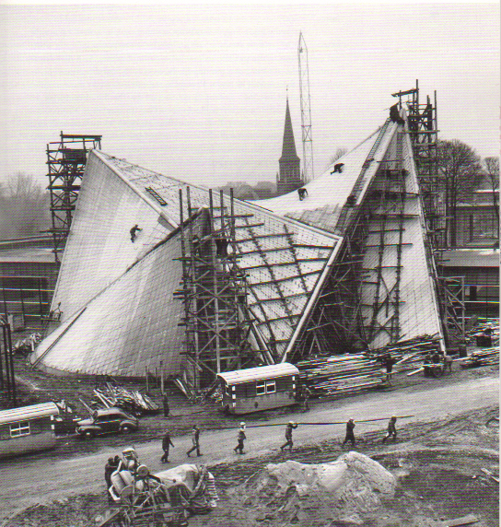

Two views of the pavillion.

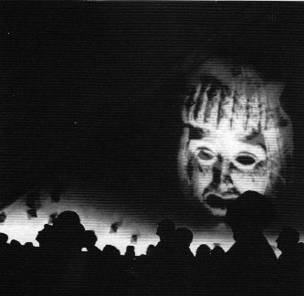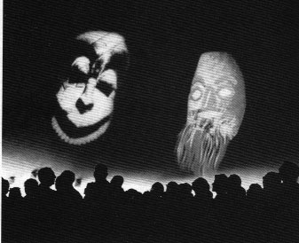

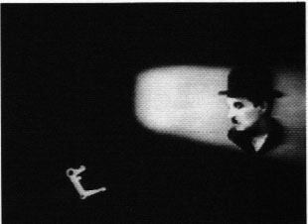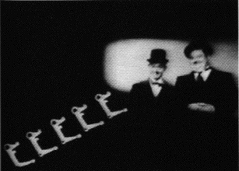

Four views inside the pavillion during a performance.

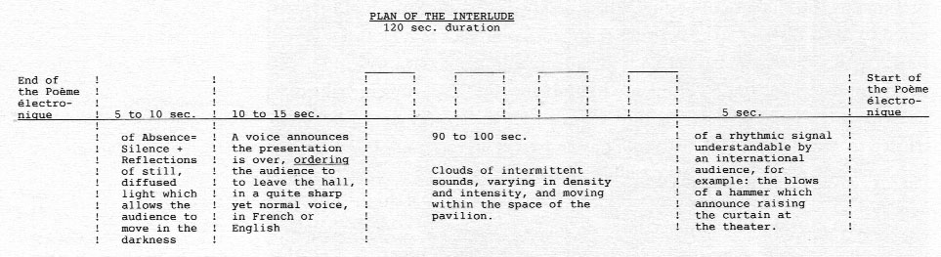

Le Corbusier’s plan for an interlude during the performance.

