025:250 COMPOSITION: ELECTRONIC MEDIA I
Fall 2009
Digidesign Products

1. Digidesign
a. History
b. Partners: Avid, Siblelius
c. Upgrade policy

2. Mbox-2 Micro
$249
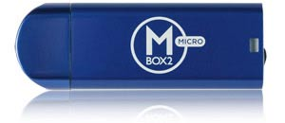

Specs

- Ultra-compact Pro Tools LE system for on-the-goediting and mixing, and music creation with virtual instruments
- and loops
- High-quality sound up to 24-bit, 48 kHz (highersample rates require pre-conversion)
- 1/8-inch stereo output jack for headphone or speakermonitoring (no audio inputs)
- Convenient volume wheel for quick headphoneadjustments
- Slick and compact anodized aluminum design
- Includes Pro Tools LE software, DigiRack and BombFactory plug-ins, and Xpand! to start creating, editing, and
- mixing right away
- Supports Music Production Toolkit and DV Toolkit™ 2options for working on the road with larger projects (up to
- 48 stereo tracks)
- Powered by USB (USB 1.1 connector, includes USB extension cable)
System Requirements:
- Digidesign-qualified Windows XP-* or Mac OS X10.4-based computer (*NOT COMPATIBLE with Windows
- XP Media Center Edition)
- 768 MB of RAM (1 GB highly recommended)
- DVD-ROM (or equivalent) drive for softwareinstallation
- Available USB port (USB hubs not supported)
Minimum 1024 x 768 screen resolution

3. Mbox-2 Mini
$449

- Specs

- 100% USB powered for maximum portability
- 2 analog inputs (XLR and ¼" jacks) & 2 analog outputs (¼" jacks)
- 2 channels of S/PDIF digital I/O (RCA)
- 4 simultaneous channels of input using both analog and digital I/O*
- 1 MIDI input & 1 MIDI output (16 channels in/16 channels out)
- Zero-latency monitoring
- 48V phantom power for condenser microphones
- Separate source selection and gain control per channel
- Headphone output with dedicated volume control
- Dedicated studio monitor volume control
- True multi-client audio/MIDI drivers (Mac OS X only; Windows XP driverscoming soon)

4. Mbox-2
$549
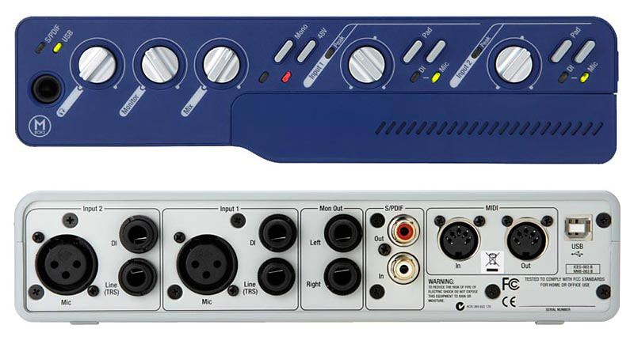

Specs

- 100% USB powered for maximum portability
- 2 analog inputs (XLR and ¼" jacks) & 2 analog outputs (¼" jacks)
- 2 channels of S/PDIF digital I/O (RCA)
- 4 simultaneous channels of input using both analog and digital I/O*
- 1 MIDI input & 1 MIDI output (16 channels in/16 channels out)
- Zero-latency monitoring
- 48V phantom power for condenser microphones
- Separate source selection and gain control per channel
- Headphone output with dedicated volume control
- Dedicated studio monitor volume control
- True multi-client audio/MIDI drivers (Mac OS X only; Windows XP driverscoming soon)

5. Mbox-2 Pro
$649
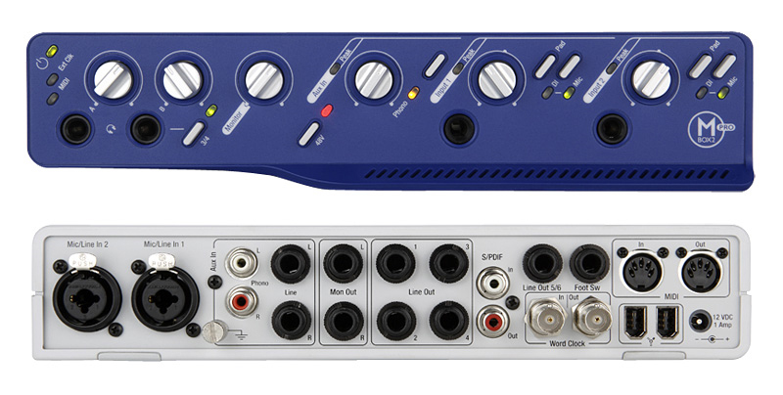

- Specs

- Powered by FireWire* or included power supply
- Supports up to 24-bit/96 kHz resolution**
- 6 simultaneous inputs/8 simultaneous outputs
- 4 analog inputs (2 XLR/1/4" TRS combo jacks & 21/4" TRS jacks)
- 6 analog outputs (1/4" jacks)
- 2 instrument DI inputs on the front panel
- 2 channels of S/PDIF digital I/O (RCA)
- Built-in phono preamp input (RCA) for directturntable connection
- 1 MIDI input and output (16 channels in/16 channelsout)
- MIDI Time Stamping (MTS) support for superior timingand accuracy
- BNC Word Clock I/O
- Low-latency monitoring
- Dedicated studio monitor outputs with volume control
- 2 stereo headphone outputs with independent volumecontrols
48V phantom power for condenser microphones

6. 003 Factory
$1,700

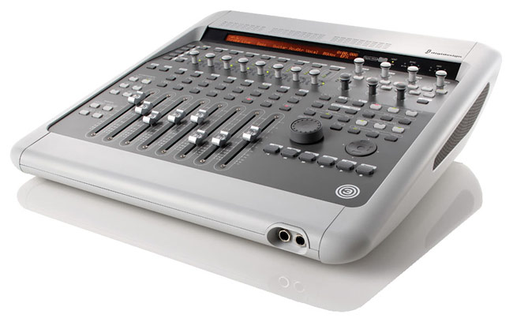

7. 003 Rack
$1,000

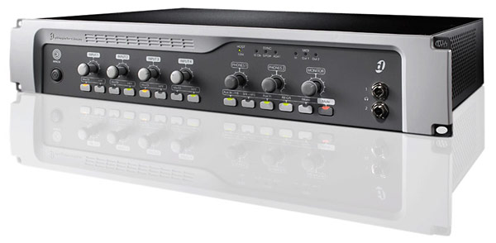

Specs for Digi 003 Rack and Factory:

Mic Inputs: Four balanced XLR jacks
Mic Phantom Power: 48V
Line Inputs: Four balanced 1/4" jacks
Aux Inputs: Two balanced 1/4" jacks
Line Outputs: Eight impedance balanced 1/4" jacks
Monitor Outputs: Two impedance balanced 1/4" jacks
Supported Sample Rates: 44.1, 48, 88.2, 96 kHz
Maximum Word Length: 24-bit
S/PDIF: 2-channel optical or RCA jack pair
Digital Optical: TOSLINK (ADAT, max 48 kHz sample rate)
Word Clock: Two BNC jacks
Host Connection: Two IEEE-1394a (FireWire) ports
MIDI: 5-pin MIDI DIN connectors - one input, two outputs

