025:251 COMPOSITION: ELECTRONIC MEDIA II
Spring 2011
Envelopes in Max/MSP

1. The general types of envelopes in electronic music shown below will be discussed in class.
a. Amplitude envelope
b. Pitch envelope
c. Filter envelope
d. Many parameters in electronic sound generation and transformation can be continuously changed over time.
One term for this is the envelope.
e. Because there are many possible applications of the envelope model in electronic music, Max/MSP has a
Function Graph object that can be used in a wide variety of situations.

2. To use the filter graph, find its icon in the palette and place it in the patcher window. The function graph icon is
shown below on the left. It appears in the patcher window as shown below on the right.

3. The function graph uses certain mathematical terminology in its operation, as discussed below.
a. The x axis is horizontal. It often represents time. This time is expressed in milliseconds.
b. The y axis is vertical. It usually represents the value, amount, depth, or range of a given parameter. This value
is expressed as a floating number.
c. These designations of x and y are sometimes called by mathematicians the domain and the range of a graph.
d. The x axis is sometimes called the domain.
e. The y axis is sometimes called the range.

4. The example on the left shows how an amplitude envelope can be constructed.

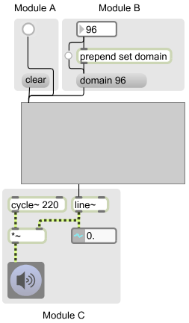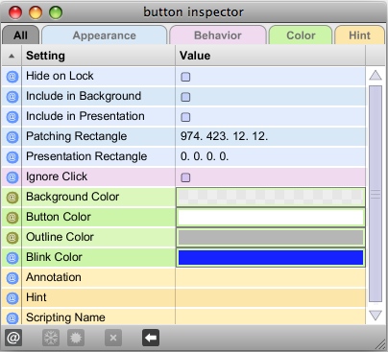

a. There are three groups of objects in this patch called Modules A, B, C. The background panels are used only as a
visual aid in this presentation and are not necessary in the actual patch itself.
b. Module A patches a bang button and a “clear” message into the left inlet.
c. Module B uses a number box to control the domain or length of the envelope. The number box can either be set
by typing or scrolling to a value, or can be produced by the selection of one of several message boxes, as well as
by a random or algorithmic method.
d. Other elements of the module will be discussed in class.
e. Module C consists of a 220 hz sine wave sent to a signal multiplier (*~), then on to the dac or EZ-dac.
f. The second outlet of the graphis patched to the left inlet of line~. This passes the string of values produced by the
envelope to the line~, which are in turn sent to the signal multiplier to control the amplitude of the sound in time.
g. The values received by the line~ object are also passed to the number~ object directly below. As discussed in a
previous class, this can be created by typing “number~” into an empty object box. Optionally, the icon number~ object in the palette can be dragged into the patcher. The icon looks like the one below:

5. The inspector in the upper right example shows how the bang button in Module B is modified.
a. The Patch Rectangle feature consists of 4 numbers. The first two show how the object is positioned in the
patcher window, which need not be considered here. The second two numbers show the size of the bang
button, which is here much smaller than the default size for visually aesthetic reasons.
b. The Blink Color has been changed from yellow to blue, also for visually aesthetic reasons.
c. The look of this bang button is different from a default bang button, indicating that this particular bang button
does not function in the usual manner. Instead it simply triggers the message box below, as discussed in class.

6. To create an envelope, do the following.
a. Click to add a starting point. As will be discussed in class, it is difficult to click on 0 x 0. A solution is to click
anywhere in the graph, then drag it to the beginning, as shown below.
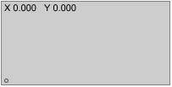

b. Add new points by clicking and dragging them to the desired locations, as shown below.
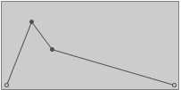

c. To remove a point, shift-click on it.

7. The graph can be re-sized in an unlocked patcher by grabbing it in the lower right corner and moving, as shown
below.

8. To make the time of the domain, changed the number box shown in Module B in Item 4, above. Note that the edit
points do not move, as shown below.

