025:251 COMPOSITION: ELECTRONIC MEDIA II
Spring 2011
Frequency and pitch in Max/MSP

1. Patch 1 is shown below and will be discussed in class.

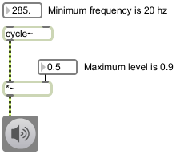

2. Patch 2 is shown below and will be discussed in class.

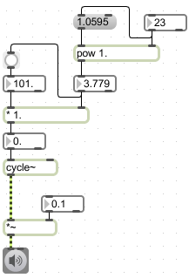

3. Patch 3 is shown below and will be discussed in class.

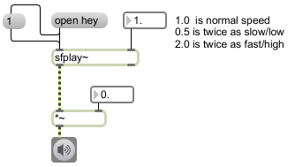

4. Patch 4 is shown below and will be discussed in class.

