025:251 COMPOSITION: ELECTRONIC MEDIA II
Spring 2011
Intro to AudioScore Ultimate

1. Relationship of AudioScore Ultimate to other software.
a. Avid is the parent company of Digidesign, Sibelius, and professional video editing software.
b. Sibelius comes bundled with AudioScore Lite.
c. AudioScore is made by Neuratron, a company not owned by Sibelius or Avid.
d. The relationship of software companies and products gives information about how well a product will be
maintained in the future, as well as how well is interacts with other software.

2. Purpose of AudioScore.
a. Change an audio signal into standard music notation, primarily pitch and rhythm.
b. The audio signal can be through a live microphone or line input, or from an audio file, such as aiff, wave, and
mp3.
c. After the audio signal has been captured by AudioScore, it presents it in pitch and rhythm notation.
d. The notated score can be played by MIDI instruments.
e. The notes can be edited.
f. The notes can also be represented as a sonogram termed “ultrasound”.
g. The notes can be saved in different formats, allowing them to be imported into Finale, Sibelius, and other music
notation software.
h. The notes can also be saved as a MIDI file, which can be imported into Pro Tools and Max/MSP, among other
programs.
i. Neither the audio, the notated score, or the ultrasound representation can be exported.

3. Some features of AudioScore Ultimate.
a. It transcribes audio to all pitches from F0 to C8
b. It transcribe individual notes from chords
c. Notes and rests can be as short as a 32nd note
d. Triplets and duplets can be represented (but I think triplets have to be created in edit mode).
e. Pitch and volume changes at a resolution of 0.01 seconds (10 ms)
f. Up to 16 instruments/notes can be represented at a time into multiple staves
g. Pitches are transcribed better than non-pitched and percussive sounds

4. Editing a transcribed score
a. Notes can be transposed, copied, cut, and pasted
b. Durations can be changed
c. A note can slide up or down in pitch by two semitones
d. Vibrato can be added to a note

5. The following steps show how to transcribe a soundfile.
a. Launch AudioScore from its icon in the dock, shown below

b. From the File menu, select “Open”, as shown below.
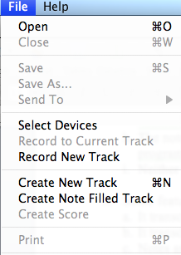
c. An open dialog will appear. Navigate and select the desired soundfile.

d. A window like the one below will appear.
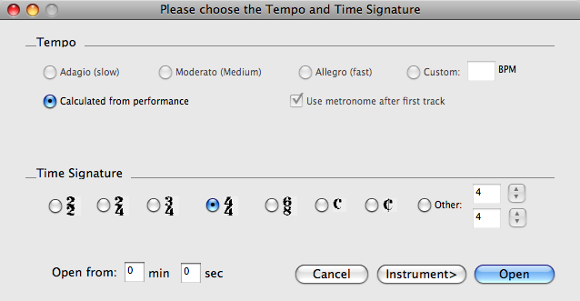
Note that tempo is set by default to “Calculated from performance”.

e. Click on “Instrument.” A window like the one below will appear.
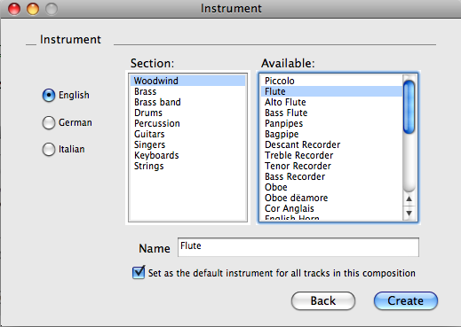
Select the desired instrument for transcription playback.

f. Screen activity shows the transcription process, at the end of which, a window like the one below will appear.
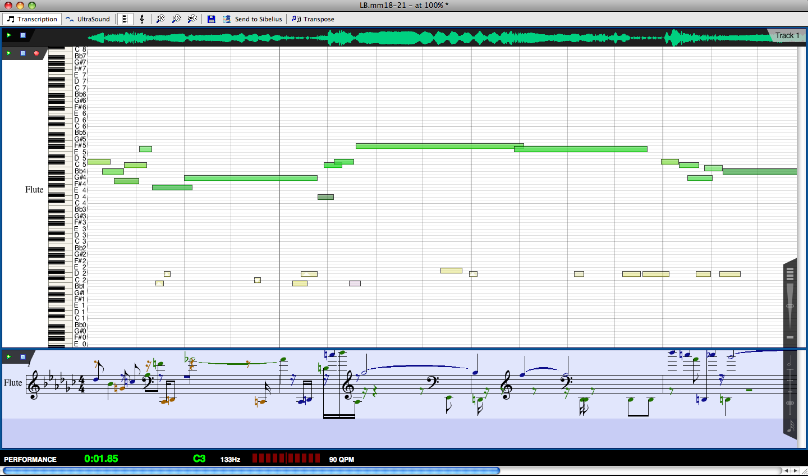

6. At the top of the screen, is a tool bar and an audio waveform, as shown below.
The play button on the left will play the original sounfile.

7. The “Performance Area” is shown below.
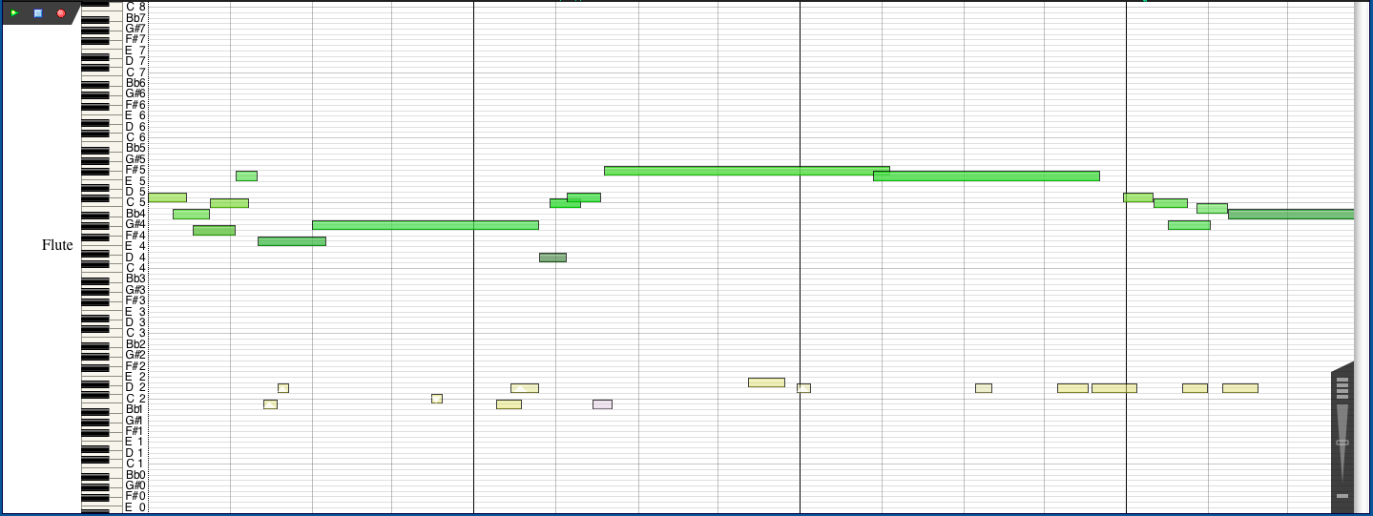
a. This piano roll notation represents every note transcribed.
b. The play button on the left will play the complete transcription by the instrument defined in Item 5e, above.

8. The “Score Preview” area is shown below.
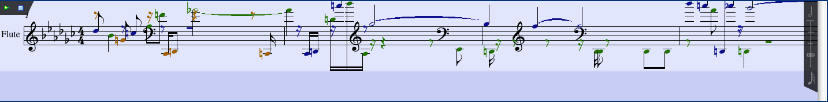
a. This notation shows pitches colored black, rust, and green. Colored notes are used in the 2nd, 3rd, and 4th voices
of the track. This will be discussed in class.
b. The play button on the left will play the notational intepretation of the track. This will be discussed in class.

9. The “Information Bar” is shown below.

10. On the right of the Performance Area and Score Preview Area are two controls, as shown below.
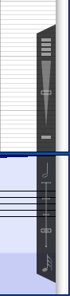

11. The top control governs the sensitivity (which appears to mean loudness) of the transcription, as demonstrated
below.
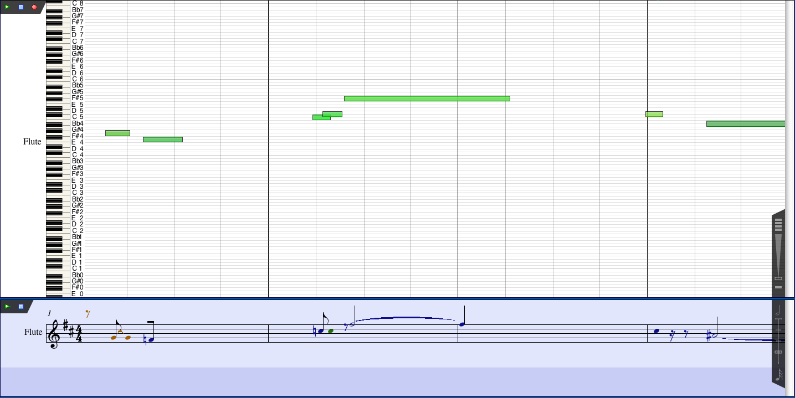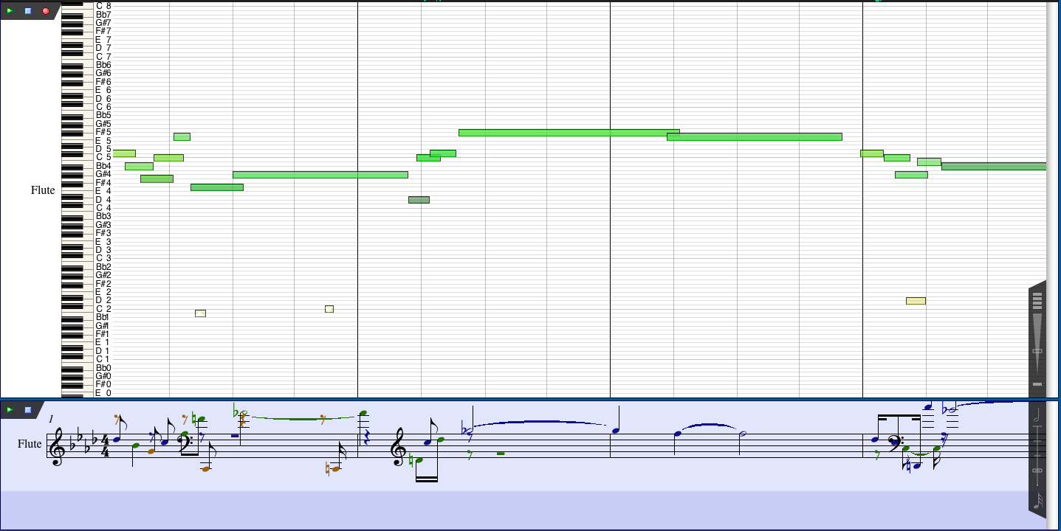

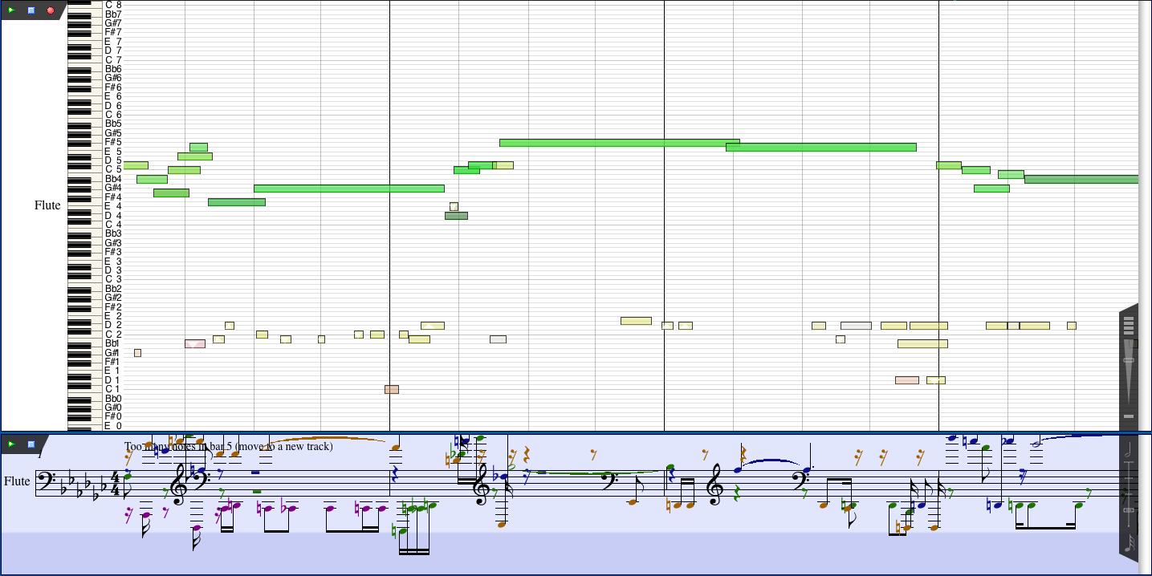
a. The images show the sensitivity at 0, 33, 66, and 100 percent.
b. The default value is 50%

12. The bottom control on the right controls the note durations shown in the Score Preview Area, as shown below.
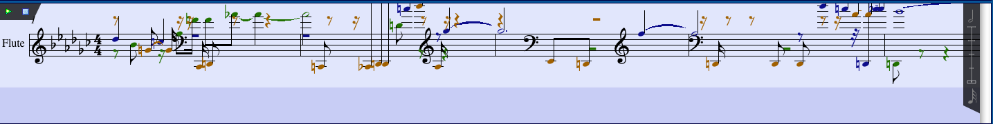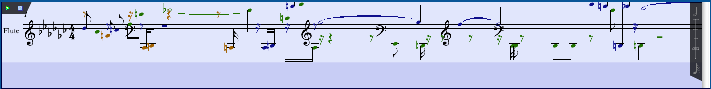

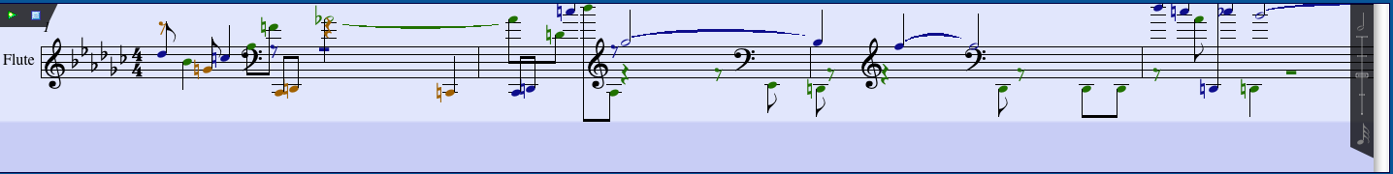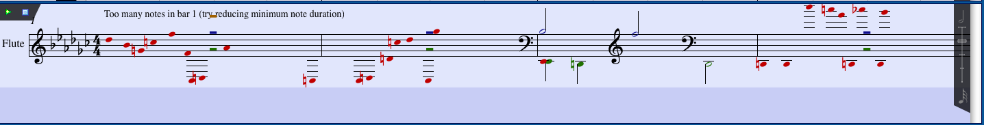
a. The images show the minimum note durations of 32nd, 16th, 8th, and quarter note values.
b. The default duration is the 16th-note.

13. A discussion on editing will be deferred for now.

14. The File>Save options are shown below.
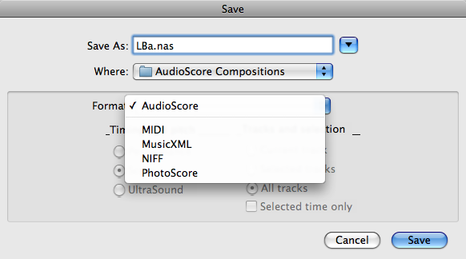

a. MIDI = Musical Instrument Digital Interface
b. MusicXML = Music Extensible Markup Language
c. NIFF = Notation Interchange File Format. Obsolete, replaced by MusicXML.
d. PhotoScore

15. To send the transcription to Sibelius, do the following.
a. From the File menu, select “Send to>Sibelius”, as shown below.
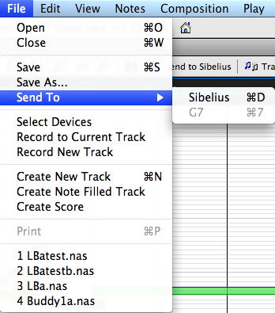
b. A window like the one below will appear.
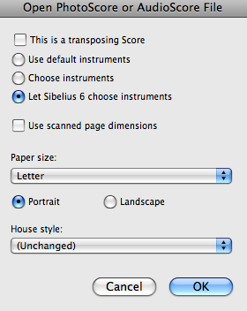
c. After selecting the desired attributes, click on OK. A score like the one below will be opened in
Sibelius.
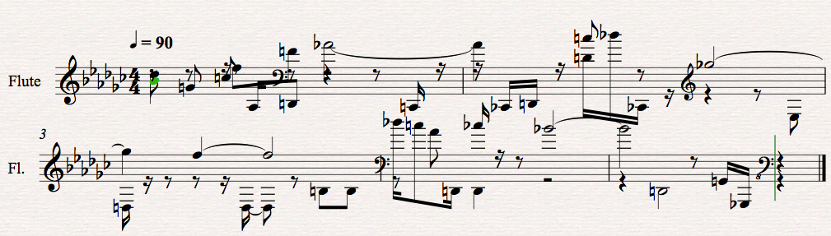
d. Obviously, the score needs to be edited either in AudioScore and/or Sibelius.

16. A score can be created in AudioScore as follows.
a. From the File menu, select “Create Score”, as shown below.
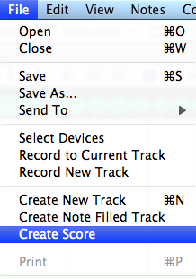
b. A score like the one below will open in AudioScore.
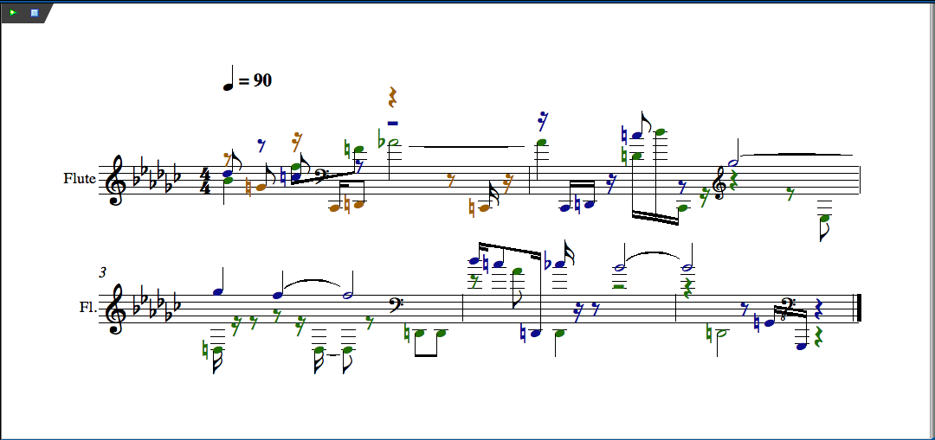

17. Other features of AudioScore will be discussed in class.

