025:251 COMPOSITION: ELECTRONIC MEDIA II
Spring 2011
The Line~ object in Max/MSP

1. The patch below shows how values sent to *~ can be sent in sequence to create a smooth line.

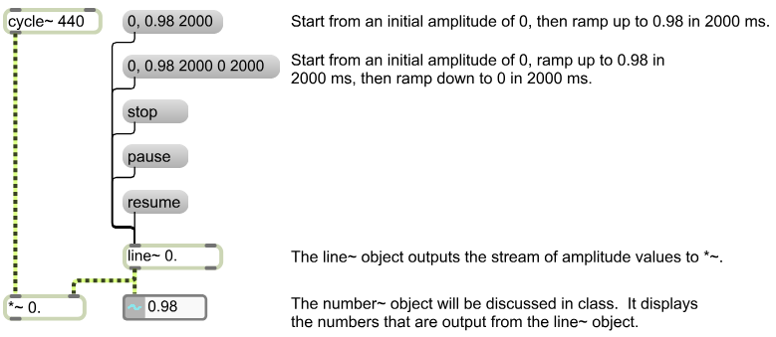

2. The cycle~ object below has an attack-release envelope.

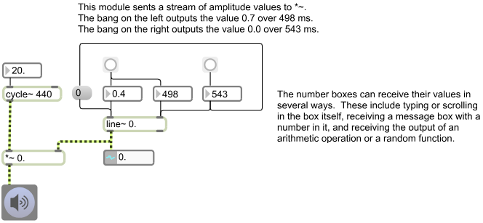

3. Consider using a line~ like the one in Item 2, above, to algorithmically soundmine a live instrument during a
performance.

