025:251 COMPOSITION: ELECTRONIC MEDIA II
Spring 2011
Live Input in Max/MSP

1. A live input, usually from a microphone, is set in the DSP Status window, as shown below on the left.
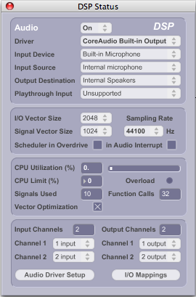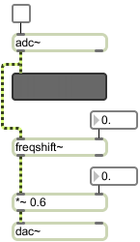

a. The signal enters the patcher through the adc~ object like the one above on the right, or by using the adc~ icon from the palette.

b. Both the adc~ and the dac~ are turned on together. This can be down either with a toggle switch patched in the
upper left inlet of either object in the window, or by clicking once on either’s icon.

c. It is advisable to patch the outlet of the adc~ into a meter like the one above. This allows you to monitor the
signal visually.

d. A very easy-to-make, yet interesting sounding processing effect is a ring modulator. A ring modulator applies
a sine wave at n hz in order to modulate it. This sine wave is called a modulator. At frequencies lower that the
threshold of human hearing, 20 hz, the effect is akin to a vibrato. As its frequency increases, the modulator
creates added frequencies called upper sidebands. These sidebands sound somewhat like out-of-tune
harmonics. As discussed in class, out of tune harmonics are a chief characteristic of metallic objects, like bells,
large metal bars, sheets of metal, and cymbals.

e. A ring modulator can be applied to a live microphone signal using the freqshift~ object, patched in the manner
shown above on the right. A ring modulator is a very interesting process when applied to wind and brass
instruments, sometimes creating the effect of extended multi-phonics. Used injudiciously, it can make a spoken
voice sound like Darth Vader.

2. A mic signal can be recorded during a performance and played back at any point in the piece. This is explained below.
a. A memory location called a buffer needs to be created before recording.
b. The example below shows a buffer~ object.
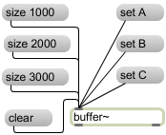

c. The message boxes “set A”, “set B”, and “set C” create buffers A, B, or C (these are not visible on the
screen). Only one buffer can be created at a time.
d. The size of the buffer is set by the message boxes “size 1000”, “size 2000”, “size 3000”.
e. The message box “clear” erases the contents of the active buffer.
f. Instead of using message boxes like the ones above to set the size of the buffer, a module like the one below
can be used.

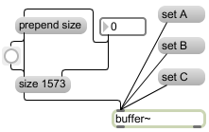

g. Here, the number box sets the size and the prepend object adds the word “size” before the value.

4. The buffer~ help window shows how to:
a. Read an existing aiff file
b. Write the buffer to an aiff file

5. The example below shows how a live mic signal can be recorded to a buffer.
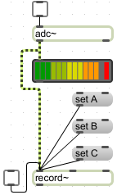

a. Here, the mic signal passes through the adc~ and into the record~ object on the bottom.
b. The desired buffer is selected by triggering one of the “set A”, “set B”, set C” objects that are connected to the left inlet of the record~ object.
c. The toggle starts and stops the recording.

6. The recording can be viewed viewed by double-clicking on either the record~ or buffer~ object. The waveform
will be displayed in a window like the one below.
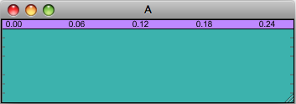

7. The module below shows how to play the buffer.
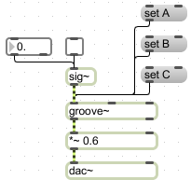

a. The “set A”, etc. message boxes select which buffer to play.
b. The sig~ object controls some aspects of the signal, and is patched into the groove~ object.
c. The toggle patched into sig~ starts and stops playback.
d. The float box patched into the sig~ object controls the speed and direction of playback.

8. Other considerations.
a. How and when to trigger all of these events?
b. Create a second voice of the live instrument?
c. Sound-mine in real time?
d. Apply an envelope or fades in/out to the buffer?
e. Discussion of cliches.

