025:251 COMPOSITION: ELECTRONIC MEDIA II
Spring 2011
Recording Soundfiles in Max/MSP

1. A patch for recording to a soundfile is shown below.

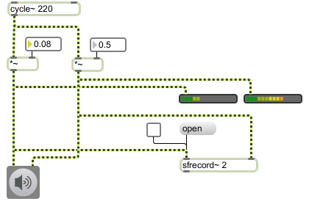

2. To record, do the following.
a. Turn on the dac.
b. Confirm that audio is reaching the meters.
c. Click on "open". Name and save to the desired location.
d. Turn the toggle to start recording.
e. Turn off the toggle to stop recording.
f. To make another soundfile, repeat all of the above steps.
g. Note that after the toggle is turned off, the soundfile cannot be overwritten.

