025:250 COMPOSITION: ELECTRONIC MEDIA I
Fall 2012
Edit Window in Pro Tools

1. Normalizing is a very important function in audio mixing. Consider the issues below.

2. One way of thinking about combining regions in the edit window is analogous to early classical orchestration,
where instruments were added together to control loudness. If you want a big sound, you don’t turn up the
volume, you combine different colors.

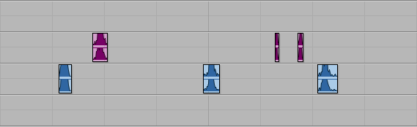

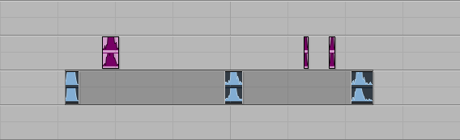

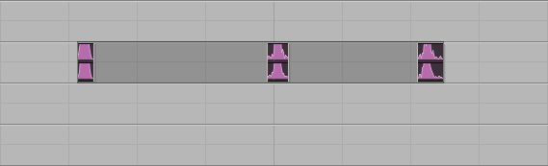

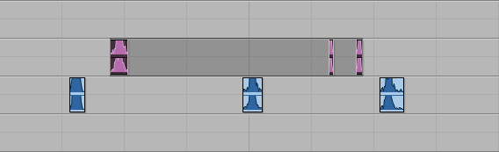

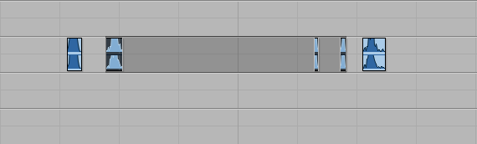

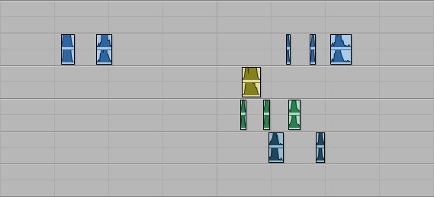

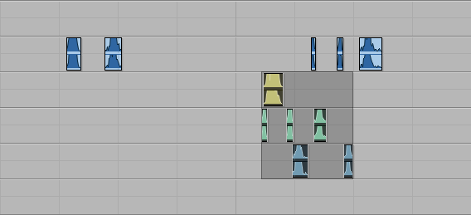

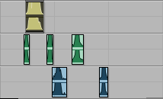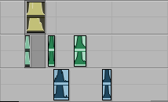

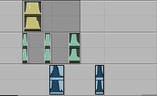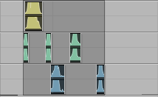

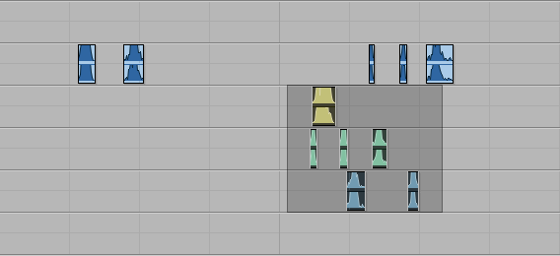

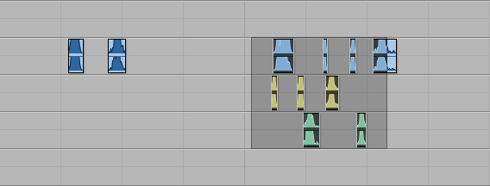

To copy and paste, first select regions to copy:
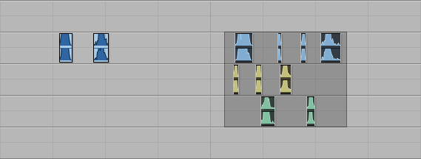

To paste, click where you want the copied regions to go. Notice that the cursor is only on a single track.
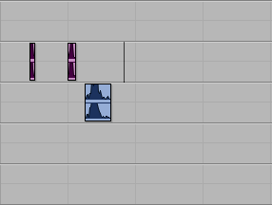

This pastes regions only from the higher track.
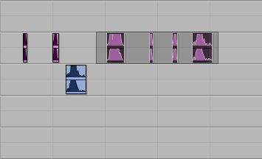

This selects 3 tracks.
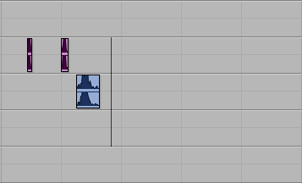

Another method is to draw a small portion of the target area:
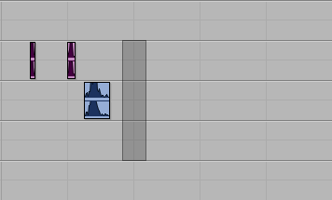

Oh-oh. This pasted the entire selection area. We need to paste the precise regions.
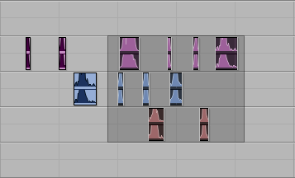

Ah, better:
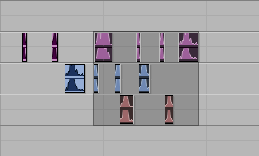

Options Menu:
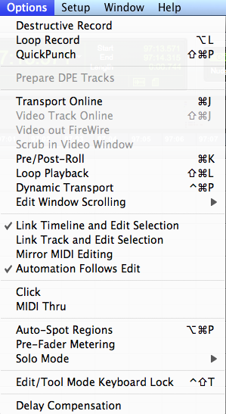

Automation issues.

If

+12.0 db (D+26.0 db)

Delta goes up to +156 db and down to –156.0 db

N. When time expanding a region, the automation does not expand with it. Below is an example.
a. Here are the regions in waveform view:

b. Here are the regions in volume automation view:

c. Here are the regions in left pan view:

d. Here are the regions in right pan view:

Notice the sharp jumps in right pan automation levels. This will create a click, but a faint one.
e. Here is a bounced stereo file of this:
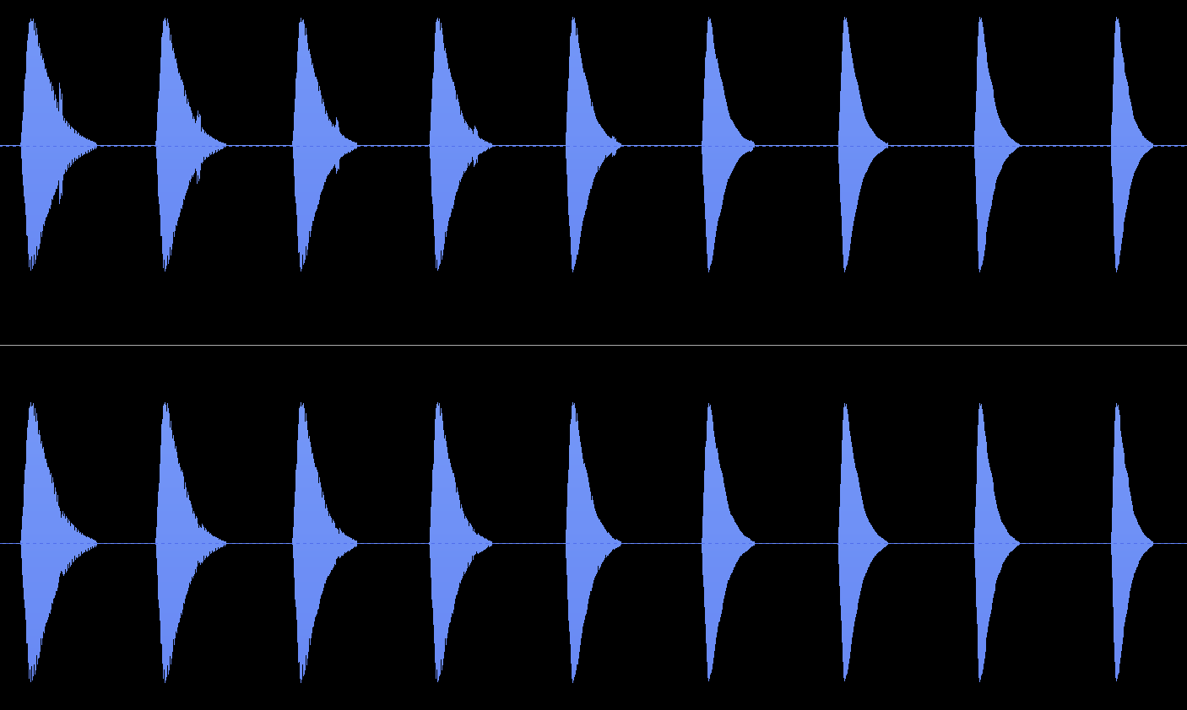

Same problem with reverb.
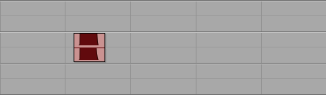

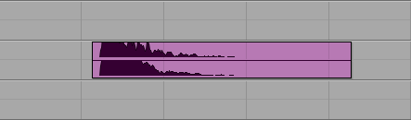

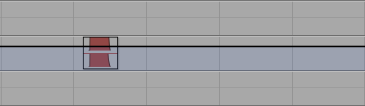

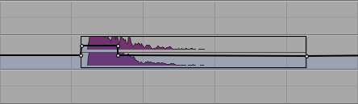

Step 1. Original section. (Note that I moved some regions for cosmetic reasons after I made the changes below.)
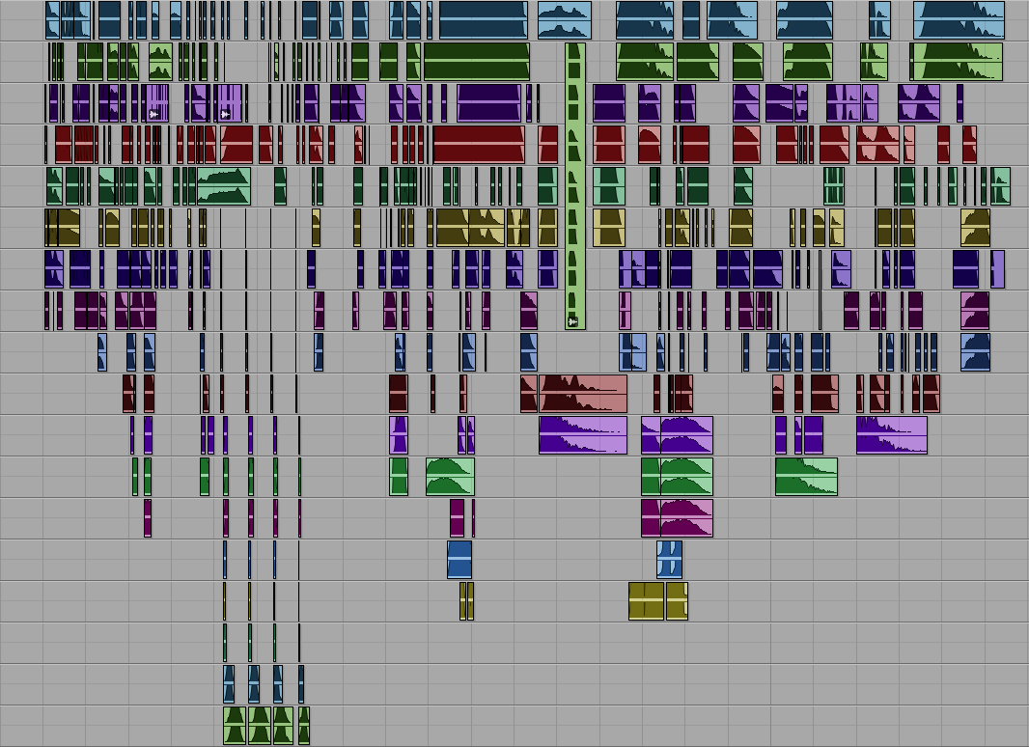

Step 2. The original now has many regions cut out. The ones shown below will be used for reverb.
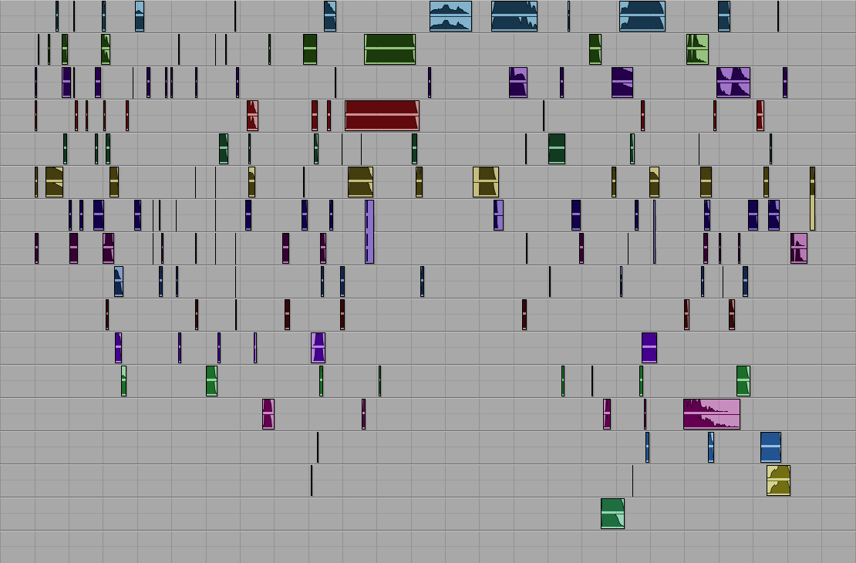

Step 3. Reverb has been applied in one pass.
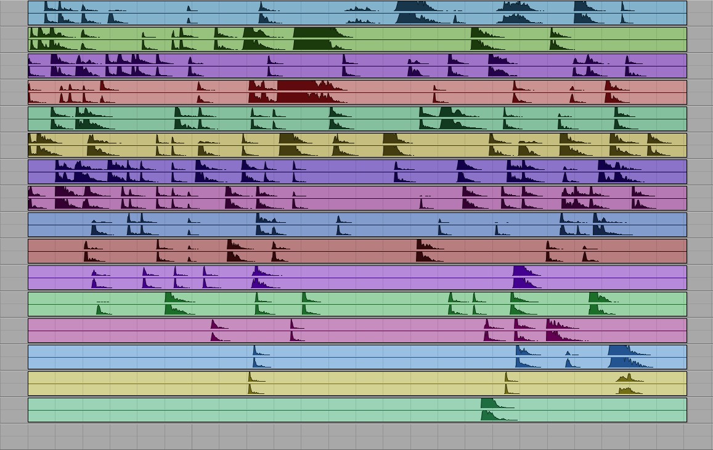

Step 4. Silences have been cut out.
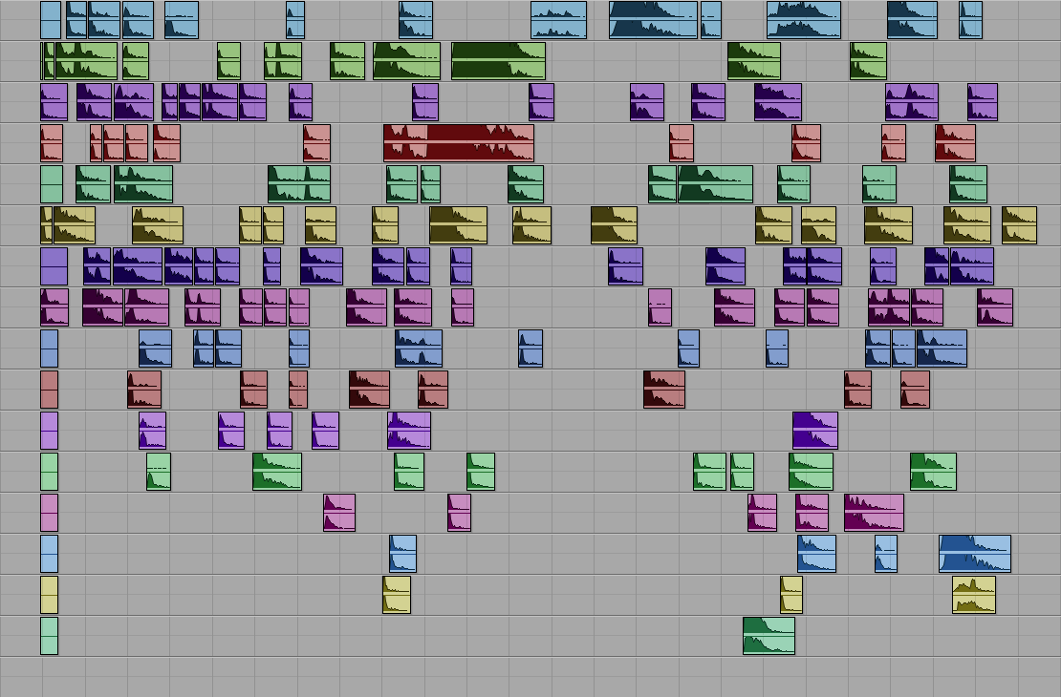

Step 5. Regions have been consolidated into 4 tracks. More regions have been cut out.
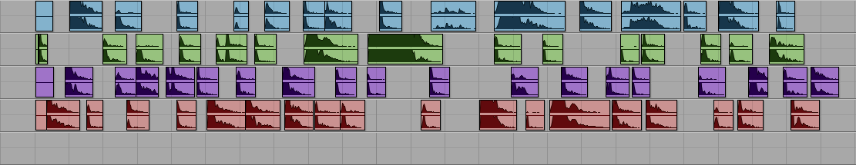

Maxim:
- Do it as little as possible.
- Do it only when necessary.
- Conserve your energy.
- Do it as little as possible to create the effect that you have done it with everything.

Plug-ins affect only the highlighted regions and parts of regions.

Below is an untransformed region.
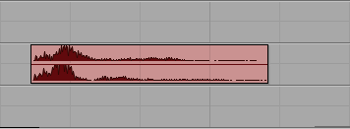

Here, the second half of the region has been highlighted.
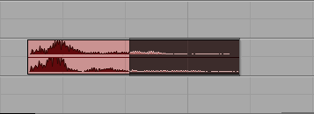

Here, the second half of the region has been normalized.
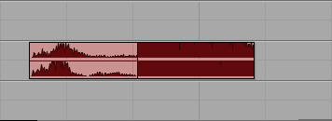

Here, the normalized portion of the region has been moved to the right, to illustrate that the normalized part of the region is actually a separate, independent region.
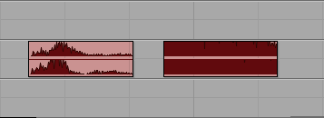

This principle applies to groups, as well. Here are 4 regions on 2 tracks.
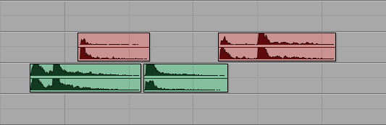

Portions of these regions are highlighted.
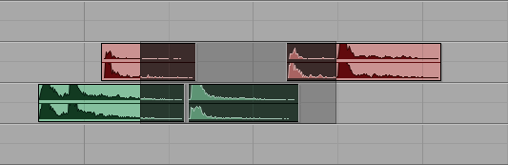

Below the highlight area has been turned into a group.
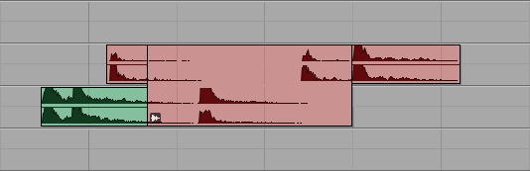

Here, the group has been moved to lower tracks. As can be seen, the 3 partially selected regions are left unchanged. The other track, which was completely highlighted, has become part of the group.
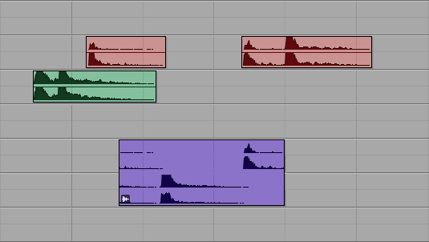

Automation issues. Double points.

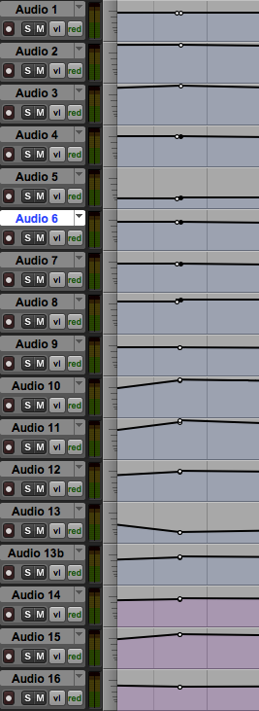 | 1
 | 2
 | 3
 | 4
 | 5
 | 6
 | 7
 | 8
 | 9
 | 10
 | 11
 | 12
 | 13
 | 13b
 | 14
 | 15
 | 16

2
1
1
3
3
3
3
3
2
2
2
2
2
2
2
2
2

X. Key command for moving a region:
a. Place the cursor where you want the region to go.
b. Hold down the control key and select the region.
c. The region moves left or right within its original track to the new location.

X. To constrain a region in the time domain from one track to another:
a. Select the region.
b. Hold down the control key and drag the region to another track at the same point in time.

X. To scroll to a specific edit window view, it can sometimes be difficult. Sometimes it seems as if a focal point is too far left, but when scrolled, then too far right. The solution is to place the cursor on the spot which should appear in the center of the window. Then, type cmd [ or cmd ]. This moves the focal point to the center, while also change the zoom, which is not the important thing. You can then zoom in the opposite direction to get back to the original zoom.

X. Since reverb washes and masks details, try these options.
a. Add reverb to the tail of a sound. This will prevent the details in the attack from becoming smeared.
b. When adding reverb to a chord where each note is in a separate track, apply it to only 1 track, or as few as
possible to produced the effect.

X. Concepts of reverberation.
a. Reverb extends the length of the note.



