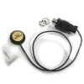
Tyler Mountain Contact Mic
http://www.amazon.com/gp/product/B0017VQXKC/ref=oh_details_o03_s00_i00

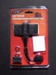
Red Contact Mic
http://www.amazon.com/gp/product/B0044KI7DO/ref=oh_details_o05_s01_i09

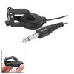
Cherub Contact Mic
http://www.amazon.com/gp/product/B004UJO41S/ref=oh_details_o05_s01_i10

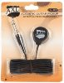
AXL Guitar Contact Mic
http://www.amazon.com/gp/product/B002C741B8/ref=oh_details_o05_s01_i11

