025:250 COMPOSITION: ELECTRONIC MEDIA I

Fall 2013
Gesture Sets

How to use cyclic permutations

1. Arrange the regions in a manner similar to the example below:
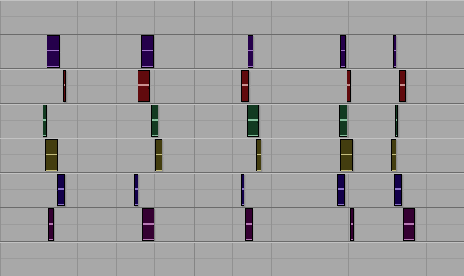
- Each grouping of regions will be called a gesture.
b. The 5 gestures above will be called Gesture Set 1.

2. Copy and paste Gesture Set 1 to the right, as shown below.
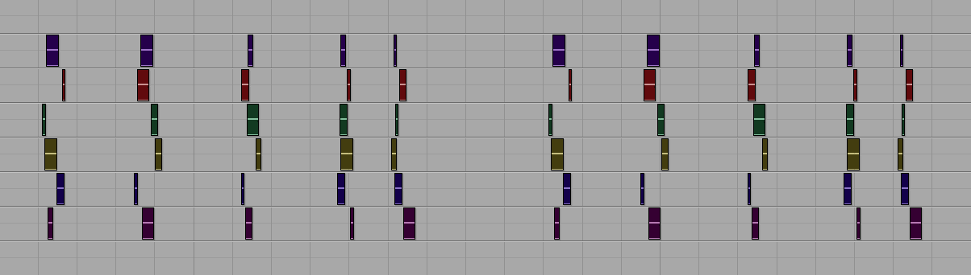
a. The gestures on the right will be called Gesture Set 2.

3. Transpose the regions of Gesture Set 2 as follows:
a. Tracks 1-2 by +2 semitones.
b. Tracks 3-4 by +4 semitones.
c. Tracks 5-6 by -1 semitone.
d. Alternatively, you could transpose by different intervals on any number of tracks.

4. Drag the individual regions in Gesture Set 2 to cyclically permute them as follows:
a. The regions in Track 1 rotate 1 space from right to left.
b. The regions in Track 2 rotate 2 spaces from right to left.
c. The regions in Track 3 rotate 3 spaces from right to left.
d. The regions in Track 4 rotate 4 spaces from right to left.
e. The regions in Track 5 stay in place.
f. The regions in Track 6 rotate 1 space from left to right.
g. When moving the regions, the precise placement of each one should be artistically made.
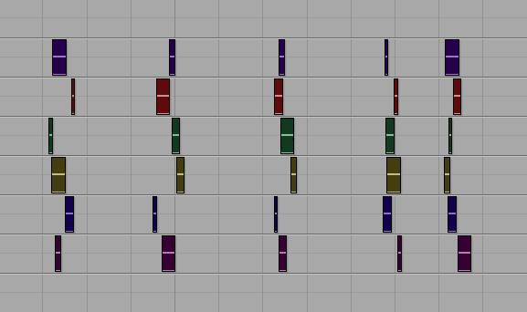 | 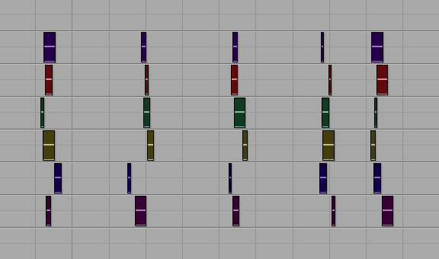 | 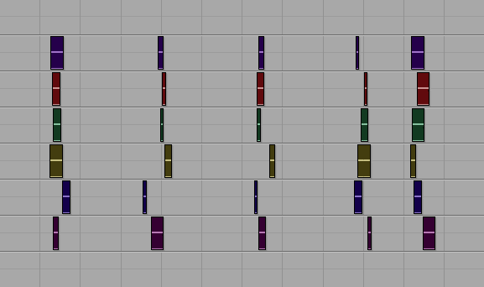 | 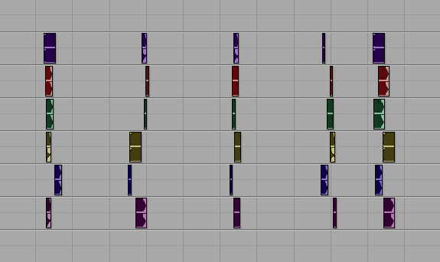 |  | 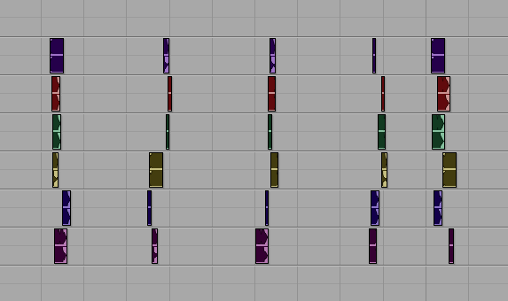
a | b | c | d | e | f

5. To create Gesture Set 3, do the following:
a. Copy and paste Gesture Set 1.
b. Cut the last column, so that there are now 4 columns, instead of 5, as shown below:
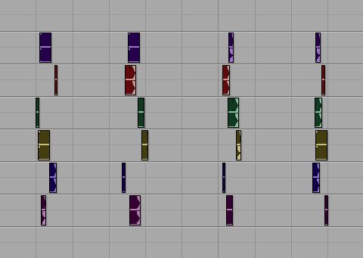

c. Transpose Tracks 1-3 by +1 semitone.
d. Transpose Tracks 4-6 by -2 semitones.

6. Drag the regions in Gesture Set 3 so that the regions in Tracks 1-3 in Columns 1-2 and interchanged with those in
Columns 3-4, as shown below.
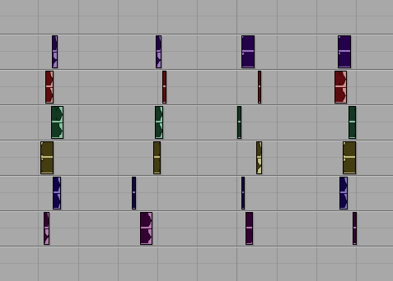

7. To create Gesture Set 4, copy and paste Gesture Set 2, then apply the same procedures in Items 5-6, as shown below.
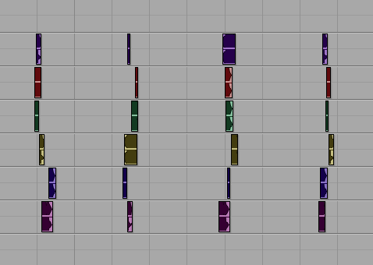

1. Consider the compositional implications of each sound.
a. Does one category of sounds work well if none of the others are used?
b. Do 2 or more categories work well together?
c. Does one

1. Beginning a piece.
a. In media res
b. Drip, drip
c. Motivic or thematic
d. Sound-mass
e. Soft, then grows louder
f. Jarringly loud
g. Motorism

2. Ending a piece.
a. Rousing conclusion
b. Return to original material
c. Decelerate
d. Fritts-style

a

b

c

d

e

f

