Composition: Electronic Music I
025:250
Fall 2013
Normalization in Pro Tools

1. Normalization is a very important housekeeping technique that should be applied in nearly every step of the way when composing in the electronic medium. When recording, obviously some sounds will be louder and some softer. When these are soundmined to be used in different contexts, this amplitude variation can be detrimental. With normalization all soundmined material will be at the same amplitude, an ideal situation to prepare for later transformations.

2. In this group of soundmined material, it is clear that some sounds are softer than others:
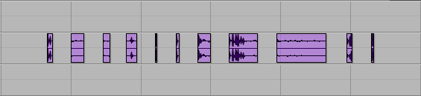

3. Select all of the audio and go to Audio Suite > Other > Normalize:
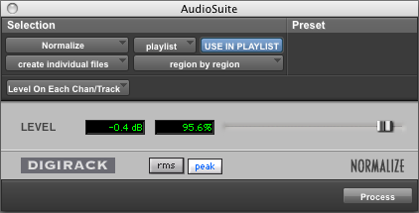

a. Note that “create individual files” is selected. This will maintain individual soundmines. If “create continuous track” were selected instead, then the eleven regions shown in number 2 would be consolidated into one region.
b. Note that “region by region” is selected. This is selected so that the level of normalization is applied to each region independent of the amplitude peaks of other regions. If “entire selection” was selected instead, normalization would be based on the loudest peak of the eleven regions and our softer regions would remain relatively softer to the louder regions.
c. Set the level around 95% to ensure there will be no clipping.
d. Click Process and compare the image below with the image from number 2:

4. Normalization will ensure that all of your audio maintains a baseline, volume consistency. You will most likely use volume automation to adjust for balance and volume control.

