025:250 COMPOSITION: ELECTRONIC MEDIA I

Fall 2013

Pro Tools Overview

1. Multi-track DAWs
a. Pro Tools history
b. Other DAWs: GarageBand, Logic, Digital Performer, Reaper

2. Interfaces
a. Digidesign interfaces: Digi-001 to 003, M-Box series
b. Other interfaces: MOTU and Metric Halo

3. Audio sample rate and bit-depth
a. Sample rate definition
b. Bit depth definition
c. Standard formats

4. Editing and Mixing in Pro Tools
a. Destructive and non-linear editing
b. Soundfiles and regions

5. Edit Window 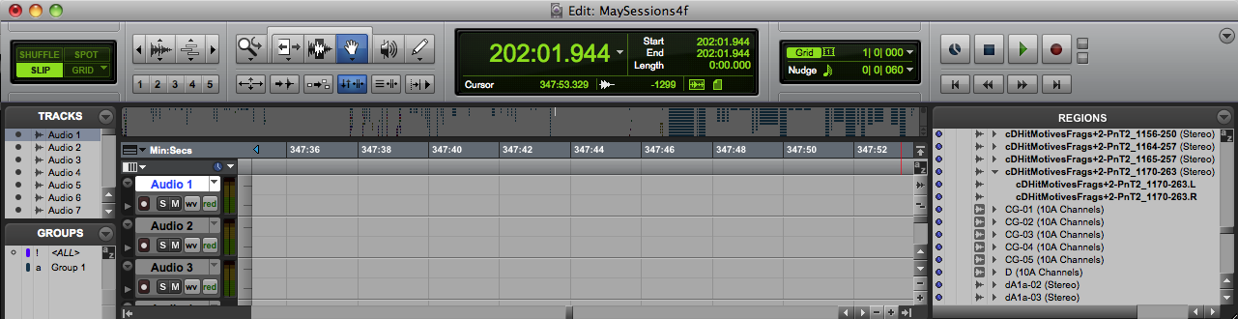
a. The top panel consists of track mode buttons, zoom buttons, edit tools, counters and edit selection indicators, grid and nudge value selectors, and transport controls.
b. Directly beneath these icons, is the universe overview, similar to the overview in Peak.
c. Underneath the universe view are time markers and rulers.
d. On the far left, are the Tracks List and Groups List. This column can be hidden and resized at the bottom of the window.
e. To the right of these lists, are the track controls.
f. To the right of the track controls are the track playlists; in class, this is referred to as the edit window.
g. On the far right is the region list. This column can be hidden and re-sized.

6. Region List
a. All audio files, regions, and groups are found in this list.
b. Audio soundfiles are displayed in boldfaced font.
c. Stereo files consist of 2 mono files, denoted L and R.
d. When an audio file is edited, it is displayed in plain font text.
e. Audio files and non-audio edits are called regions.
f. When a non-audio region is processed with a plug-in, it becomes an audio file. Appended to such a file is an abbreviation of the type of process or plug-in operation that created it.
g. Regions can also be grouped, as seen in the list and discussed in class.

7. Window Control
a. Re-sizing the window.
b. Scroll bars.
c. Horizontal zoom key commands are cmd] and cmd[, the same as Peak.
8. Tracks and Regions in the edit window are discussed below.
a. Shown below are regions organized in tracks.
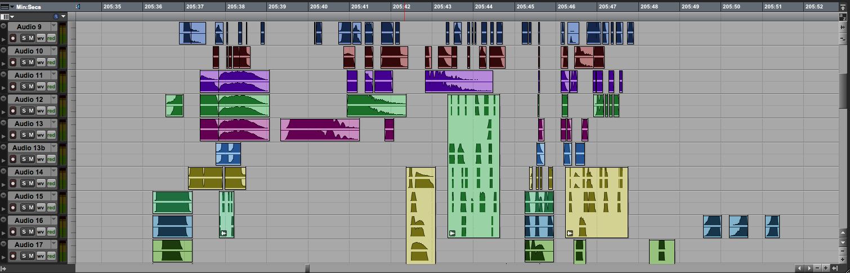
b. Notice that some regions are grouped together, which makes moving gestures, motives, and phrases easier.
c. Consider that a group can be pitch-shifted together as a unit, or the individual tracks can be pitch-shifted independently.

9. Track Automation
a. Shown below are the automated volume controls for the regions above in Item 4a.
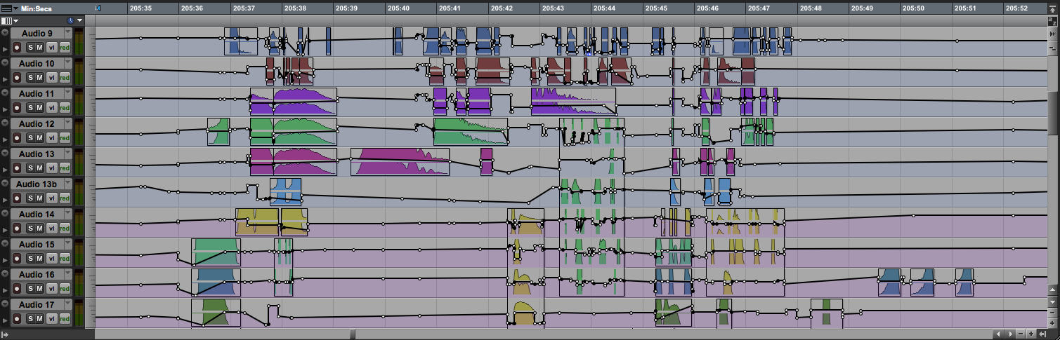
b. Below are the automated controls for left panning.
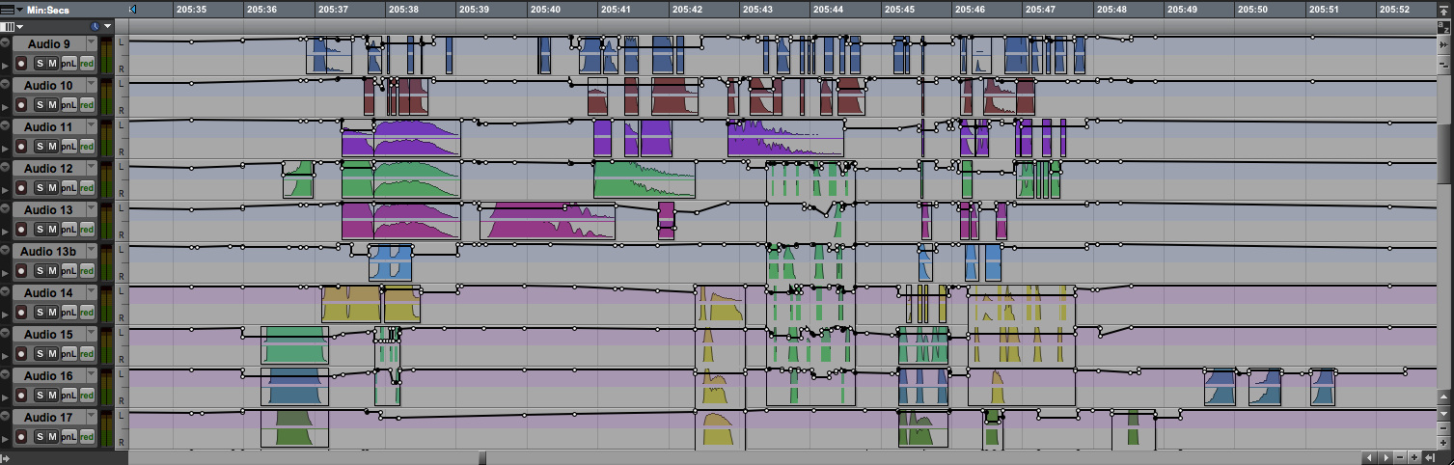
c. Below are the automated controls for right panning.


