025:250 COMPOSITION: ELECTRONIC MEDIA I

Fall 2013
Selecting Multiple Regions

1. To select 2 regions in the same track, do the following.
a. Click on the region on the left.
b. Hold down the shift key.
c. Click on the region on the right.
d. Notice that both regions are highlighted, as well as the empty space between them, as shown below.
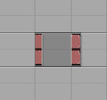
e. Another method is to click on the region on the left, hold down the shift key, and drag the cursor to the right, until
the second region is highlighted.
f. It often is not necessary to highlight the regions precisely. A quicker method is to click to the left of the first
region, hold down the shift key, and drag the cursor to the right, until the second region is highlighted.
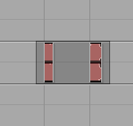

2. To select 2 regions in different tracks, do the following.
a. Click on the region in the lower track.
b. Hold down the shift key.
c. Click on the region above.
d. Notice that both regions are highlighted, but not the empty track between them, as shown below.
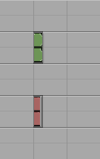
e. Another method is to click to the left of the bottom regions, hold down the shift key, and drag the cursor up to the
top region, until it is highlighted, as shown below.
