025:250 COMPOSITION: ELECTRONIC MEDIA I

Fall 2013
Convolution in SoundHack

1. Convolution is a process that can take a soundfile and mathematically process it with another soundfile. Used with
one two pitched sounds, the result can be something harmonically rich, akin to a multiphonic. A program called
SoundHack does this very well. The following explains what to do.

2. Open one of the soundfiles you played in class today, and do the following:
a. Select a fragment that is fairly loud, with a duration of approximately 20 ms.
b. Copy and paste it to a new stereo file.
c. Normalize it and make sure there is no silence.
d. Don’t fade in or out.
e. Name it Imp1.

3. Find another soundfile with different characteristics, in terms of harmonicity and pitch register. Repeat Step 2,
above. Name the file Imp2. Keep doing this until you have 5-8 sounds of different harmonic content, pitch register,
and duration, within a span of 10-100 ms.

4. Find SoundHack in the dock, or on the computer somewhere.

5. Find SoundHack in the dock, it looks like the icon below:
a) Launch SoundHack from the dock.
b) Select a soundfile from File>Open. Two windows will appear.
c) The window below shows soundfile information.
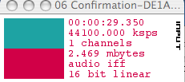

d) The window below shows playback information. Press spacebar to play; press return to stop.
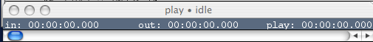

6. To use the convolution function, do the following:
- Open any soundfile you wish to convolve. These should be from Assignment 1.
- Select Hack>Convolution.
- A dialog like the one below will appear:
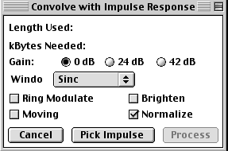
- Select the options shown above, then click on “Pick Impulse”.
- An open dialog will appear. Select one of the Imp files you created in Steps 2-3.
- Click on “Process”. A new file will be created named “file1 * file2”.

7. Open this file in Peak, normalize it, and evaluate it. Consider pitch-shifting it. If you like it, give it a name that can
be used to identify it in a meaningful way.

8. Try as many combinations of Imp files and soundfiles from Assignment 1.

