Composition: Electronic Music I
025:250
Fall 2013
Soundmining in Pro Tools

1. Create a new session in Pro Tools and begin with at least two stereo tracks. One track will contain the original audio from which we will cut from. The others will be the tracks you will paste into:
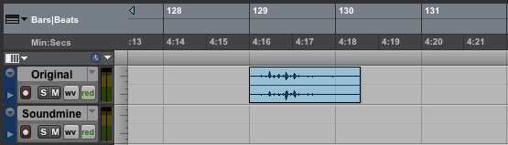

2. Using the Mins:Secs ruler as an aid (View > Rulers; “Minutes:Seconds” should be checked), zoom in (command ]) until the grid lines mark every second. As you work you may need to zoom in closer.
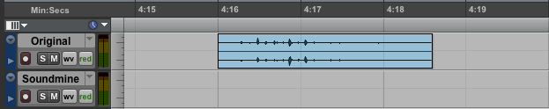

3. Soundmining is the technique of isolating events on a localized level. Below, I have selected a region that I want to soundmine:
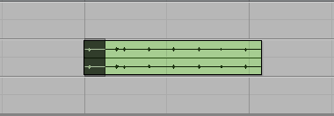

4. By click-and-dragging the little blue arrows at the top of the Edit Window (also known as “Timeline Selection Markers”), you can readjust and re-audit the selection until you satisfactorily localized the event you are after. In this example, I needed to slide both markers to the right so that the start marker was nearer to the attack and the end marker included the tail of the event:
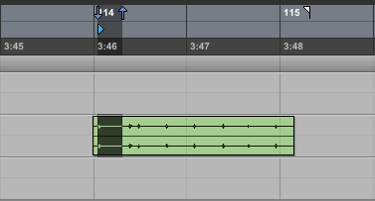

5. Now, cut-and-paste the selection to the track below. As you work, you may want to discard portions of audio that do not contain any desired events such as silence, chatter, etc.:
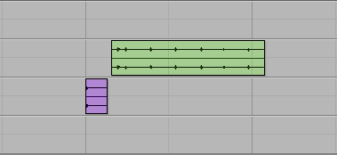

6. Next, we will normalize the extraction:
a. Select the region, then go to Audio Suite > Other > Normalize and set it to 98 percent, then click Process.
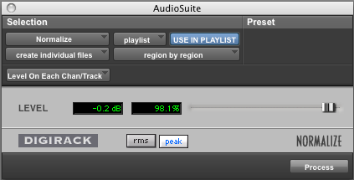

b. The audio region will look more like this after normalization (compare with item 5):
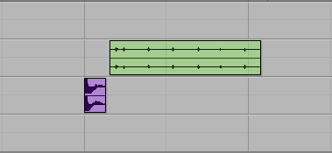

7. Because we cut the audio without due diligence of finding a zero, it is likely there are clicks at the beginning and ending of the region. To correct this, we can add fades into and out of the region:
a. Select the region, then go to Edit > Fades > Create (or, Command F), set your preferences, and click OK.
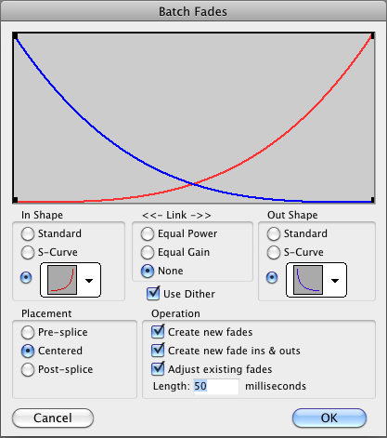

b. When we create fades, we triple the number of regions in our session: one for the fade in, the main region, and the fade out. Not only does this create unnecessary amounts of regions (especially as we will likely perform this technique on each extraction) it also creates a “Fades” folder which can be problematic if misplaced. In the zoomed-in image below, we can see the three regions marked by vertical lines:
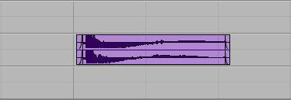

c. To solve the problems discussed in 7b, consolidate the three regions by going to Edit > Consolidate Regions, or Option Shift 3:
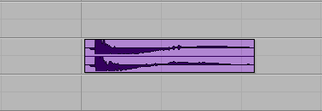

8. Repeat steps 3-7 until you have depleted the original audio of its resources. As you work, you may want to experiment with soundmining the extractions further.

9. Normalization often raises the gain of unwanted low frequencies (room noise, line noise, etc.), rendering audio muddy and boomy. However, this can be fixed using an equalization tool known as a Hi-Pass filter.
a. Select the muddy region and go to Audio Suite > EQ > Q1 Stereo, and under the drop down menu “Type” select Hi-Pass:
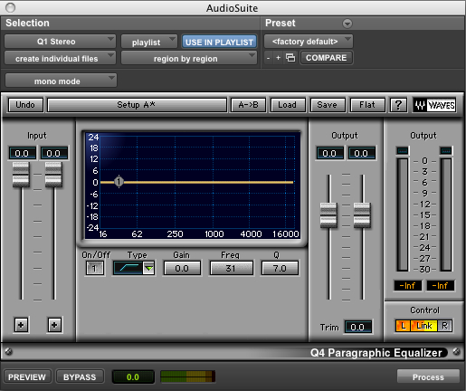

b. Either by preview—recommended—or intuition, slide the node labeled “1” left or right. The more to the right the node is slid in a Hi-Pass filter, the more of the original character of the audio is altered, especially if slid passed the fundamental of the sound source. Use your ears and avoid crossing that threshold.
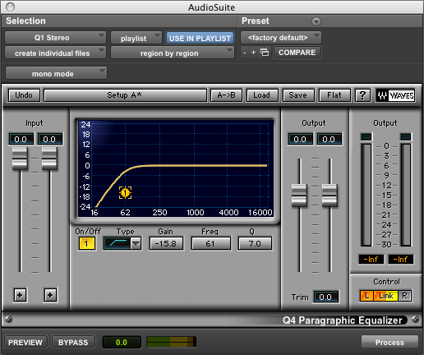

c. Use a Lo-Pass filter or Band-Pass to get rid of hiss. This can be selected in the same Q1 Stereo window under Type. Analogous to the Hi-Pass filter, the more left the node is moved in Lo-Pass filtering, the more the original character of the audio will be altered:

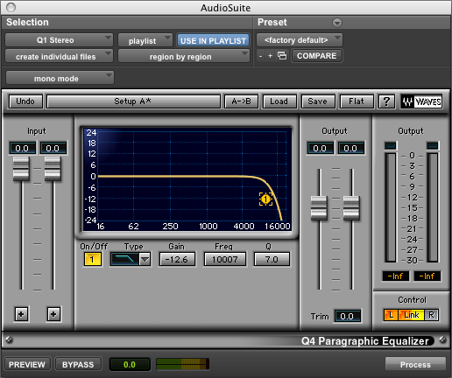

10. Any time you use a filter in this way, you are subtracting audio signal. Therefore it is important to re-normalize your filtered audio.

10. After re-normalizing, you may find that there are still noisy aspects to your audio. Either repeat steps 9-10, or you may want to use the iZotope RX 2 Denoiser plug-in. This plug-in works beautifully, but only if used with care.

11. iZotope RX 2 Denoiser works best when “taught” what to subtract from the signal. In order for iZotope to “learn” what to subtract, you must select an area within the region that is just noise and does not contain any audio from the sound source (including decay). The greater duration of noise you are able to select the better, as iZotope will create an increasingly accurate profile to subtract.
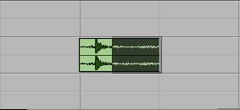

12. In the image above, I made certain none of the source bled into the selected area. Now, go to Audio Suite > Noise Reduction > iZotope RX 2 Denoiser:

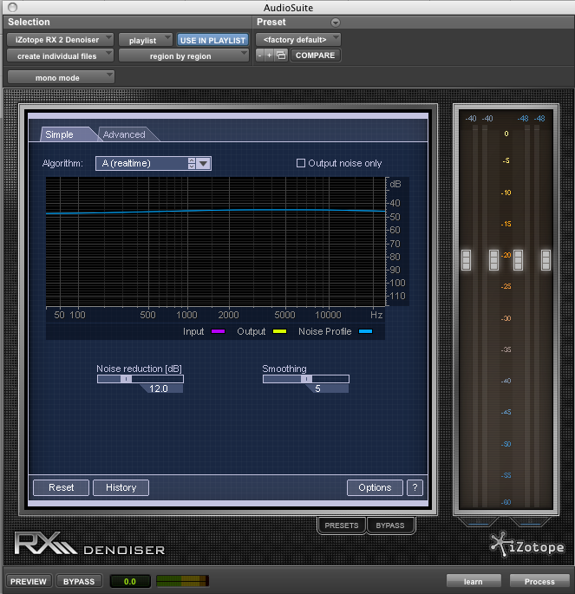

13. In the lower right corner click on the “learn” button and a noise profile is created:
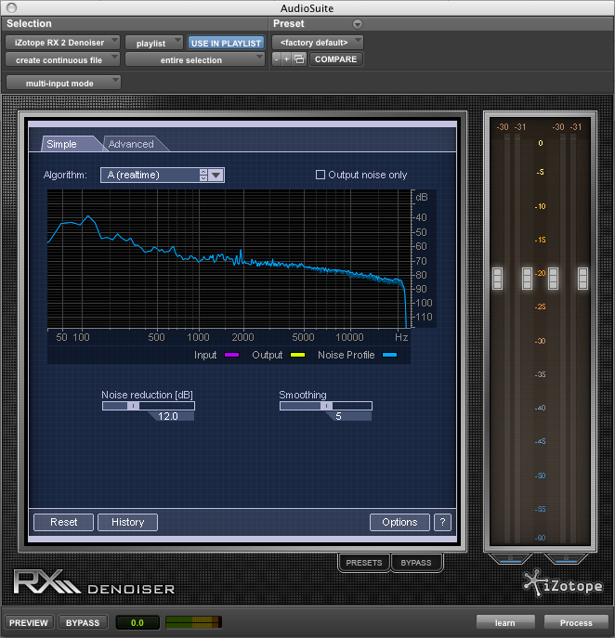
14. Now select the entire region. If you click process at this point, iZotope will do a decent enough job. However, like with Q1 equalizer, you may get better results by clicking “preview” and sliding the “Noise reduction (dB)” slider left and right discriminately, listening for the noise to dissolve away:
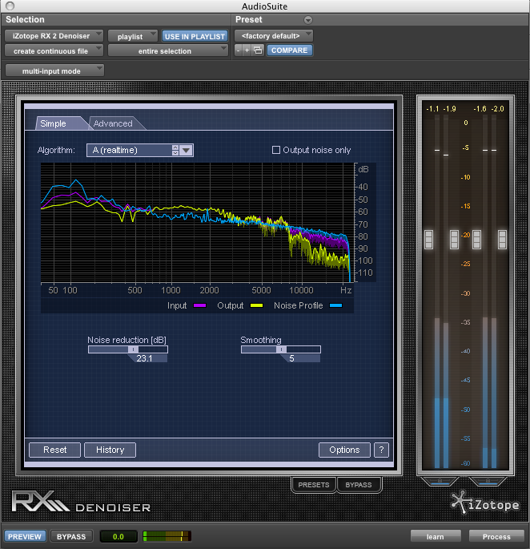

15. Once you find the noise adequately subtracted, click process. The region should be pristine now. Compare the wave file here with the image below 11:
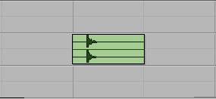

16. Because iZotope works best when used in this particular way, you may find it too cumbersome to use as frequently as you might Q1. If this is the case, use it in extreme cases where Hi-Pass does not adequately clean the audio.

