Composition: Electronic Music II
025:251
Spring 2013
More on MIDI

1. This handout is to help guide you in additional work in MIDI for the purpose of composing an instrument + “tape” (or fixed media, if you prefer) piece. It assumes you have finished the electronic portion of the piece and you are now ready to add the instrumental portion.

2. You will want to add at least two tracks, at the bare minimum:
a. Create an Instrument track and assign it whichever instrument you intend to compose for using the XPand instrument plug-in (you may prefer a different Instrument plug-in, but realize that not every computer will necessarily have the same plug-ins—Xpand, on the other hand, is native to Pro Tools and so it’s the safest bet).
b. Create a Stereo track that will house the electronic portion of your piece. You may want additional Stereo tracks to allow more freedom as your compositional process reaches fruition.

3. Import the electronic component of your piece by dragging the file to the Pro Tools icon or dragging it directly to the Stereo track in Pro Tools. At this point, your workspace should look something like this:
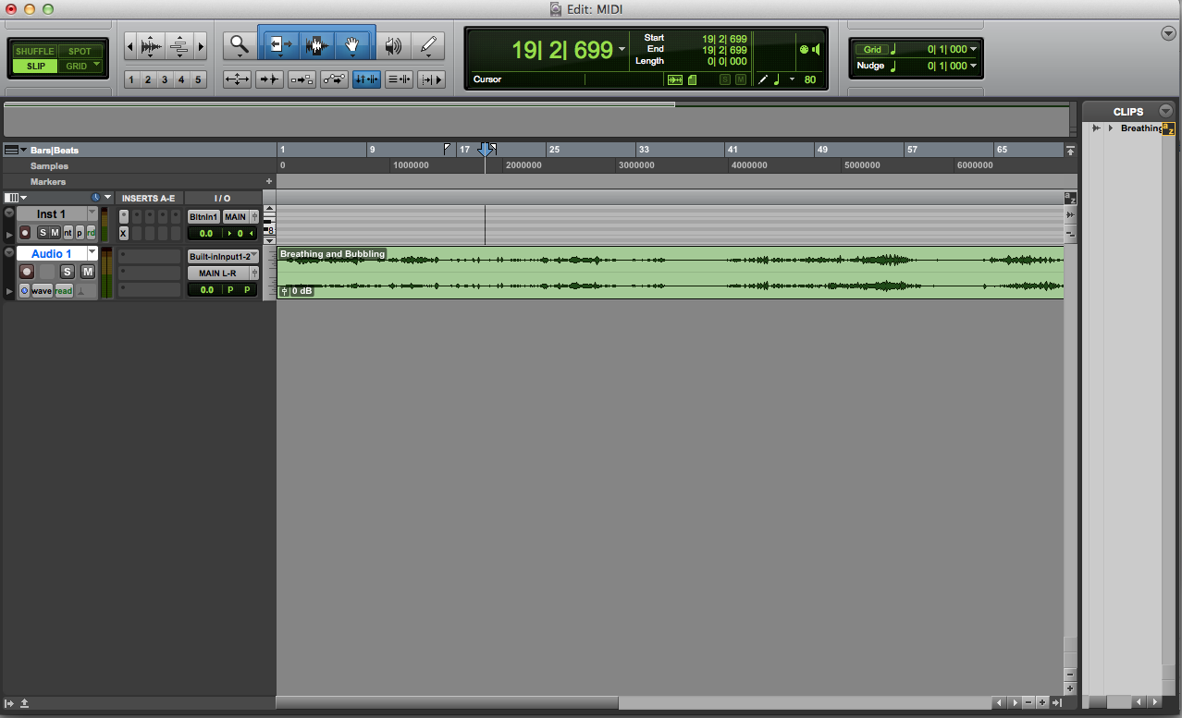

4. Before you begin composing, there are a few more “house-keeping” issues you might want to consider. Those include Meter and Tempo. Adjusting these features act independently of your audio track. That is, “slowing” down the tempo from the default 120 bpm to 60 will not slow down the audio track…

5. Meter. You can set your meter by selecting Event>Time Operations>Time Operations Window which will open a window shown on the following page:
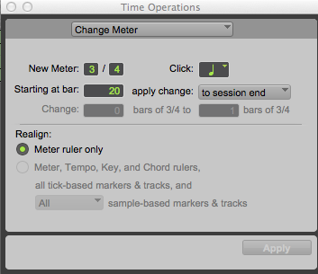

Notice what we can control in the above image.
a. We can set a new meter by adjusting the numbers right of “New Meter:”
b. We can change the value of the “Click” if we want to record using a Click track. We can even set it as a dotted value if we so desire.
c. We can determine which measure we want the meter change to apply, “Starting at Bar:”
d. We can also “apply change” in three ways by clicking what is currently set as “to session end”:
i. In the image above, the meter will change to 3/4 from measure 20 to the end (or until we add a different meter—say, in bar 30 for example.)
ii. We can select an area for which to apply the new meter (“to selected range”)
iii. Or, we can apply the change to the specific bar only (“until next bar”)

6. Tempo. We can set Tempo by selecting Event>Tempo Operations>Tempo Operations Window. A window like the one below will open:
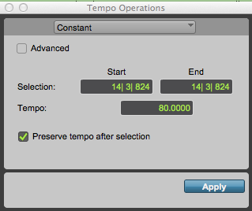

Notice the values in the above image. See where it reads14:3:824? Those numbers represent measure (14), beat (3), and which “tick” of the beat out of a possible 960 (this is the limit of subdividing in Pro Tools where 480=an eighth note, 240=sixteenth note, and so on). This is too cumbersome for our purposes. The reason why I get such an exact number is because I was in “slip” mode. It might behoove you to use “grid” when working in MIDI. Otherwise, you can manually type in the values.
a. In the image above, tempo will change from the default 120 to 80 starting at this exact moment (14:3:824).
b. If, on the other hand, we were to select an area, we could also compose an accelerando or ritard using “Linear” function. In the image in the following page, the MIDI track will ritard linearly starting at 120 bpm in m. 2, beat 1 to 80 in m. 5, beat 1. I uncheck “Preserve tempo after selection” because I want to stay at 80 bpm. If the box is checked, the tempo will go back to 120 on beat 1 of measure 5:
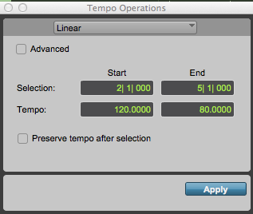

7. Once you have set your tempo and meter, you are ready to start writing notes. If you use the main Edit Window, you will probably want to adjust the height of the Instrument track. I like to adjust it according to the instrument’s range. Because most flute players can play from C4 to C7, I’ve set my track height accordingly. To do this, use the arrows above and below the piano roll to scroll to the appropriate range:
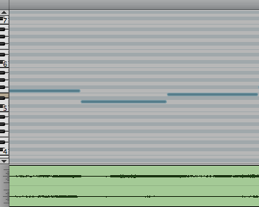

8. Using the pencil tool, you can write in notes. Use the settings in the Main Counter to your advantage:
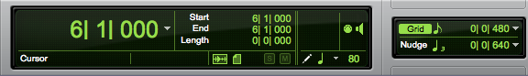

In the image above, the pencil is set to draw in quarter notes. I have the grid set to eighth notes in case I want quarter note syncopation. To change these—the note value or the grid—simply click on the note and change it to what works best for you. Note that it is limited to triplets. Any ideas how to get quintuplets?

9. If the Nancarrow approach isn’t for you, you can open the MIDI Editor under Window and toggle on the two sixteenth notes at the upper left of this window to compose in a score format:
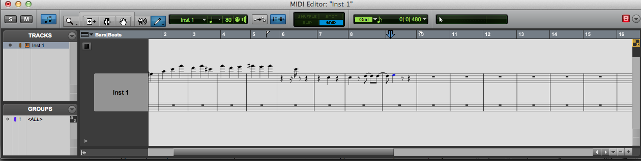

In the MIDI Editor window, you can change the value of note to the right of the main tool bar. Grid can be adjusted similarly to the Main Edit window as discussed before. In the above image, it is set to eighth notes.
10. To make your MIDI sound more human, consider freely drawing in velocity to vary attack. To do this, click on the arrow underneath the track name “Inst 1” in the grey box.
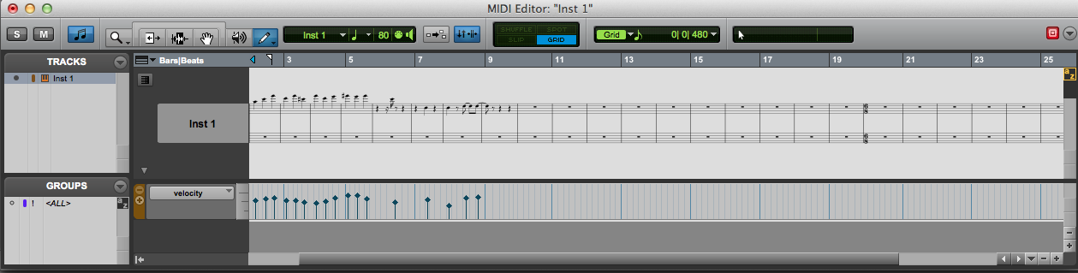

In the above image I’ve already edited the velocity by drawing with the pencil tool. You will want to do this with volume as well:
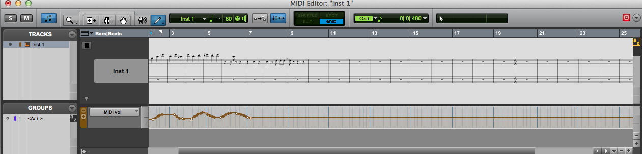

11. Go forth!

