Composition: Electronic Music II
025:251
Spring 2013
[urn] and [drunk] objects: Relatives of the [random] object

1. The [urn] object, shown below, generates random numbers without duplicates (i.e. how iTunes “shuffle” function works). These randomly generated numbers are sent out of its left outlet; its right outlet sends a bang once all numbers have been spent.
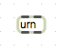
a. INLETS: the left receives bangs and messages; the right sets its integer argument
b. OUTLETS: the left sends randomly generated integers based on its argument per bang; the right sends a bang after all integers have been used.
c. An [urn] object with the argument 3 could generate series {0, 1, 2}, {0, 2, 1}, {1, 2, 0}, {1, 0, 2}, {2, 1, 0}, or {2, 0, 1}. Like the [random] object, [urn] randomly generates 0 through one less than its argument. The caveat here, for repetition’s sake, is that there are no duplicates.
d. If you were to set the [urn] object into action via a metro (or, alternatively, randomly triggered by bangs per your unique patch), shown below, it will stop generating integers once it uses the entire set: 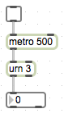
e. To solve this dilemma, we will make use of its right outlet, and left inlet. What does that outlet and inlet do again…? See solution below:
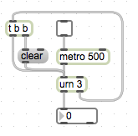
f. Why did I use a [trigger] object? Discuss in class.

2. The [drunk] object has two arguments: its range (0-X) and its “step” range.
a. The middle and right inlets set these values, respectively. The outlet sends the generated integer.
Consider the patch below:
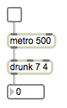
The output will be within 0-7 (yes 7, not 6); every 500 milliseconds, per [metro], a new number will be generated but will not deviate more than 3 (like random, the step range is 0 to one less the argument) from the previous integer. For example, if the current output is 1, the following output could not be 5-7.
a. Using a negative number for its step range will “suppress duplicates.” I have never used a negative step range, so I will let you experiment with that.

