025:250 COMPOSITION: ELECTRONIC MEDIA I
Fall 2014
Bounce to Disk
Jonathan Wilson

- Bouncing to Disk is an important feature that we use in Pro Tools. It allows us to mix the audio from all tracks down into a single audio file.
- Before bouncing to disk, check for overs in ALL REGIONS. If there are any overs, check your volume automation.
- To bounce to disk, select the area that you wish to bounce. Then, go to File, scroll down to “Bounce to” and click “Disk…”
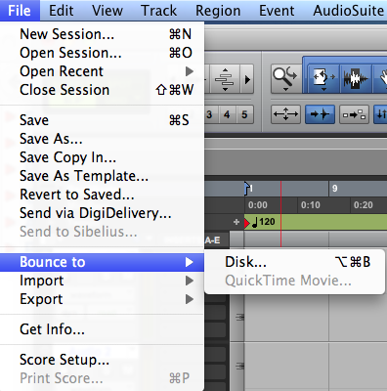
You can also access it by pressing “option command b”.
- Here are some things to consider when we are ready to bounce to disk.
  - Settings that should be used when bouncing to Disk:
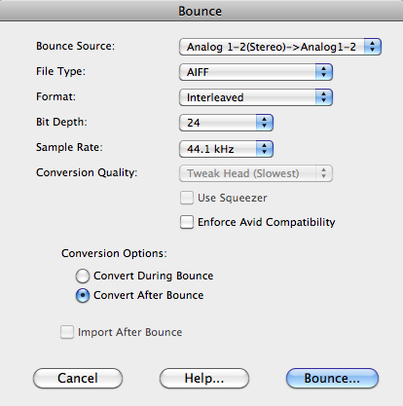
    - Bounce Source: Analog 1-2 (Stereo) -> Analog1-2
    - File Type: AIFF
    - Format: Interleaved
    - Depth: 24-bit
    - Sample Rate: 44.1kHz
    - Conversion Options: Convert after Bounce
  - Naming Bounced Files
    - We use the ß symbol at the start of a bounced filename as an easy way to locate these files. For example, “ßMetals1.aiff” is considerably easier to find than “Metals1.aiff”. To get the ß letter, hold down “alt/option” and type “s”. Make your naming system simple and easy to remember.
    - There are two places you can save the files you bounce to disk.
      - You can save your bounced files to your Audio Files Folder of your Pro Tools session. I have found that this makes scrolling down to the bounced files rather tedious and time-consuming.
      - Create a new folder in your Pro Tools session, name the folder “Bounced Files”, and save the files bounced to disk there. I find this way much more manageable and keeps me organized.

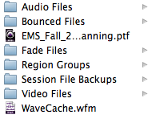
- Once you name your file, click the save button and wait for the bouncing process to finish. Once it’s finished, check for any overs in your tracks. If there are any, look for them and adjust the volume automation on that track.
- It is very helpful to open up the newly bounced file and check for overs too. This can happen even when none of the tracks produce an over. A great way to check this is to do one of the following:
  - Insert the newly bounced file into your Pro Tools session and listen to it.
  - Open up the newly bounced file in Peak Pro 6. Peak Pro 6 provides a very visual view of the waveform of a sound file. Here, in this case, when I bounced this file, I found overs in Peak Pro 6 even though I didn’t seem to have any overs in any of the tracks on Pro Tools.
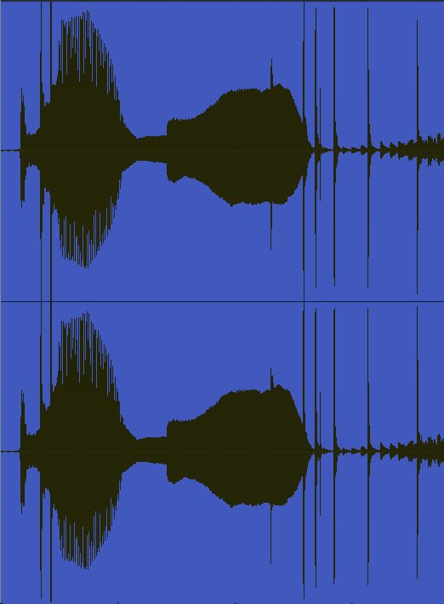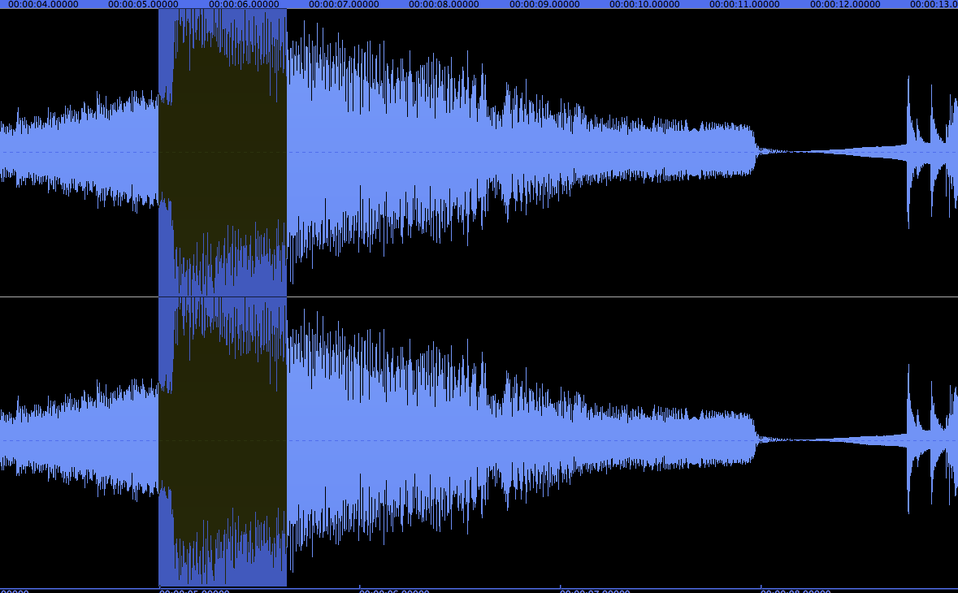
This happens when the combined volume of these tracks exceeds 0 dB.
  - When this happens, go back to Pro Tools and adjust the volume automation at those places. Bounce the file again and check for further overs.

