025:250 COMPOSITION: ELECTRONIC MEDIA I
Fall 2014
Hard Drive – Copying and Relinking

- Once we have recorded a new file to the computer, we will want to copy the session from the computer to an external hard drive. That way, we can continue working either at home or in another studio.
- Once we have copied the session to a new folder, to prevent future problems of missing files or fades, we want to make sure that we allocate all newly created files to the proper folder.
- To do this, open the session from the external hard drive. In Pro Tools, go to Setup => Disk Allocation…
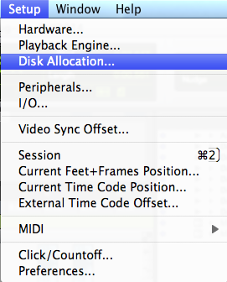
- Click on the Audio Track you wish to change. Hold down the mouse button to get the small directory window to appear.
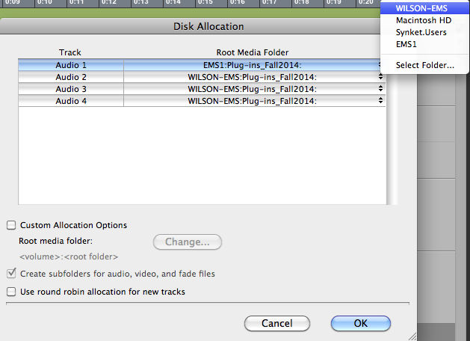
- Sometimes, files can end up missing, as in the following example:
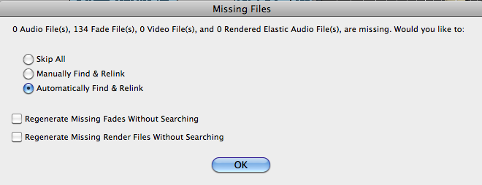
- When this happens, it would be preferable to skip all or “Manually find and relink”. The option “automatically find and relink” is time-consuming and slower. It is more preferable for us to take care of this issue directly.
- The question is then how to find those files and get them back. There are several ways to do this.
- Click on the arrow tab next to “Regions”, scroll down to “Show”, and then click “Full Path”. This will provide the full path of all files in the regions list.
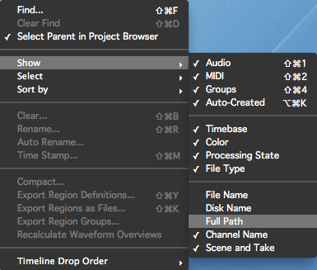
- Ideally, all files in the current session are located in the same folder.
- Files with italicized font in the regions list are missing files.
- When many files are missing, it would be tedious to go through this process with each individual file. The following procedure is useful with multiple files that need to be copied and relinked to a different Pro Tools Session.
  - In Pro Tools go to Window => Project.
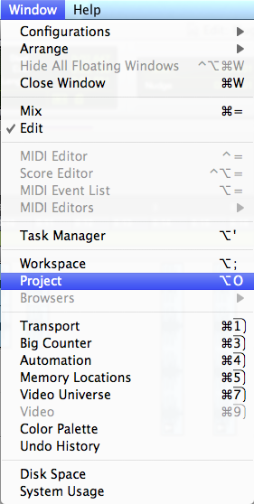
  - While in Project, open up the audio files folder for the current session and highlight the italicized files.
  - Click on the arrow at the top right corner of the menu and you will find a number of options available for what to do with these files. The best option is to select “Copy and Relink”.
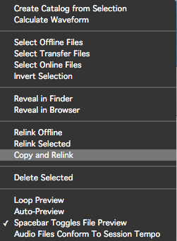
  - After selecting this option, a new window will open and prompt you to select the folder as to where these files shall be copied and relinked. Usually, Pro Tools defaults to the audio files folder of the current session. It is best to check and make sure that you are copying the files to the right folder before going any further. Once the desired folder is selected, click Open.
  - The missing files will be copied from the folder in which they were located and pasted into your audio files. Plus, the missing regions will be relinked to those new audio files in your audio files folder.
  - If you still feel unsure what to do, please contact one of the TA’s right away if you experience any problems with missing files in your Pro Tools session, and we’ll do everything we can to help you.

