025:250 COMPOSITION: ELECTRONIC MEDIA I
Fall 2014
Panning
Jonathan Wilson

- In Pro Tools, it is important for composers to take advantage of the entire stereo field. Think about where your sounds are heard in playback and how they travel from one area of the stereo field to another.
- Here are a couple of important things to know about panning in Pro Tools:
  - When working with stereo files, you can only edit one side of the stereo field at a time. As you can see, when editing pan automation, there are two separate automations that can be edited: pan L and pan R.
  - It is possible to edit both pan L and R at the same time, but it can be confusing to look at, especially when viewing multiple tracks.
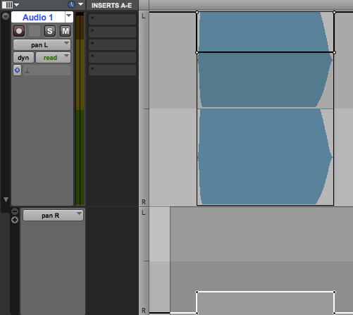
  - When working with mono files, you are controlling the location of the sound in a single speaker.
  - One can copy and paste the edit points from one side of the stereo track to another. For example, one can copy the edit points of the right side of stereo track to the right side of another track.
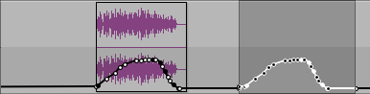
  - It is not possible to copy something from one side of a stereo track to the other. For example, one cannot copy edit points from pan L and paste it into pan R. Similarly, one cannot copy edit points for panning from a mono track to a stereo track.

